Renu Teotia  Noida, UP, India  www.linkedin.com/in/renu-teotia-13b369121/  M: +91 9877896576, 9876082750  Email: mailto:renuteotia4@gmail.com  AWS|Kubernetes|Docker|DevOps|Terraform|CI CD |  | 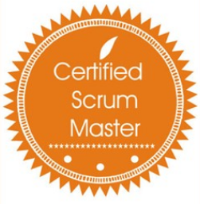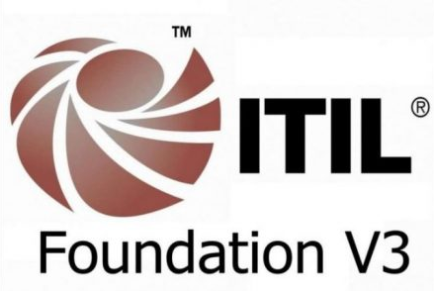
An AWS/Azure certified professional with about 2+ years of experience focused on AWS and hands-on experience in Azure.
- Knowledgeable, highly dependable and result-oriented professional in designing, deploying and managing Container Platform
- Extensive experience across core pillars of public clouds, including security, availability, performance, and cost-efficiency
- Ability to drive the project with teams from around the globe - experience working with onsite/off-shore models and multi-stakeholder environment

PROFESSIONAL EXPERIENCE :
Adidas
Site Reliability Engineer | Payments Team Dec 2020 – Present
- Working as a site reliability engineer
- Creating Monitors and Triggers in Kibana Dashboard using extraction query for different errors in different global markets.
- Creation of a process to make sure SSL Cert is updated on time, by right team.

NIIT Technologies Ltd, Greater Noida
Engineer – Cloud Services |Cloud Practice Team Aug 2018 – Dec 2020
- Working as AWS Cloud Engineer
- Infrastructure Provisioning and Management
- IaaC -Automation of architectures and solutions using Cloud Formation and Terraform
- Working on POCs (Azure/AWS) – IaaS/PaaS/Devops/IaC
- Write specifications - High level and low design documents
- Responsible for building highly resilient, scalable, reusable, and performant AWS infrastructure in an efficient manner
- Technical Demos and assistance to customers

DOMAIN EXPERTISE
- Deep, hands-on technical expertise on Amazon Web Services (AWS) and its features / offerings.
- Azure or AWS based Containerization skills
- Experience developing and refining solutions and services for Microsoft Azure/AWS Landing zones
- In-depth understanding of entire Container (Docker, EKS,AKS) Eco-System with respect to Applications & Infrastructure
- Deploy K8s Cluster using Kubeadm and Kubectl
- K8s YAML for deployment
- Container registry for storing container images
- Ingress controller for application load balancing
- Implement container security architecture
- Build Docker container images
- Monitoring and logging of Containers using AWS Container Insights
- Experience service health monitoring and alerting architecture, e.g Prometheus, Grafana
- Jenkins for CI/CD pipelines
- Git, GitLab, Docker for Desktop, AWS CLI
- Experience in writing cloud automation scripts/code such as Terraform, Cloud Formation Template (AWS CFT) etc.
- Exposure to following AWS Services:
- EC2, S3, IAM, Route53, RDS, VPC, SQS, SNS, Elastic Load Balancers, Auto Scaling, Cloud Watch, Cloud Trail Kinesis Firehose, AWS Elastic Search, etc.
- AWS Database Migration Service (Heterogeneous and Homogenous)
- Exposure to following Microsoft Azure Services:
- Azure Core Platform: Compute, Storage, Networking, AKS

SELECTED PROJECTS
Client Organization: Cathay Pacific Services Limited, Hong Kong
- Migrate traditional application to Kubernetes using EKS
- Created HLD for the customer
- Assisted application team with creation of Docker Images to be able to migrate to EKS
- Created Landing Zone comprising of VPC, Direct Connect, VPN, Route Tables
- Provisioned EKS cluster using Cloud formation
- Deployed RDS, ECR
- Created YAML for deployment and services, Ingress Controller, HPA, Pod Affinity
- Enabled logging for containers using Container Insights and Elastic Search
- Post Provisioning Hyper Care tasks like autoscaling, monitoring, etc.

Client Organization: IAG, UK
- Log Management using AWS Cloud Watch
- Pushed Application Logs and configured alerts using CloudWatch
- Created JSON Templates using Cloud Formation to automate the infrastructure provisioning

SCHOLASTICS

MCA from Chandigarh Engineering College (Punjab Technical University)
Year: 2016-2018
Result: 70%

BCA from Chandigarh Group of Colleges (Punjab Technical University)
Year: 2013-2016
Result: 67%

PERSONAL DOSSIER
Gender : Female
Nationality : Indian
Father’s Name : Mr. Dharmendra Kumar
Hobbies : Dance (Bhangra)

