Prince Kumar Tiwari

Tableau Developer (Udemy Tableau 2019 Desktop Certified)

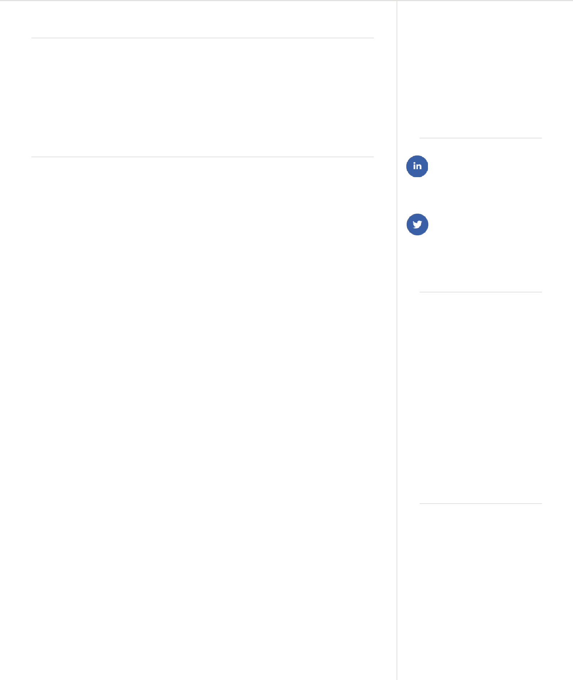

RESUME OBJECTIVE

Information Processor with 5.2 years of experience in a high-pressure and fast-paced professional environment. Independently motivated team player aiming to boost department efficiency by successfully completing all projects well within their deadlines.

**EXPERIENCE**

**Kpro Solutions Pvt. Ltd.**

PROJECT: DAIMLER AG (MERCEDES-BENZ, JAPAN)

Role: Tableau Developer

* Developing Dashboard using Tableau
* Building, publishing customized interactive reports and dashboards, report scheduling using Tableau server
* Involved in understanding business requirements
* Data analysis, data preparation along with imputation
* Presentation of final result using tableau.
* Process and Platform Enabling, Maintenances and Monitoring

Technologies:

* Tableau, Hive, SQL, Hadoop, Python, Microsoft Azure

PROJECT:  **Bank of New York (BNY Mellon)**

Role: Tableau Developer

* Developing a risk engine dashboard using Tableau
* Developed data pipeline using Apache NiFi and stored in

Oracle DB

* Data analysis, data preparation along with imputation
* Presentation of result using tableau.

Technologies:

Tableau, Apache NiFi, Oracle, Splunk

**CONTACTS**

**Email:**

prince.jnu13@gmail.com **Phone:** 7090168451 **Address:** Bangalore

**SOCIAL**

prince-tiwari-a25a49a3

live:prince_tiwary

**SKILLS**

* + Tableau
  + MySQL
  + Apache NiFi
  + Splunk
  + Google Cloud
  + Html
  + CSS
  + JavaScript
  + PHP
  + Python
  + Git

**EDUCATION**

**Bachelor of technology**

Computer Science

PROJECT:(AVAYA CALL CENTER)

Role: Tableau Developer

* Developing Dashboard using Tableau
* Developing call center dashboard showing all the detail of employee Receiving call, outgoing call, abandoned call, call volume a Time, implement various filer
* Involved in understanding business requirements
* Data analysis, data preparation
* Presentation of result using tableau.

Technologies:

* Tableau, SQL

PROJECT:(Kpro Therd Eye Product for Banking application)

Role: Tableau Developer

* Developing Dashboard using Tableau
* Getting live data from various source like CCTV camera used various analytical model to

Analysis those data and capturing all the activity of employee and customer using tableau visualize

All the activity

* Involved in designing and business requirements
* Data analysis, data preparation

Technologies:

* Tableau, SQL, Python, Machine learning

PROJECT:( Techvidyalaya)

Role: Full Stack Developer)

* Developing education website
* Involved in designing and business requirements
* Integrating payment gateway

Technologies:

* HTML, CSS, JavaScript, PHP, MySql