Satish Annelli 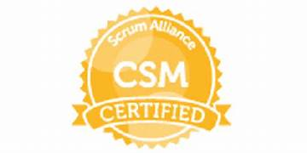





Certified Scrum Master
Objective
Servant leader for technology teams to improve its ability to self-manage, produce high quality work and set the bar for delivery expectations through advanced agile project management practices, innovative retrospective, and team building activities to increase team morale.

Contact
+91 91003 60848

Satisimha211@gmail.com
Hyderabad – Telangana
India

EDUCATION
HARD SKILLS
SOFT SKILLS
Certified Scrum Master
Scrum Alliance

Master of Business Administration - Pune

- Scrum Master for a team of 14 working on Bonita BPM, PHP, and SQL, implementing Agile methodologies and Scrum ceremonies to facilitate the on-time product delivery
- Facilitated 47 Scrum of Scrum calls to build synergies and bridge communication among various technology teams
- Implemented Agile mindset by conducting burndown chart, team velocity analyses, and continuous improvement initiatives
- Communication skills

- Business etiquettes

- Email etiquettes

- Conflict Mgmt

- Presentation Skills
- ITIL
- Scrum Framework
- SDLC
- JIRA
- Waterfall to Agile Migration
- Sprint Cadence
- Product backlog grooming
- Confluence

www.linkedin.com/in/annelli-satish-10890715

Experience:

Organization : Ember Technologies, LLC
Projects : www.libraryoflife.com | www.kcnr.net
Date of Joining : December 2020
Role : Scrum Master

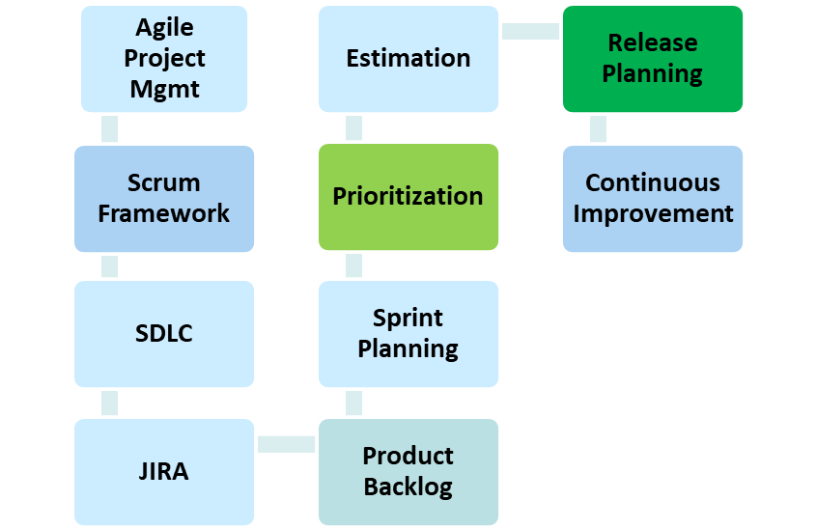

- Scrum Master for 2 Scrum teams consisting of 12 members to streamline a web & mobile video sharing app project
- Facilitate teams’ planning and tracking activities while coaching in Agile principles
- Successfully transform the team’s waterfall mindset to Agile by developing effective training materials for teams to understand Agile delivery
- Responsible for providing the necessary tools and reporting to manage program delivery
- Responsible for management of program workstream progress and execution against agreed upon objectives
- Responsible for monitoring and managing core Program Management expectations and coordinate/execute corrective action to address gaps
- Coordinate with the platform dev lead, project managers, and product owners to do sprint and release planning for the platform
- Coordinate with release management & QA to ensure smooth release processes are maintained
- Responsible for communicating expectations and milestones for Clarity updates to Resource managers
- Responsible to implement and execute disciplined Change control process including communication, estimation and impact to scrum teams and testing
- Worked closely with Stakeholders, Product Owner’s, and Architects to clarify the schedule, status and details of each project.
- Served as Single point of contact, to drive effective communication through-out all project phases reducing cost through streamlined communications
- Implemented Agile Project Management methodologies using Scrum framework across projects
- Supported the product owner’s in managing the customer expectations for project deliverables and managed stake holder communications, resulting in
- customer engagement with new features
- Led Sprint planning, daily scrum, demo/review and retrospectives
- Continually refined and evolved Agile process for predictable and rapid software delivery resulting in achieving project milestones
- Managed a well – defined project management process and championed ongoing process improvement initiatives to implement best practices for agile project management
- Enacted change and continuous improvement increasing the productivity and quality
- Focused on continuous improvement through team retrospectives after each release

Experience:

Organization : CTS (Cognizant Technology Solutions)
Project : O&A Hub.
Client : Kaiser Permanente
Date of Joining : 02nd Nov 2018 – Feb 2020
Role : Scrum Master

- Focused primarily on trainings the team to write good user stories prioritize the work based on business values.
- Interfaced with Program Management Office to ensure project goals and requirements are being met
- Protected team from over commitment, managed backlog, prioritized resolution of defects.
- Worked with the Scrum Team and the Product Owner to negotiate the minimum viable product for delivery
- Assisted team to remove impediments by having an understanding the control and release processes
- Assisted with internal and external communication, improved transparency, and radiated information
- Assisted with prioritization and resolution of software defects
- Built relationship with Product owner and other stake holders to facilitate team's interaction with them
- Coached Product Owners in creation and maintenance of Product Backlog
- Coached team members on Agile principles and providing general guidance on the methodology
- Continuously learned Agile/Scrum techniques and shared findings with the team
- Facilitated getting the work done without coercion, assigning, or dictating the work
- Facilitated sprint planning, daily stand-up, review and retrospective
- Helped team to solve problems rather than provide solutions
- Organized and facilitated project planning, daily stand-up meetings, reviews, retrospectives, sprint, release planning, demos, and other Scrum-related meetings
- Provided all support to the team using a servant leadership style whenever possible, and led by example
- Removed impediments by finding the right personnel to remove the impediment
- Took responsibility of delivery and management of the tasks
- Tracked and effectively communicated team velocity and sprint/release progress to all affected teams and management
- Updated Agile tracking systems to provide transparency on product and sprint backlogs

Experience:

Organization : CTS (Cognizant Technology Solutions.)
Competency : Core Engineering Cross Platform Services.
Client : UBS
Date of Joining : 12th August 2015 – 18th October 2018
Role : Business Analyst / Agile Scrum Master

Cognizant Technology Solutions (Cognizant) (NASDAQ: CTSH) is an American multinational IT services and consulting corporation headquartered in Teaneck, New Jersey, United States (CMML5, a fortune 1000 company) is a leading provider of information technology, consulting and business process outsourcing services with $4.50 billion (2010) turnover, more than 35 global deliveries & over 1 lakh employees.

- As a Process coach, continuously train, coach the higher management, teams, and Scrum Masters in Agile Scrum and conduct incubation workshops as required
- Working closely with Process Owners keeping the Product backlog with up to date well-groomed user stories and maintaining the list prioritized
- Facilitate Daily Scrum meetings, Sprint planning, Sprint review, and Sprint retrospective
- Work with Process owner and team on Artifacts Such as Product Backlog, Sprint Backlog, Sprint Burn down, Release Burn down
- Organize and facilitate Sprint planning, daily stand-up meetings, reviews, retrospectives, and Release planning, and other Scrum-related meeting
- Encouraging the team to come up with reusable elements and use the best practices
- Helped the product owners to come up with set of stories for better understanding for estimate and development.
- Motivated the team to come up with quality shippable product and meet the product goals.
- Track and report status and other metrics against goals on Sprints via JIRA dashboard.
- Plan communication strategies to ensure status, activities, accomplishments, issues, and risks are communicated to senior management, project stakeholders, and IT teams proactively
- Ensuring team's focus on Sprint goal and track progress to ensure project milestones were completed on time, on budget and with the desired results
- Responsible for project delivery in Agile and/ Waterfall environment Anticipated and managed change effectively in rapidly evolving global business environments
- Drive continuous improvement via Inspect and Adapt discussions / workshops
- Assist with internal and external communication, improving transparency, and radiating information via JIRA dashboards

Experience:
Organization : CSC (Legacy DXC.)
Competency : GIS - Service Delivery.
Client : DuPont
Date of Joining : 13th June 2013 – August 7 2015

Experience:
Organization : Herbalife International India Private Limited.
Competency : Service Management Analyst
Date of Joining : 06th June 2011 – 31st May 2013

Experience:
Organization : Yell Adworks India Private Limited (Acquired by TCS)
Competency : Change & Configuration Mgmt Analyst - Service Management
Date of Joining : Sept 2007 – Nov 2010

Experience:
Organization : IBM Global Services
Client : Westpac Banking Corporation
Competency : ITSM
Designation : Change Analyst
Date of Joining : December 2006 – August 2007

Experience:
Organization : Solivar Software
Designation : EDI Analyst
Date of Joining : February 2003 – Nov 2006.

Personal Details

Father’s Name: Mohan Rao.
Occupation : Retd. Engineer South Central Railways.
Marital Status : Married.
Interests : Sports, Music and reading books.
Passport : P5058979
Business VISA : USA B1/B2 Valid till 2027.

References Available on Request

