SWAGATA DAS
2x Certified Salesforce Developer
Accenture Solutions Private Limited
Address: R/49, Kamdahari Purba Para, Garia, Kolkata – 84
Contact: +91 – 9836182465, 8240106683
Email: swagata.das.1988@gmail.com

PROFFESIONAL SUMMARY
- Having total 9 years and 4 months of experience in various Product Enhancement/Development and Application Development.
- Having total 4 years of experience in Salesforce Development.
- Currently working in Accenture Solutions Private Limited as Application Development Specialist in Salesforce.
- Had worked Pursuit Software 2018-2019 and Evolving System 2014-2018.
- Adept in end-to-end development of software products – effort estimation, designing, coding, unit testing, debugging, documentation and implementation.
- Experience in handling team to get the work done in time also worked in pressure situation being involved in multiple project requirements simultaneously.
- A stringent follower of process improvement approach in delivering quality product.
- An effective communicator with honed team management, analytical and logical problem-solving abilities.

OBJECTIVE
Intend to build a career with committed & dedicated people, which will help me to explore myself fully and realize my potential. Willing to work as a key player in challenging & creative environment.

ACADEMIC QUALIFICATION
Degree and Date | Institute | Marks Obtained
Masters in Computer Application,2013 | RCC Institute Of Information Technology, Kolkata. | 8.26
Bachelors in Computer Application, 2010 | Netaji Subhash Engineering College, Kolkata. | 7.67(DGPA)
12th ,WBCHSE, 2007 | Ballygunge Govt. High School, Kolkata. | 61.2%
10th ,WBBSE, 2005 | Ballygunge Govt. High School, Kolkata. | 66.25%

Salesforce Technologies Working/Worked with
- Programming Languages: Apex
- DBMS Packages: SOQL, SOSL, Triggers
- Environment : Sales Cloud, Service Cloud, Community Cloud
- Web Designing: LWC, Aura
- OOTB Tools: Lightning Flow, Process Builder Validation rule etc.
- Development Tools: VS Studio, SFDC Workbench
- Web Services: REST

Other Technology worked with
- Programming Languages: Java 1.7,1.6,J2EE,Python 2
- DBMS Packages: Oracle 10g,11g,12c
- Operating Systems: Linux, Windows
- Web Designing: HTML, JSP, JSF
- Development Tools: Vs Code, Eclipse, vi Editor, SQL Developer, Toad, SOAP UI
- Application Server: Apache Tomcat
- Web Services: SOAP,REST

SKILLS
- Linguistic proficiency:
      - English
      - Bengali
      - Hindi.
- Proficient in MS OFFICE, Internet and other Windows applications.
- Quick learner and hard-working.

Project Handled

- Project Name : Apollo Development Project
Client: CIBC (Canadian Imperial Bank of Commerce)
Duration: June 2021 to April 2022
Technology: LWC, Apex, Integration REST API, Lightning Flow, Service Cloud
Environment: Windows
Role: Team Lead come Lead Developer
Organization: Accenture Solutions Private Limited
Synopsis: As a part of Apollo project we developed a customized case management system in salesforce where a bank employee can create and update cases like Fraud, Card lost etc. based on the request of a client. The system will fetch client’s information like Debit Card/Credit Card/Deposit Account etc. from a 3rd party API in run time and show it in UI. After case creation notify User via mail/SMS. Assign the case to a User/Queue if not attended within certain days based on severity then the case will be escalated to the Manager. After Case assignment bank will connect with the user and try to solve the case as soon as possible and for fraud case bank will compensate a certain amount to the customer. Follow up with the customer after certain days until the case is resolved/closed.

Key Role:
- Understand the requirement, discuss and provide solution to the design team, provide estimation of user stories, guide junior developers to complete their user story.
- Develop complex LWC, Apex class, Implement 3rd party Integration to meet client requirement, Debug issues in higher environment etc. Give Demo to clients on a regular basis to show till how much we have developed.

- Project Name : ECRM Development Project
Client: CIBC (Canadian Imperial Bank of Commerce)
Duration: July 2020 to June 2021
Technology: LWC, Apex, Integration REST API, Lightning Flow, Sales Cloud
Environment: Windows
Role: Senior Developer
Organization: Accenture Solutions Private Limited
Synopsis: As a Financial Advisor of the Bank when you call your clients to book a date to discuss financial planning you will see all the details of client like address details, phone details, previous investments, products (Debit Card, Credit Card etc.) in the details page and all the data will populate in runtime fetching data from 3rd Party API. At the end of the discussion the FA will create a note in salesforce for the tracking purpose and the note will be visible to all the people who are present in the Role Hierarchy.

Key Role:
- Understand the requirement, discuss and provide solution to the design team, provide estimation of user stories, help other developers to complete their user story.
- Develop LWC, Apex class, Implement 3rd party Integration, Debug issues in higher environment etc.

- Project Name : Motiva Logistics Development Project
Client: Motiva
Duration: December 2019 to June 2020
Technology: Aura, Apex, Community Cloud
Environment: Windows
Role: Senior Developer
Organization: Accenture Solutions Private Limited
Synopsis: As a part Motiva Logistics Project we developed a portal in community cloud for external users who can create/edit Account, Product etc. track oil tankers like from where they will load oil and where they will offload oils, what are the routes they will cover etc.

Key Role:
- Understand the requirement, discuss and provide solution to the design team, provide estimation of user stories, help other developers to complete their user story.
- Develop Aura, Apex class Debug issues in higher environment etc.

- Project Name : SFDC Development and Maintenance Project
Client: Renowned American Company
Duration: May 2019 to till date
Technology: Apex, SOQL, triggers, Java
Environment: Windows
Role: Development
Organization: Pursuit Software Development Pvt. Ltd.
Synopsis: Integrate Salesforce with other Application, to create Case, Opportunity etc. Load Data in Salesforce from CSV file using Java. Export Data into a CSV File by using Data Loader. Convert Profiles from Salesforce License to Platform License. Access meta-data using API in the Same Org with JWT connectivity. Write Test Class to cover Apex Class coverage.

Key Role:
- Understand Salesforce API to integrate other Application using Connected APP.
- Write Java Class/ Apex Class as per requirement also write the test class.

- Project Name : OKTA Usage Reporting Tool Development
Client: Internal
Duration: Aug 2018 to April 2019
Technology: Java, Python, MySQL, Salesforce, AWS, REST API
Environment: Windows
Role: Development
Organization: Pursuit Software Development Pvt. Ltd.
Synopsis: OKTA is an SSO Product. “OKTA Usage Reporting Tool” is used to get Login information from OKTA and help to know how many user Login into certain application for how many times between a time span. Which helps them to understand how many paid license they have brought for certain application and how many is using actually, which will directly impact their revenue. Back end of this Tool written in Python and Database is MySQL and deployed in AWS.

Key Role:
- Understand OKTA Log File and its relationship between each attribute of log and OKTA API.
- Understand Salesforce and Integrate with OKTA to get information about user.
- Database design and writing Python code which will insert data into Database.
- Deploy in AWS and automate Python Script execution.

- Project Name : USSD System for European Telecom Service Provider
Client: Orange Moldova
Duration: May 2017 to July 2018
Technology: Core Java, Oracle, XML, Python, SOAP API
Environment: Linux, vi editor
Role: Development
Organization: Rate Integration Software Technologies Pvt. Ltd
Synopsis: USSD(Unstructured Supplementary Service Data) Product developed in core Java, XML and Python, which helps mobile users to make short code with some particular number and perform some operation as per their requirement to know their balance/activate some service/deactivate some service etc. for both prepaid/post-paid customer.

Key Role:
- Understand Customer Requirement, Prepare set of questions and note the answers in a document which will help during development phase.
- Write down the Business Logic as per requirement in XML file with Python Blocks.
- Implement third party SOAP API using Java.
- If needed then modify Product code written in Core Java.
- Communicate with QA team to fix bugs during Testing. Then also communicate with IDE (Integrate and Development Engineer) during NIT (Network Integrate Testing) to fix bugs.

- Project Name : USSD System for Middle East Telecom Service Provider
Client: DU
Duration: April 2016 to May 2017
Technology: Core Java, Oracle, XML, Python, SOAP API
Environment: Linux, vi editor
Role: Development
Organization: Rate Integration Software Technologies Pvt. Ltd
Synopsis: USSD(Unstructured Supplementary Service Data) Product developed in core Java, XML and Python, which helps mobile users to make short code with some particular number and perform some operation as per their requirement to know their balance/activate some service/deactivate some service etc. for both prepaid/post-paid customer.

Key Role:
- Understand Customer Requirement, Prepare set of questions and note the answers in a document which will help during development phase.
- Write down the Business Logic as per requirement in XML file with Python Blocks.
- Implement third party SOAP API using Java.
- If needed then modify Product code written in Core Java.
- Communicate with QA team to fix bugs during Testing. Then also communicate with IDE (Integrate and Development Engineer) during NIT (Network Integrate Testing) to fix bugs.

- Project Name : Loyalty Management for Renowned Middle East Telecom Service Provider
Client: Zain Bahrain
Duration: December 2013 to April 2016
Technology: Core Java, Oracle, RLM Catalogue Manager (Company product)
Environment: Linux, VI editor
Role: Development, Testing, Client Support
Organization: Rate Integration Technologies Pvt. Ltd
Synopsis: RLM (Real Time Marketing) is a telecom Product which helps Telecom Operators to know about each customers behaviour like how much they top-up how frequently, how many they make calls of Local/STD/ISD, how many they send message and based on that Operator can give various offer to users and this will directly effect on the revenue of the Telecom Operator.
Key Role:
- Understand Customer Requirement, discuss queries during development phase.
- Write down the Business Logic as per requirement in RLM Catalogue Manager.
- Write down file parsing Logic and Insert into DB in Core Java, also write down Benefit like send SMS, send request to IN for service activation or de-activation in core Java
- Testing the Business Logic end to end and communicate with customer during UAT.
- Deploy into Production and give support to client.

Certifications
Salesforce PD1  Passed on: 18/04/2019  Credential Id: 20016918 | 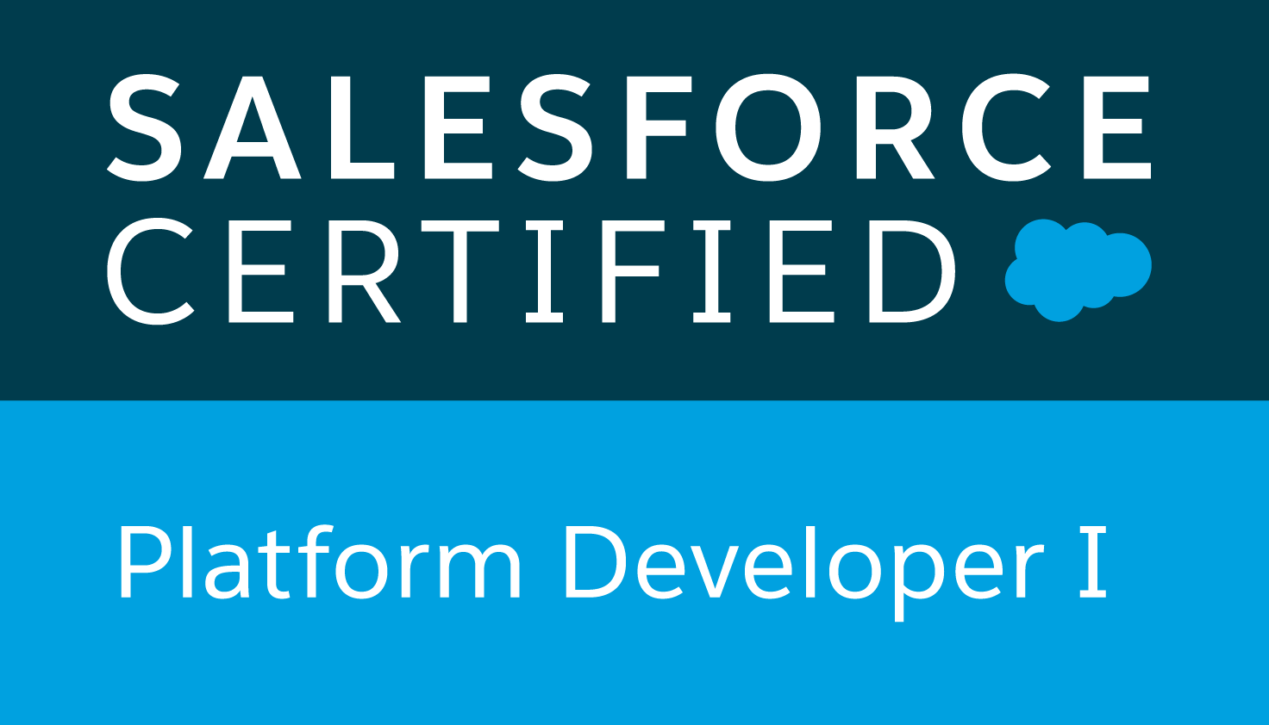
Salesforce Admin  Passed on: 04/08/2022  Credential Id: 2473106 | 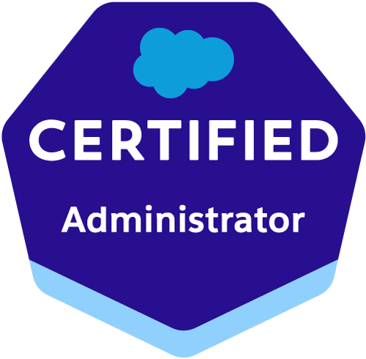

EXTRA CURRICULAR PROFICIENC
Participated in various sports events in school & college. Took part in inter school football Championship and also district football Championship.

HOBBIES & INTERESTS

Playing football, watching movies, listening to music, travelling.

PERSONAL MEMORANDUM
Date of Birth: November 05, 1988
Nationality: Indian
Marital Status: Married

Passport: Indian Passport Valid till 2033.

DECLARATION
I do hereby declare that all statements made in this resume are true, complete and correct to the best of my knowledge and belief.
Place: Kolkata _________________________________
(Swagata Das)

