**Anil M**  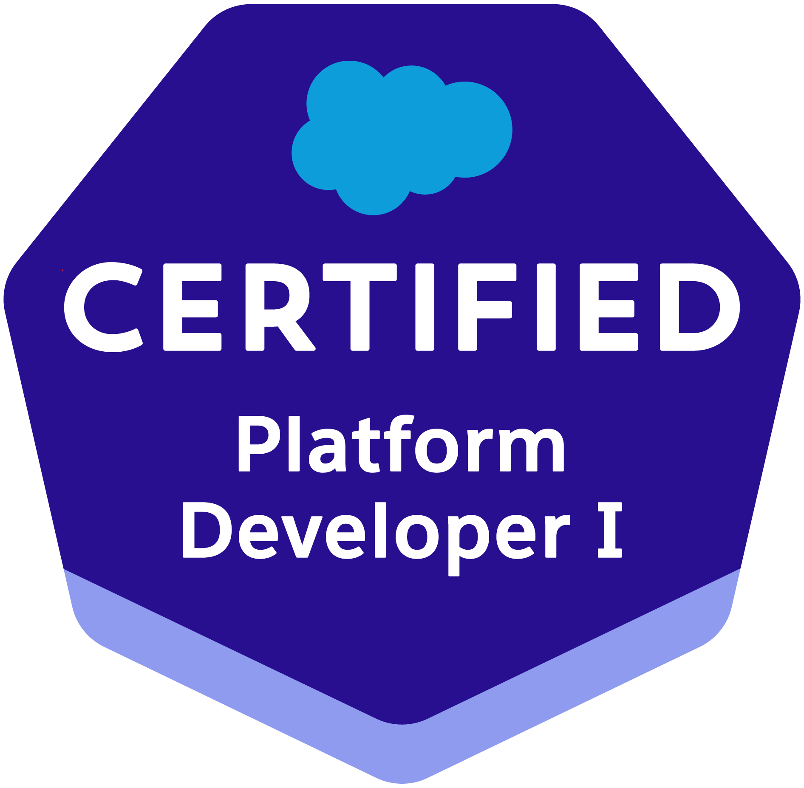

**Ph: +91 7396809440**

**Email : middelaanil1994@gmail.com**

**PROFESSIONAL SUMMARY:**

* **Having Totally 5 years of experience in the IT industry and having 4 years of Experience in Designing, Development, Testing and Implementation by using Salesforce CRM and 1 Years of Experience in Mainframe as a developer.**
* **Hands on Experience in Aura Lightning Component Development and Lightning Web Components**
* **Experience in working with Salesforce CLI/SFDX and VS Code.**
* **Having knowledge with REST API Services in Integration**
* **Having Experience in Automation tools like Workflow Rules,Process Builder and flows**
* **Experience on deployment processes by using Change sets**
* **Proficiency in Automations like Workflow Rules, Process Builders and Flows.**
* **Experience in working with Different sandbox environments like UAT, SIT, PreProd and Production Environments.**
* **Proficient in using data migration tool like Salesforce Apex Data Loader.**

**TECHNICAL SKILLSET:**

|  |  |
| --- | --- |
| **Salesforce** | **Lightning Components, Lightning Web Components, Apex Triggers, Apex Classes, Visual force, SOQL, Administration.** |
| **Languages** | **HTML, JavaScript,COBOL,DB2** |
| **Tools** | **Apex Data loader, Force.com Migration Tool, Workbench and Salesforce CLI, VS Code,Endover,change-man,Control M** |

**PROFESSIONAL EXPERIENCE:**

* **Working as Developer in Cognizant Technology solutions Pvt Ltd from JULY-2021 to till now**
* **Worked as software Developer in Pulsebyte software Consulting Pvt Ltd from MAY-2018 to till JUNE-2021**

**Client: CVS Health JULY 2021 – Till Date**

**Projects: CVS Antham Build team**

**Role: Salesforce Developer/Support**

#### Description: CVS Health Corporation is an American healthcare company that owns CVS Pharmacy, a retail pharmacy chain. CVS Health is using Salesforce CRM for their retail outlets management

**Responsibilities:**

* **Working on Lightning Aura and LWC components as part of Enhancements and tickets.**
* **Working on Apex Classes,Apex Triggers and Asynchronous Process as part of Project.**
* **Participating in client calls for the Business Application improvements**
* **Incident Management and Resolution in Service now portal**
* **Code fixes in lower environments and deploy to Production using change sets**

**Client: Abbvie FEB 2019 – JUNE 2021**

**Projects: Tesla**

**Role: Salesforce Developer/Support**

#### Description: Tesla is using Salesforce CRM for the Products and Customer Management and using salescloud

**Responsibilities:**

* **Incident Management and Resolution in Service Now Portal**
* **As Part of ticket management need to modify the components Aura,LWC and Apex**
* **Interacting with the client for the status updates on the tickets**
* **Bug fixing and moving the changes to the Production**
* **Maintaining Code Coverage for the Apex Classes with best Practices.**

**Client: National Life Insurance Group MAY 2018 – JAN 2019**

**Projects: Vsam To DB2 Conversions and Migrations**

**Role: Software Developer**

#### Description: This project mainly deals with conversion of its database from VSAM to DB2. It involves Database design, data conversion, program conversion of batch and online programs, proc and JCL conversion. It also involves regression testing.

**Responsibilities:**

* **Involved in both Batch and Online Applications.**
* **Involved in Impact Analysis and preparing Technical Specifications.**
* **Understanding the Design document and preparing UTP.**
* **Making the Changes according to Design document.**
* **Preparing Test data and Involved in Peer Reviews..**
* **Attending status calls and code walkthrough meetings.**
* **Preparing understanding documents for the code changes.**
* **Involved in oncall support for production cycle.**
* **Generated adhoc reports into excel sheets and sent to end users.Bug fixing and moving the changes to the Production**

**Educational Qualification:**

* **Bachelor Of Technology 2016 from KNR college of Engineering and Research under University JNTUH**

**Personal Information:**

**Father’s Name : Narsinga rao**

**Mother ‘s Name : Jyothi**

**Gender : Male**

**Date of Birth : 14 -DEC-1994**

**Marital Status : Married**

**Declaration:**

**I hereby declare that the above information is correct and true to the best of my knowledge & belief.**

**Place: Hyderabad**

**Date:**  (**Anil M)**