
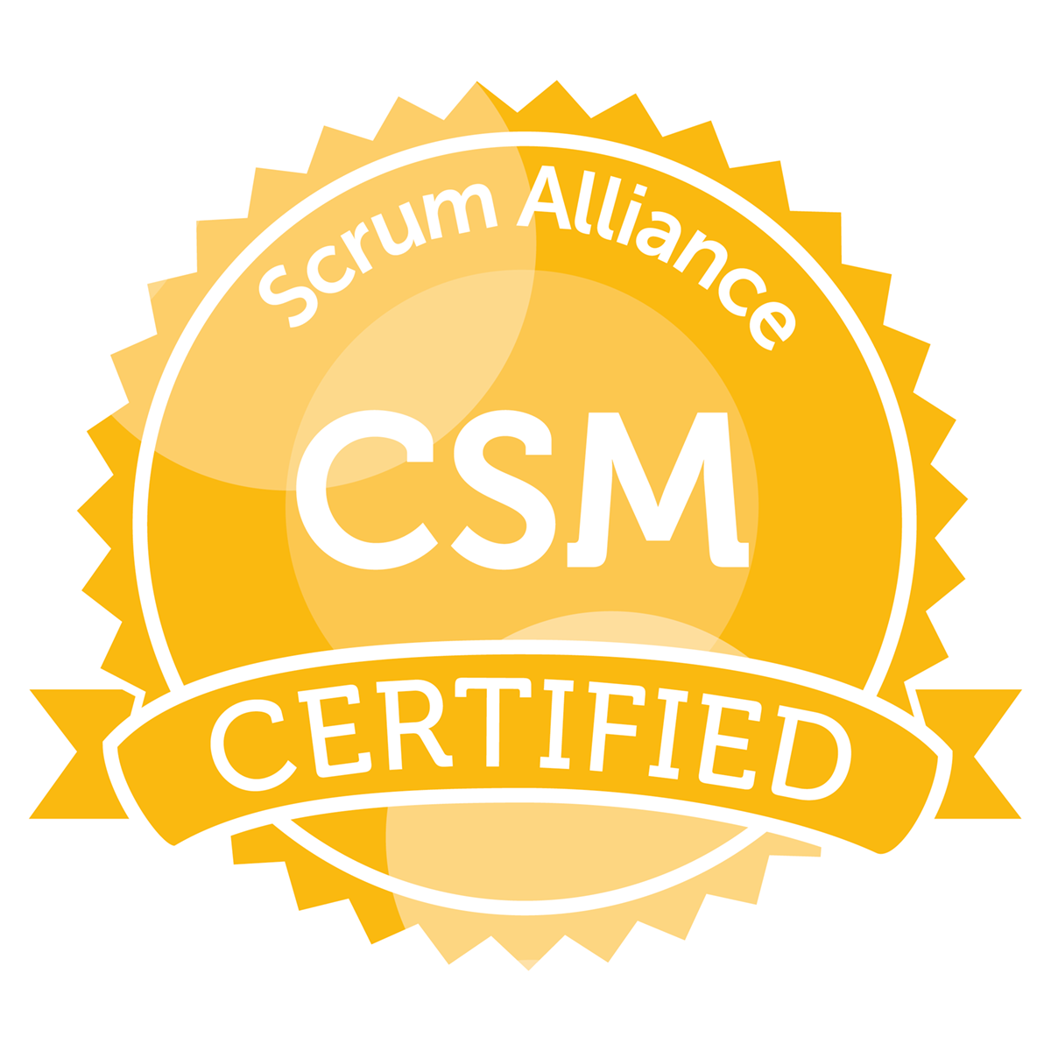
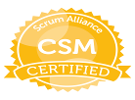
Rohit Mehrotra
Mobile: +91-6301894070, 9538965128 ~ E-Mail: scrummasterrohit@gmail.com

LinkedIn: https://in.linkedin.com/in/rohitmehrotra2016

Objective

Seeking a Scrum Master position.

Professional Summary

- Bring along a total 14 Years of experience working in Product Based organizations & currently associated with “Chubb as a Scrum Master.
- 7 Years of Experience as Scrum Master/Agile Transformation Lead.
- 1 Year of working experience as Safe Scrum Master
- Have strong knowledge and experience in Scrum Process Framework, Team Leading and JAVA/J2EE.
- Core strengths Facilitating Scrum Process, Handling cross border team, Team Empowerment,
- Expertise in Release Estimation, Release Delivery, Backlog Management, Dependency Management
- Good knowledge of Scaled Agile Framework.
- Good Experience in Collaborating with Business and Partners.
- Good in People Management and end to end Project Delivery.
- Good in Enabling team to meet Sprint and Release DOD.
- Good in Handling Multiple Teams and Removing Impediments
- Good in coaching team about the Scrum Framework.
- Good in guiding teams to deliver the stories with highest quality.
- Good experience in handling Scrum of Scrums at Dependency level and Organizational level.
- Having good knowledge of Jira to maintain Sprint Backlog, Dashboard, charts.
- Having good knowledge of Confluence to maintain Project docs and Reports.
- Good in conflict management.
- Knowledge of CI/CD pipeline.
- Having good knowledge of AWS, worked with teams hosting their applications to PCF/AWS.
- Good Knowledge of J2ee frameworks like Spring, Hibernate, Struts and Restful Web Services.
- Good knowledge of Core Java, Junit 4.
- Good knowledge of J2ee Design Patterns, Code Refactoring and Clean Coding.
- Extensively worked in Banking, Electrical, Telecom, Warranty, Travel, Logistics, Insurance domain.

Skills

Scrum:
- Facilitate meetings (daily scrum, sprint planning, sprint demo and retrospective)
- Shielding the team
- Conflict resolutions
- Coaching Agile practices
- Tight grip on Agile Estimating and planning
- Forecasting
- Removing impediments
- Creating communication channel (Team, Product owner, Stakeholders)
- Servant leader
- Enforcing Rules

Technical:

Languages | Java, HTML, CSS
Standards /  Frameworks | Spring, Struts 2, Hibernate, REST, SOAP, Maven, ANT, Agile, AWS
Infrastructure | JBoss, IBM WebSphere, Tomcat, BEA WebLogic, Jenkins, Oracle, Bit Bucket, Subversion, CVS, Microsoft Windows, Linux
Development Tools | Eclipse, Jira, SQL Developer

Certification
Scrum Alliance CSM
Scrum Alliance CSPO
Leading Safe 4.5
ICP-ACC (ICAgile Certified Professional – Agile Coaching)
Nokia Siemens Internal Scrum Master Course

Education
Master of Computer Applications | 2007
Harcourt Butler Technological Institute (HBTI) | Kanpur, UP

Experience

Scrum Master  Chubb Insurance (R&D), Hyderabad | Sep 2020 – Till Date
- Part of (Digital & Data Analytics) Team (API Development and Data Mastering using ETL and MDM).
- Working as Scrum Master for 2 Team`s in Data Analytics division of Chubb.
- Teams I am associated with Develop API`s and do data mastering using ETL and MDM.
- Collaborate with partners from US, Europe and APAC region.
- Coaching the new teams about Scrum Framework/Estimations process and other practices.
- Facilitating Release Planning, Sprint Planning, Backlog Grooming, and Retrospective meetings
- Removed team impediments daily to allow the team to deliver the sprint goals and deliverables.
- Collaborated with members of the Product, Business and Engineering Teams to develop and maintain Product Backlogs
- Lead daily stand-ups and scrum ceremonies.
- Responsible for End To End Delivery.
- Have weekly sync up meetings with Dependent team to discuss open issues.
- Track burn down, issues and progress of release using Jira.

SCRUM MASTER  DBS DAH2 (R&D), Hyderabad | Sep 2017– Sep 2020
- Part of (Core API) Digital Transformation Team (Open Banking Initiative).
- Working with a group of Scrum Master to do Agile Transformation for a Team of 70 members.
- Working as Scrum Master for Team of 9 members.
- Collaborate with partners from Taiwan, Indonesia, Hongkong and Singapore.
- Coaching the new teams about Scrum Framework/Estimations process and other practices.
- Coaching/Mentoring two cross functional team.
- Facilitating Release Planning, Sprint Planning, Backlog Grooming, and Retrospective meetings
- Removed team impediments daily to allow the team to deliver the sprint goals and deliverables.
- Facilitated team and cross-team Retrospectives to build good working relationships.
- Collaborated with members of the Product, Business and Engineering Teams to develop and maintain Product Backlogs
- Helping team interacting with Business and Partners.
- Lead daily stand-ups and scrum ceremonies.
- Responsible for End To End Delivery of Customer Journey.
- Have weekly sync up meetings with Dependent team to discuss open issues.
- Track burn down, issues and progress of release using Jira.
- Involve in release planning, story/task creation in Jira, Jira overall maintenance.

SCRUM MASTER  Schneider Electric (R&D), Bangalore | July 2016 – Sep 2017
- Worked with DCES (Digital Customer Experience) Team.
- Responsible for Agile Scrum team of Size 10(Dev Team Size 7).
- Collaborated with Partners and Business Team from European Region (Spain, Belgium, France).
- Coached/Mentored a cross functional team of 10 resources to deliver quality products.
- Utilized Agile Scrum practices to help the team increase their velocity within two releases.
- Facilitated Release Planning, Sprint Planning, Backlog Grooming, and Retrospective meetings
- Removed team impediments daily to allow the team to deliver the sprint goals and deliverables.
- Facilitated team and cross-team Retrospectives to build good working relationships.
- Collaborated with members of the Product, Business and Engineering Teams to develop and maintain Product Backlogs
- Lead daily stand-ups and scrum ceremonies.
- Work with product owners to groom the backlog and plan sprints.
- Have weekly sync up meetings with Dependent team to discuss open issues.
- Track burn down, issues and progress of release using Jira.
- Update all the stack holders in weekly SOS meetings.

SCRUM MASTER  Nokia Siemens Networks (R&D), Bangalore | July 2013 – July 2016
- Part of the team developing Network Management System (OSS).
- Got an opportunity to Implement Scaled Agile (Safe) Framework.
- Worked as a Servant Leader for an Agile Scrum Team (Safe) of 11 members.
- Helped team to improve their velocity and guided new members about the Estimation process.
- Facilitated Release Planning, Sprint Planning, Backlog Grooming, and Retrospective meetings
- Guide team in Coordination with other Teams in Agile Release Train.
- Facilitated team Retrospectives to build good working relationships.
- Collaborated with members of the Product and Engineering Teams to develop and maintain Product Backlogs
- Lead daily stand-ups and scrum ceremonies.
- Work with product owners to groom the backlog and plan sprints.
- Have weekly sync up meetings with Dependent team to discuss open issues.
- Track burn down, issues and progress of release.
- Update all the stack holders in weekly SOS meetings.
- Involved in code reviews and clean coding.

Senior Software Engineer  Tavant Technologies (R&D), Bangalore | May 2010 – July 2013  Client: Ingersoll Rand International
- Responsible for the documenting, developing and maintaining the highly complex software application.
- Estimation, design and development of various modules.
- Engaging Maintenance team on Specific requirement and deliver them to Clients.
- Provide status reporting and engineering information back to management, support teams, and customer.
- Environment included Java, Struts 2, Hibernate 3, Spring 2, JBoss jBPM 3, Oracle.

Software Engineer  NTT Data, Bangalore | Dec 2009 – May 2010  Client: Affinia
- Writing new modules in the application using JSP/Servlet and Struts.
- Design and coding for Applications.
- Fixes and Testing of Application.
- Environment included Java, J2EE, WebSphere, Oracle, Spring, Hibernate, Struts

Software Engineer  Arkane Solutions, Bangalore  - Worked on a Travel Application used for Flight bookings, cancellation and refund processing.  - Worked in the Application from Scratch.  - Involved in Designing, coding and debugging.  - Fixes and Testing of Application.  - Environment included Java, J2EE, Oracle, WebSphere, Struts 1.2, Spring, Hibernate, Jsp/Servlet | June 2007 – Nov 2009

