Miss. Rupali Gautam Sarpe | 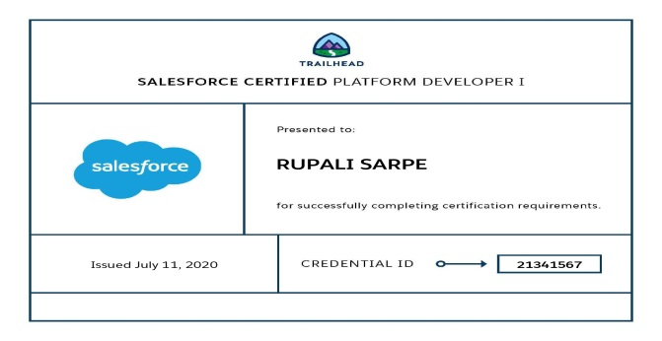
Salesforce Certified Developer

prupali660@gmail.com , +918446159231

Professional Summary:
- Master in Technology with 1+ year of IT Experience as Admin majorly in Salesforce.com platform as Salesforce Administrator.
- Majorly worked on Salesforce Administration, Apex development And Triggers .
- Salesforce.com experience includes Salesforce.com Configuration like Workflow Rules, Process Builder, User Profile, Roles, Business processes, Record Types, Page Layouts, Reports and Dashboards, Monitoring, Validation Rules, Approval Process, Security Implementation, Case Management, Knowledge Management, Import Wizard, Data Loader, Chatter, Lightning Process Builder, custom apps, Visual force page and apex Programming.
- Result oriented team player, and takes complete ownership of successful project delivery, help and mentors the team in achieving goals.
- Delivered projects on Salesforce.com Sales Cloud, Service Cloud and Force.com platform, Data Migration, Salesforce Platform Support and Release and Deployment using Change Set.
- In depth technical knowledge industry standards, best practices in areas of Salesforce Implementation, Consulting, Administration and Support front.

Education:
Degree/Diploma | University/Board | Year of Passing | Percentage
M.Tech (Chemical Engg.) | Amaravati University | 2012 | 7.65 CGPA
B.Tech (Chemical Engg.) | Amaravati University | 2010 | 68.19
HSC | Amravati Board | 2006 | 66.50
SSC | Amravati Board | 2004 | 78

Organization | Designation | Duration
D.J.P.Polytechnic Jalna | Assistant Lecturer | March 2011-Feb 2013
Government Polytechnic Yavatmal | Assistant Lecturer | Dec 2013-April 2016
Net Gyani IT Services Pvt Ltd,Pune. | Associate Software Engineer | 01 April 2019 to Till Date

Cerification:
- Copado certification Administrator (Certification ID:000958)
- Platform Developer 1 (Certification ID:21341567)

Technical Skills:
Programming Language | Apex, Visualforce.
Web Technologies | HTML,CSS
Data Base | SOQL.
Operating System | Windows 95/98/2000, XP, Mac, Vista, Win7,Win8
CRM | Salesforce.com CRM

Project # 1:
Project Title | Service cloud Implementations.
Project Domain | Banking /Finance
Duration | April 2019 –Sep 2019
Solution | Salesforce.com Implementations, Administration, Support, Data Loader & Reports.
Designation | Salesforce Developer/Administrator
Team Size | 8
Environment | Salesforce.com CRM

Roles and Responsibilities:
- Conducted requirements workshops with customer and gather requirements for Service Cloud Implementation.
- Worked on solution design to map complex business requirements with salesforce.com functionality.
- Implemented Service Cloud application (Console) with Configuration and Development
- Contributed in Unit Testing and System Integration testing.
- Deployment of Salesforce.com solution with the help of Change Set and Migration tools.
- Contributed to Data Cleansing, Data Loading and Exporting.
- Worked on Reports and Dashboards to provide real time inside of Data to organization.
- Resolve Salesforce.com CRM administration support issues.
- Work on L1 and L2 incidents and provide resolution to complex business requirements.
- Work on Workflow Rules, Approval Process, Page Layouts, Record Types, Monitor Audit Trail.
- Involved in Change Management and Incident Management process.
- Prepare Daily, Weekly and Monthly Reports for management review.
Project #: 2
Project Title | Sales Cloud Implementation
Project Domain | Telecom
Duration | Oct 2019–March 2020
Solution | Salesforce.com Sales Cloud Solution
Designation | Salesforce Developer/Administrator
Team Size | 8
Environment | Salesforce.com

Project Description:
Client had traditional sales and Marketing Process for creating and managing Campaigns, Lead and Opportunities. All prospects were captured on legacy systems, Excel sheet and on paper. It was very complicated process to convert leads to opportunity and close deals. There was no standardized process of deal closure and Quote generation. There was no data at one place and it was spread across different locations and different teams. We at Net Gyani proposed the client to implement Sales Cloud for streamline business process and standardise automated approval of quotes in order to increase lead conversion and sales intern.
At Net Gyani we have implemented Salesforce.com Sales Cloud Solution for automated lead capture from website, Social Media and Streamline lead conversion process providing record visibility across the teas using Salesforce Security Model. We also implemented sales process which suits client’s business process with automated workflows, triggers and Approval process and implemented sales console for providing 360 view of customer’s data and real time insights using sales reporting and Dashboards.
Roles and Responsibilities:
- Conducted requirements workshops with customer and gather requirements for Sales Cloud Implementation.
- Worked on solution design to map complex business requirements with salesforce.com functionality.
- Implemented Sales Cloud application with Configuration and Development
- Contributed in Unit Testing and System Integration testing.
- Deployment of Salesforce.com solution with the help of Change Set and Migration tools.
- Contributed to Data Cleansing, Data Loading and Exporting.
- Worked on Reports and Dashboards to provide real time inside of Data to organization.
- Worked on writing trigger for complex business logic.
- Developed Visualforce pages based on the requirements.

Personal Information
Name | Miss. Rupali Gautam Sarpe
Email Address | prupali660@gmail.com
Passport Number, Issue and Expiry Date | NA
Contact Number | 8446159231
Languages | English, Hindi, Marathi
Current Location | Pune, Maharashtra

Place: Pune
Date:
Miss. Rupali Sarpe

