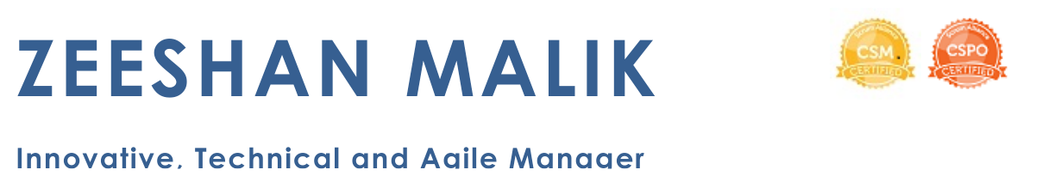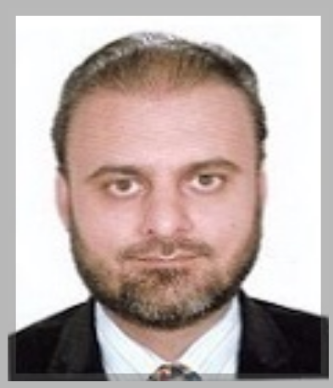

Lahore, Pakistan | [zeemalik78@yahoo.com](mailto:zeemalik78@yahoo.com) | +923004200764 | [www.linkedin.com/in/zeeshanmalik](https://www.linkedin.com/in/zeeshanmalik)

**----------------------------------------- Profile Summary --------------------------------------------**

Global experience in managing development and delivery of large complex project, leading effective, cross functional, distributed and self-organized teams in high-tech fast paced agile environments, whilemanaging and aligning dependencies and expectations across all stakeholders**.**

* Expert in complete **project lifecycle** including initiation, planning, execution, monitoring, control, testing, delivery and implementation
* Proficient in **converting customer business requirements** into **project plan, product roadmap, and release plan** covering scope, budget, costs, timelines of deliverables, resources, quality, procurement, risk management, change management and mitigation plans
* Experience in **creating and maintaining product backlog**, estimations, schedules, design specifications, KPIs and ROI analysis
* Strong knowledge of **software engineering methodologies**, best principles, patterns and tools for design, development and testing
* Equipped with modern concepts of **MVP,** **Cloud,** **Micro Services, TDD, BDD, DDD, CI/CD, SOA, SAAS** and **Restful APIs**
* Skilled in driving **Scrum ceremonies** including defining user stories, sizing, sprint planning, daily scrum, sprint review and retrospectives
* A **people’s person** with ability to collaborate and work effectively with individuals at all levels including global clients, C-levels and product teams to discover, implement and align key business and technical requirements, resolve problems and suggest solutions
* Expert in significantly **improving operational performance** in all functional areas while keeping an eye on bottom line business benefit
* Skillfulindefining and implementing **processes and SOPs**, spanning multiple areas including project management, agile methodologies, engineering, resource management, communication, conflict resolution, issue tracking, quality standards, release and deployment
* Experienced in **recruiting, assembling, developing and managing** high performance cross-functional **engineering teams**
* Enjoy **leading**, **motivating** and providing **technical guidance** to teams that take pride in developing high-quality, dependable software
* Excellent skills in **communication**, **presentation**, **time management** and **organization**. Acquired **international exposure** by travelling and attending client meetings, delivering trainings and workshops in Switzerland, Belgium, Dubai and UK

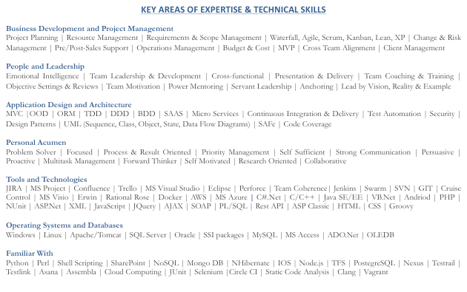

**Professional Experience**

**Senior Software Project Manager – May 2019 to Oct 2020**

**Devsinc -** Full service technology company, dealing in mobile, web and cloud solutions with focus on web and enterprise mobile applications. I own and manage development and delivery of multiple projects and lead scrum activities. I work closely with directors, client teams, sales teams, project development teams to **define, refine and drive** initiatives and goals.

* Successfully managed and delivered **complex mobile and web development** projects, ensuring client satisfaction**,** scope, time and cost.
* **Develop project plans** including scope, resources, release, risks, mitigationand help the team in progressing and achieving project goals
* Engage with customer and technical team to **define product back log**, **create estimations** and **set** **priorities** as per value to customer
* **Drive** effective **scrum ceremonies** including backlog grooming, sprint planning, daily scrum, sprint planning, demos and retrospectives
* **Implemented** organization wide **Agile Scrum, CI**, **Automation**, processes and practices for development and project management
* Provide **leadership and overall management** to **cross-functional** global product, project management and engineering teams
* **Designed** and managed **development of exchange platform** connecting ecommerce based seller platforms to 3rd party service providers
* **Work with product owners** to define **product roadmap**, goals, needs and track them accordingly with help of scrum masters and team
* **Manage, lead and coach** globally distributed,cross-functional project teams in making technology decisions in design and development
* **Hire, develop**, **set** **performance targets** and perform one to one meetings and performance reviews for each of the team member

**Senior Agile Development Manager – July 2013 to Sep 2018**

**U-Blox AG** **-** Swiss company, dealing in highly integrated solutions for microelectronics, wireless communications and positioning devices. I managed multiple embedded systems development and integration projects and solutions aligned with business portfolio strategy and product line while leading and managing cross-functional Agile teams.

* Successfully delivered **multi-million dollar** agile delivery 4G LTE software development projects. Led teams through design, architecture, implementation and delivery, while collaborating and working closely with distributed teams of developers, architects and QA
* **Develop project plan, release plans**, milestones, costs, resources, quality standards, acceptance criteria, and testing and rollout strategies
* **Support** and **guide** team members especially with respect to managing, refining and improving product quality, change requests, customer expectations, coding guideline and standards. **Liaison** with chipset vendors, clients and internal teams ensuring quick resolution of tickets
* **Track** and distribute **relevant KPIs and metrics** periodically, including client satisfaction and churn rate, burn down, team velocity, code coverage, project status reports and issues showing progress to stakeholders including clients, program managers and directors
* **Responsible** for selection, acquisition, customization and integration of **tools** required for project management, development and CI/CD
* **Introduced** and implemented **TDD**, **DDD** and **Micro services** architecture and patterns in one of the major company’s online portal
* Designed and implemented **customized JIRA tool** and its integration with Swarm, Jenkins, Perforce, Testrail and internal systems
* **Recruit**, train, manage and drive technical roadmap and objectives for remotely distributed development teams

**Senior Technical Project Manager – Sep 2012 to Jul 2013**

**Service Sales Corporation -** Major player in Pakistan’s footwear retail and wholesale with 3500+ stores.

I was responsible for managing and leading all software development, integrations and IT maintenance activities and projects **for Supply chain,**

**Retails and Warehouse Management systems** including gathering requirements, creating project plans, design, execution and delivery.

* **Successfully designed,** developed and delivered a **$10 million ERP project** in time, budget and quality.
* **Increased performance** and **throughput** in supply chain system by **40%** and **revenue** by **15%** by introducing **enterprise-wide technical architecture** to shift organization from monolithic legacy environment to latest distributed platform.
* **Implemented** and improved software engineering **processes** and **tools** affecting development and delivery.
* **Implemented** Oracle Retail Merchandizing System, upgrading from Microsoft dynamics RMS headquarter (EPOS) to Microsoft Dynamics AX and integration between EPOS, ORMS and EBS.
* **Led** and successfully completed the **data migration** effort from legacy to new system.
* **Designed** and integrated WMS (legacy system) with the new system.

**Software Team Lead - Aug 2009 to Sep 2012**

**Formulatrix Inc -** US based company captures the market in liquid handling, robotics and protein crystallization solutions

I was responsible for leading design, development and integration of **protein crystallization tool** (Desktop/Web/Mobile) including modules like experiment design, liquid dispensing, image collection, image viewing and data analysis.

* **Grew annual revenue from $17M to $30M** over the span of 3 years by introducing and developing new software components.
* **Increased the accuracy of tool by 45%** by designing and implementing an effective data analytics tool by using data mining and analysis techniques on a **100Gb+ database**.
* **Led** agroup of engineers to design, develop, test and deliver multiple **integration solutions**.
* **Gather requirements** and **prepare technical documentation** after discussing business details with clients.
* **Interact and collaborate** with clients and product users for making sure the client satisfaction and expectations are met as required.

**Principle Software Engineer - Aug 2006 to Aug 2009**

**SAMVisions (DevASP) -** USA based, major player in affiliate marketing industry and online price comparison engine

I was responsible to lead development and integration of **ecommerce solutions, ETL shopping engines** which work with affiliates.

* **Developed and implemented ETL tool** for automatically importing products and coupons data feeds from thousands of affiliate merchants into temporary databases and then clean, transform, standardize and export data it into the live databases.
* **Increased online sales by 45%** and **performance** **of products search engine by 60%** by introducing new features for users.
* **Introduced and implemented** new concept of **online shopping community** and social interaction between customers.
* **Recruited, trained and managed** multiple software developers and test engineers.

**Senior Software Engineer - Sep 2004 to Aug 2006**

**CureMD Corporation -** USA based leading provider of innovative health information management solution .I designed and developed a distributed online **Electronic Health Record** system for hospitals and doctors including both desktop and web modules.

* **Designed and developed** the **EHR solutions**. Improved performance by 40% by revamping legacy systems with latest architecture.
* **Integrated** different components of health care system including patient records, scheduling, billing, patient portal and mobile care.
* **Improved system performance** and **security** by introducing stored procedures and tuning queries and indexes.

**Other Consultation Projects**

**Bridging Loan Management Web App** - Manage client loan history, events, reports, email notifications and reminders for payment due dates

**Fault Locator IOS/Android App** - Manage and monitor property surveys and repairs, costs and schedules

**Family Dollar IOS/Android App** - Manage and monitor departmental store supervision surveys for a large US stores chain

**Cintas IOS/Android App** - Manage routes using maps for a large customer services company in USA

**Real Estate Management Web App** - Support real estate match making, premier listing services to buyers, seller, agents

**Education and Technical trainings**

**M.S. Computer Science** Lahore University of Management Sciences (2005 - 2008)

**B.S. Computer Science** Sir Syed University of Engineering and Technology (2000 - 2004)

**Certified Scrum Master ®** – Scrum Alliance 2019

**Certified Scrum Product Owner ®** – Scrum Alliance 2019

**Certified Atlassian JIRA Administrator** - Valiantys London, UK 2017

**PMP-PMI Training** – Lahore, 2019

**PMP-ACP Training** – Lahore, 2020

**Scrum@Scale Training** – Lahore, 2020

**Program/Project Management Training** - Leuven, Belgium 2014

**Team Leadership, Business Communication and SMART Goal Setting Training** – Zurich, Switzerland 2014

**Oracle RMS Training** - Dubai 2012

**Research Work**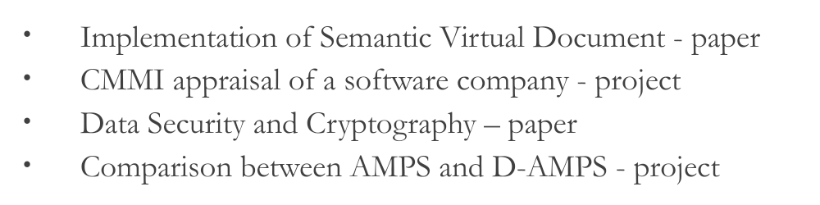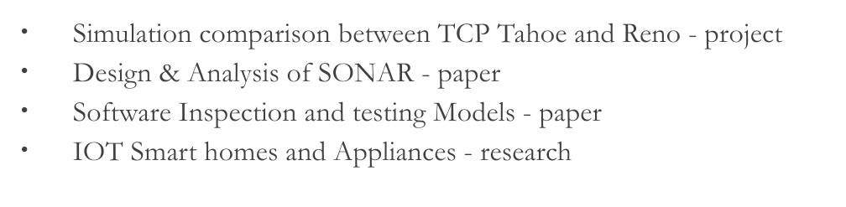

**Other Activities and Interests**

