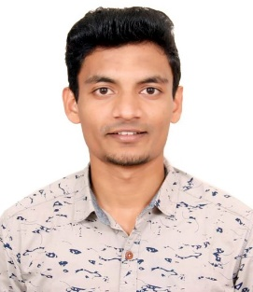

SANKET C DORLIKAR

Vadgaon bk, Pune, Maharashtra 411041.

Contact no. : 8055699500

Email ID: sanket.dorlikar@gmail.com

**OBJECTIVE:** Seeking a career that is challenging, interesting and which gives me an opportunity to learn and enhance my skills and strength in conjunction with organizational goals and objectives.

**EDUCATION QUALIFICATION:**

|  |  |  |  |  |
| --- | --- | --- | --- | --- |
| **Qualifications** | **Institution** | **Board/University** | **Year of Passing** | **Percentage/Grades** |
| B.E* | Smt. Kashibai Navale College of Engineering, Pune. | Savitribai Phule Pune University | Pursuing | 5.90 |
| 12th | Om Satya Sai Jr.College,Bhandara | H.S.C | 2016 | 71 |
| 10th | Christanand School,Brahmapuri | S.S.C | 2014 | 84 |

|  |  |  |  |  |  |
| --- | --- | --- | --- | --- | --- |
| *Semester | 1 | 2 | 3 | 4 | 5 |
| SGPA | 6.24 | 5.96 | 5.76 | 5.76 | 5.98 |

**PROJECTS:**

* Third yearProject: Movie ticket booking application.

**ACHIEVEMENTS:**

# Secured 3rd position in “Expert C programmer” event in 2017 held at SKNCOE.

# Got 1st position in robo race Competition held at SKNCOE.

**CO-CURRICULAR ACTIVITIES:**

* Completed Fundamental Digital Marketing Course
* Completed C and C++ development course

**EXTRA CURRICULAR ACTIVITIES:**

# Participated in mystery bag competition held at SKNCOE

**HOBBIES:**

* Travelling across the globe.
* To make Best out of Waste.
* Cooking.

**PERSONAL DETAILS:**

* Fathers Name : Mr. Chandrakant P Dorlikar
* Mothers Name : Mrs. Varsha C Dorlikar
* DOB :09 April 1998
* Language Known : English, Hindi, Marathi.

Date:

Place:

Signature

(SANKET C DORLIKAR)