**Lakshmi Prasanna**

**Data Engineer**

[**k.lakshmiadf@gmail.com**](mailto:k.lakshmiadf@gmail.com) **7676668339 Bangalore**

# EDUCATION

KITS College of Engineering - B.Tech April 2016 - May 2020 Markapur

**CERTIFICATION**

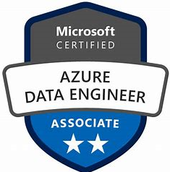 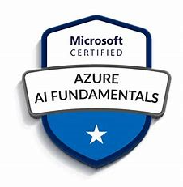 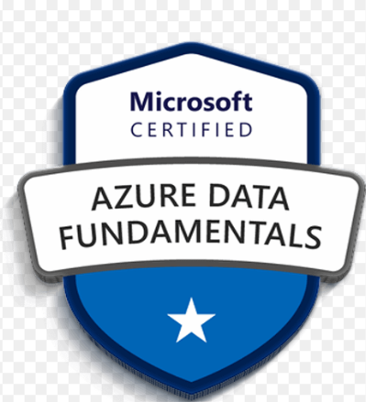

# Professional Experience Summary

3+ Years of strong experience in the IT industry as a MS SQL Server Developers and Azure Data Factory experience in design, Development and implementation of database system using MS-SQL Server 2014/2012 for both OLTP & Data warehousing system application with various business domains like financial and corporates business.

* Strong development skills with Azure Data Lake, Azure Data Factory, SQL Data Warehouse Azure Blob, Azure Storage Explorer
* Implemented Copy activity, Custom Azure Data Factory Pipeline Activities for On-cloud ETL processing
* Experience on different Integration runtimes (IR) Azure data factory to loading the data from (SQL,Oracle and CSV files )
* Working on the migration of on-premises data (oracle/Sql/ and CSV files) to azure data lake store using azure data factory.
* Creating the ADF Pipeline and scheduling the event-based trigger and it will load the files every day.
* Creating the variable in ADF passing some coma separated datasets using those datasets only the pipeline run, any other dataset the pipeline got failed.
* Creating the linked servers for define the connection to the data source and a dataset that represents the structure of the data.
* We are triggering and scheduling the jobs for start date, recurrence, end date etc. for the trigger, and associate with a pipeline.
* Using different activities like (for Each activity, get metadata activity, Lookup activity and if condition activity to build the pipeline.
* Experience in Azure Data Bricks to write code in Scala, Pyspark and SQL as per the business requirement
* Extensive database programming Experience in writing T-SQL Stored procedures, Constraints and Indexes using various DDL and DML commands.
* Comfortable in working with filters/calculated columns/measures/relationships and transformations of Edit Query section.

**Skills**

|  |  |
| --- | --- |
| **DATABASES** | SQL Server |
| **Tools** | **Azure Data Factory, Azure data Lake, Pyspark, Azure data Bricks**  **& Good Knowledge in Spark** |
| **Programming knowledge** | **SQL Server, PySpark,** |

## **Work Experience**

**1.HCL Technologies (since Jun-2020 to Till date)**

|  |  |
| --- | --- |
| Role | Microsoft modern data platform |
| Designation | Data Engineer |
| Client | Corporate Finance System |
| Domain | Finance |
| Tools & Technologies Used | **Azure Data Factory, Azure Data Bricks, Azure Data Lake, PySpark** |

* Everyday getting files in landing zone through Middleware, and we extract and transform and load the files into external table.
* Arrange the proper schema file for the data file and we load the data as delta load with the help of primary key.
* Once data got loaded into the external tables in dev, validating the data in external table then moving those tasks to QA team for testing then it will movie to other environments.
* Running the different API through the ADF Pipe. As per the environments.
* Checking the KTS, ETS and BD for the files in the Preprocessor checking the schema and data types and load the data.
* Creating processed views and spark views as per the requirement and maintaining the proper dependencies in base table.
* Maintaining the data like append, Merge, replace, Replace by key kind of data Loades
* Creating the ADF Pile and scheduling the event-based trigger and it will load the files every day.
* Creating the variable in ADF passing some coma separated datasets using those datasets only the pipeline run, any other dataset the pipeline got failed.
* Creating log table to find the exact log information where it got failed.
* Knowledge in all types of Database migrations with all the versions of SQL Server.
* Strong Knowledge on Power BI to import data from various sources such as SQL Server, SQL DB, MS Excel etc.
* Experience in publishing the Power BI Desktop models to Power Bi Service to create highly informative dashboards, collaborate using workspaces, apps, and to get quick insights about datasets
* Primarily involved in Data Migration using SQL, SQL Azure, Azure storage, and Azure Data Factory, SSIS, PowerShell
* Strong development skills with Azure Data Lake, Azure Data Factory, SQL Data Warehouse Azure Blob, Azure Storage Explorer
* Experience managing Big Data platform deployed in Azure Cloud
* Implemented Copy activity, Custom Azure Data Factory Pipeline Activities for On-cloud ETL processing.

## Soft Skill Set

* Motivated, able to work smoothly under pressure and meeting deadlines on time.
* Positive attitude, Hard Work and ability to stretch in order to achieve targets.
* Ready to accept new challenges and adapt to new environment quickly.
* Create an environment of trust and cooperation through an open exchange of ideas towards achieving team goals.

## Declaration:

I **Lakshmi Prasanna**, do hereby declare the above furnished information is true to the best of my knowledge and belief.

Place:

Date: **Lakshmi Prasanna**