Nagma M. Shaikh | 2 years | Salesforce Administrator

* : [**nagma216shaikh@gmail.com**](mailto:nagma216shaikh@gmail.com)

 : **09511276436**

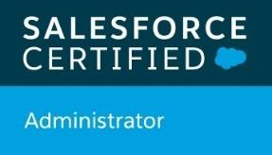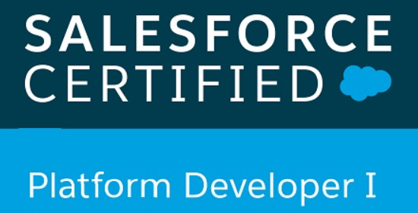

# Professional summary

* 4.9 years of overall experience at Tata Communications Ltd. out of which 2 years as a Salesforce Administrator and 2.6 years as Software tester.
* Strong technical skills and knowledge of Salesforce standard methodologies with proven success in leading end- to-end implementation and ensuring effectiveness of various responsibilities to meet specifications
* Significant experience of working with customers, project managers and technical teams for securing and executing concurrent delivery
* Strong problem solving & technical skills coupled with decision making for enabling effective solutions leading to high customer satisfaction and low operational costs
* Problem solver with a passion for learning skilled in grasping the big picture, conceptualizing, developing & implementing solutions and partnering closely with business leaders & stakeholders

# Technical Skill

* **Salesforce skills :** Service Cloud, Sales Cloud, Force.com Platform
* **Operating Systems :** Windows
* **Language :** Apex, Visualforce, SOQL, JavaScript, SQL
* **Tools :** Data Loader, Workbench, JIRA

# Education

* Bachelor of Engineering(E&TC), from Solapur University in 2015 with Distinction
* Diploma(E&TC), from MSBTE in 2012 with Distinction

# Core Experience

* Experience with **Classic** and **Lightning** UI & have good knowledge of salesforce **security model**
* Proficiency in **SFDC Administrative** tasks includes creating **Profiles, Roles, Users, Page Layouts, Email Services, Approvals, Workflows, Actions, Tasks and Events.**
* Hands on experience in creating **Reports and Dashboards** as per business need.
* Skilled in customizing standard objects like Accounts, Contacts, Opportunities, Cases, Leads, and Custom objects as per client’s need.

### Hands on experience of implementation – Data model (Custom Objects and relationships), Record type, Page layouts, Reports and Dashboards, Custom Formula Fields, Field Dependencies, Validation Rules, Work Flows and Approval Process.

* Experience in activities related to **SFDC**, **Saleforce.com setup, Configuration, Customization, Administration, Data Migration and deployment** of applications to **Force.com** platform for large user groups.
* Implementing requirement using **workflows, email alerts, filters, formula fields, Workbench, etc.,**
* Good knowledge of **Service Cloud** and **Sales Cloud**

# Work Experience

### Dec 18 – Till Date, Tata Communications Ltd, as Salesforce Administrator:

Clients – Telus, Bell Canada and AT&T

### Key Result Areas

* Mainly worked with **Case Management** and **Lead Management** in SFDC.
* Created **Page Layouts, User Profiles, Record types, Custom tabs**, organized fields and other components on a record detail and edit pages
* Extensive experienced **Custom Objects, Custom Tabs, Reports & Dashboards** for various modules of applications and **Roles and Hierarchy based page layouts, Approval Processes**.
* Experienced in defining **Custom Formulas and creating Validation Rules** to suit the needs of the data model and ensure data quality.
* Experience in designing entities like creating the **Relationships, Junction Objects, Master-Detail, Lookups, Entity Relationship data model, Workflow rules and Process Builder.**
* Handled on-going customization/ alteration of Salesforce.com.
* Maintained security including sharing rules and security levels.
* Imported data by mapping to business objects in CRM system using **Apex data loader** and **Import/Export wizard**
* Support train new end users on the salesforce.com application.

S

### Feb’16- Dec’18, Tata Communications Ltd., as a Software tester

### Key Result Areas:

* Generate Test Execution Plan for the products developed.
* Understand requirements and technical specifications of the business users.
* Design the test bed for requirements raised by business user.
* Perform manual test case execution according to the plan and release the product for user acceptance testing.
* Perform the System Integration Testing for the developed products.
* Co-ordinate with the development team for resolving the raised defects.
* Data base testing, System testing, UI testing

# Personal Details

* **Name :** Nagma M. Shukur Shaikh
* **Date of Birth :** June 29, 1993

## **Address :** Flat# 8, Ushakiran residency,Dighi Pune

* **Languages Known**: English, Hindi, Marathi