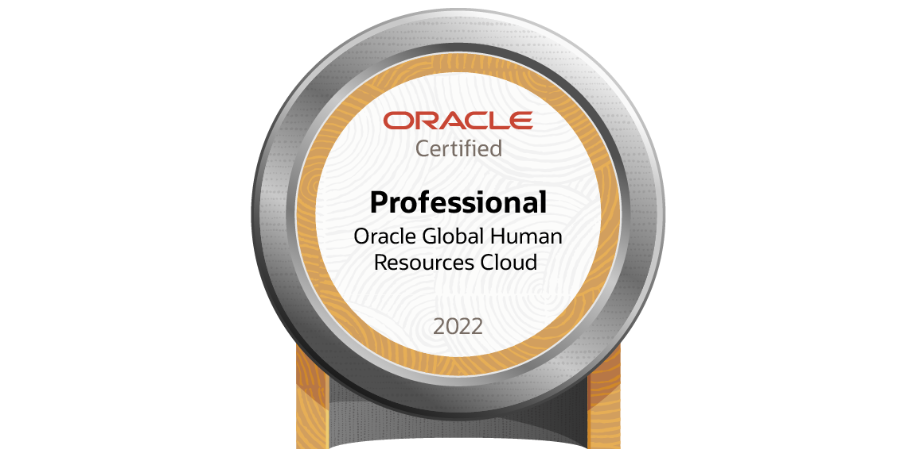
Oracle Fusion Technical Consultant (HCM)

Y. Peddi Reddy
Mobile: +91-90307 82163
Email: ypreddy.cloud@gmail.com

Objectives

Looking forward for an opportunity in a challenging environment, where I can utilize my experience and skills in contribution effectively to the success of the organization and also for the improvement of my personal skills.

Professional Experience

- Having around 5 years of experience as Oracle Fusion Technical Consultant with expertise in Implementation of Human Capital Management (HCM).
- Expertise in Global HR, Payroll, Compensation and Absence Management.
- Having best practice in Design, Development and Customization of Standard Reports.
- Hands-on experience in the development of BIP Reports, Parameter Handling, LOV creation, Bursting, ESS job creation and Scheduled Processes in Fusion.
- Having Experience in design and development of OTBI Analysis, Agents and Action Links.
- Having Experience in the Data Migration process into Oracle Fusion applications using HDL and HSDL.
- Strong experience in working with Oracle Fusion Applications.
- Strong experience in Oracle Fusion BIP Reports.
- Having Experience on HCM Extracts and User Entities.
- Experience in Developing Fusion Descriptive Flex fields (DFF), Extensible Flex fields (EFF).
- Experience in Analyzing SQL code and solving the bugs effectively.
- Involved in various Implementation, Testing, and Support projects in and Cloud Human Capital Management.
- Experience in implementing Outbound Bursting through Email, UCM and FTP servers.
- Strong experience in loading data for Human Capital Management module like Worksforce Structures, Worker, Assignments, Global Transfer, Rehire, User Role, Element Entries, W4 Tax withholding Calculation Card for Federal and State.
- Knowledge on Fast Formulas.
- Ability to learn & develop using new technologies quickly.

Academic Profile

- Master of Computer Applications (MCA) with an aggregate of 66%

Technical Skills

Languages | SQL
RDBMS | Oracle 11g (SQL)
ERP | Oracle Fusion HCM (R13)
TOOLS | HDL, HSDL, OTBI, BI Publisher Reports, HCM Extrcts, SQL Developer
Project Management Tools | JIRA

Professional Experience

- Worked as Technical Consultant at Tech Mahindra, Hyderabad
(From September 2022 to December 2023)
- Worked as Technical Consultant at Eion Technology PV LTD, Hyderabad.
(From April 2018 to September 2022)

Project 4 #

Client | Albertsons – USA
Duration | September 2022 to December 2023
Environment | Oracle BI Publisher Reports (Human Capital Management), HDL & OTBI, SQL and MS Word
Role | Technical Consultant
Client Description | Albertsons Companies is one of the largest food and drug retailers in the United States, with over 2,200 stores in 34 states and the District of Columbia. Banners include Albertsons, Safeway, Vons, Jewel-Osco, Shaw's, Acme, Tom Thumb, Randalls, United Supermarkets, Pavilions, Star Market, Haggen, Carrs, Kings Food Markets, and Balducci's Food Lovers Market. Support stores with 22 distribution centers and 19 manufacturing plants.

Key Responsibilities:

- Migration of the W4 tax withholding data for Federal and State calculation card in the Payroll module by using the HCM Data Loader (HDL), HSDL.
- Developed reconciliation reports for validating the data loaded.
- Developed BIP Reports as per business Requirement.
- Created Custom Lookups
- Prepared technical documents for Data Conversion

Project 3 #

Client | Nakheel Properties
Duration | April 2021 to September 2022
Environment | Oracle BI Publisher Reports (Human Capital Management), HCM Extracts, OTBI, HDL, SQL and MS Word
Role | Technical Consultant
Client Description | Nakheel Properties is a real estate development company based in Dubai, United Arab Emirates. The formal name of the company is Nakheel PJSC and it was a subsidiary of Dubai World and a private state-owned enterprise. Nakheel was seen as key to resolving Dubai's debt crisis in 2009–2010. The company has been reported to be the second-largest property developer in Dubai after Emaar Properties.

Roles and Responsibilities:
- Migration of the Data for the various business objects in the Core HR module by using the HCM Data Loader (HDL).
- Developed reconciliation reports for validating the data loaded.
- Developed BIP Reports as per business Requirement.
- Development of OTBI Reports.
- Worked on HCM Extracts to fetch data from Fusion and sending this data through different delivery options like (WCC, Email)

Project 2 #

Client | Bayer
Duration | January 2020 to March 2021
Environment | Oracle Fusion HCM
Role | Technical Consultant
Client Description | Bayer AG is a German multinational pharmaceutical and life sciences company and one of the largest pharmaceutical companies in the world. Headquartered in Leverkusen, Bayer's areas of business include pharmaceuticals; consumer healthcare products, agricultural chemicals, seeds and biotechnology products.

Roles and Responsibilities:
- Migration of the Data for the various business objects by using the HCM Data Loader (HDL).
- Development of new reports as per the client requirements and customizing existing reports.
- Registrations of Custom ESS Jobs as per Project Requirement
- Creation of Value sets in various Modules of the application.
- Development of OTBI Reports.
- Periodic communication with users regarding the progress on the issues being worked on.
- Involved the form Personalization’s for the Various Requirements.
- Developed the Customizations for the Various Requirements.
- Identification and handling of errors related to migration and configurations.
- Registering BIP reports in Oracle Fusion using ESS.

Project 1 #

Client | McKesson
Duration | April 2018 to December 2020
Environment | Oracle Fusion HCM
Role | Technical Consultant
Client Description | McKesson Corporation is an American company distributing pharmaceuticals and providing health information technology, medical supplies, and care management tools. The company delivers a third of all pharmaceuticals used in North America and employs over 78,000 employees.

Roles and Responsibilities:
- Worked with functional consultants to understand and review the feasibility of business requirements
- Gathering business requirements for enhancements, customizations and developing technical requirement documents
- Involved in design and development of Fusion Data Migrations/Conversions using HDL.
- Involved in the development of BIP reports in Oracle Fusion Cloud as per business requirement.
- Exporting reports into various output formats like PDF, Excel, XML, HTML, CSV etc
- Developed OTBI-Reports based on client requirement.
- Involved in various phases like requirement gathering, Construction, UAT, Post production etc.

