**Pradeepa D**

Salesforce.Com Developer/Release Manager at **CAPGEMINI**

8310126503/9060457729

pradeepad90@gmail.com

**CAREER OBJECTIVE**

Looking for a challenging position as a Salesforce.com (SFDC) Developer/Release Manager with a view to enhance both the breadth and depth of my current knowledge base through significant contributions to the organization.

**PROFESSONAL SUMMARY**

* Over **9 Years** of IT experience in Analysis, Support, Development, Testing, Documentation, Maintenance, Release Management of application in Cloud and UI Technologies.
* Expertise with Administration and Configuration of Salesforce.com CRM to populate and maintain data.
* Experience in Salesforce.com (SFDC) development and implementation as a Developer.
* Experience in UI development (Technical Support) and enhancement.
* Strong Analytical skills, excellent communication and organizational skills, able to work independently as well as in a team.
* Getting together with the team is an added advantage to work in groups and to drive a team.
* Having good interpersonal skills and quick learner of new technologies willing to take up responsibilities.
* Good knowledge on Release Management using DevOps Tools like Bitbucket, Jenkins & SourceTree

**SKILL SET**

**Operating Systems** : Windows 7, Windows 8 & Windows 10

**Programming Languages** : Apex Triggers, Apex Class, Visual Force Pages, Lightning, Ant Migration Tool,SOQL, SOSL, HTML, CSS, Javascript and Bootstrap

**Tools** : Data Loader, Eclipse, Workbench, Jenkins, SourceTree, BitBucket, Beyond Compare, IntelliJ, SonarQube, VS Code, TFS, Jira

**Packages** : MS Office 2003/2007/2010

**CERTIFICATIONS**

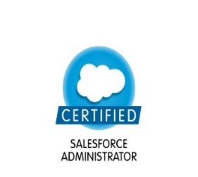  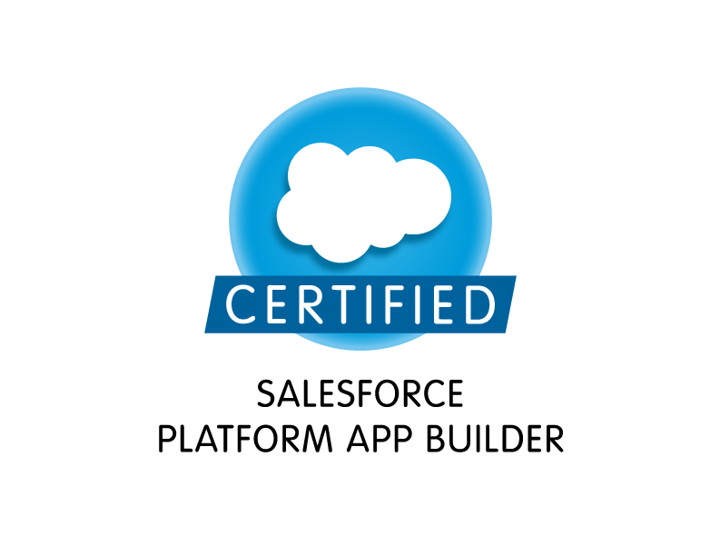  

SFDC Admin SFDC PD-1 SFDC App Builder Service Cloud Sales Cloud

**PROFESSIONAL EXPERTISE**

* Experience in **Configuration**, **Development** of **Salesforce** applications based on **Apex** Language and **Lightning** by leveraging **Force.com Platform**.
* Hands on experience with **Apex Trigger, Apex Class** and **Visual Force.**
* Experience working with **Deployments on salesforce.com Sandbox** environments by using **Change Sets**, **Ant Migration Tool, Bitbucket & Jenkins**.
* Have good working knowledge in querying **Salesforce** database using **SOQL & SOSL** queries using **Force.com Explorer.**
* Basic hands on experience with **HTML, CSS, Bootstrap,** and **Javascript.**
* Excellent communication, interpersonal skills and self-motivated to implement next-generation paradigms.
* Excellent analytical, problem solving, communication skills and a team player.
* Excellent knowledge on deployment using DevOps Tools like Jenknins, Bitbucket, Sourcetree etc.

**CURRENT EXPERIENCE**

**Company Name** : CAPGEMINI

**Designation** : Senior Consultant

**Domain**  : DCX

**Period** : April 2018 - Till date

**Total Experience** : 3.5 Years

**PREVIOUS EXPERIENCE**

**Company Name** : WIPRO TECHNOLOGIES LIMITED

**Designation** : Senior Software Engineer

**Domain**  : BAS

**Period** : Aug 2012 – April 2018

**Total Experience** : 5.7 years

**PROJECT PROFILE**

1. **Voluntary Benefits - Migration to Salesforce**

|  |  |
| --- | --- |
| **Role** | Developer |
| Project Outline | VB(Voluntary Benefits) will migrate from Workbench to the “Mercerforce 365 CM” aka Salesforce.  “Mercerforce 365 CM” is an implementation of Service Cloud and separate from the corporate instance called “Mercerforce” which is an implementation of Sales Cloud.  The VB application is a Mercerforce 365 CM application in which an agent in the contact center could quickly pull up a caller’s account and document a phone call. The application searches across multiple legacy systems to retrieve all associated relationships (policies, claims, products information etc.) based on information provided by the caller. VB provides an agent the information needed to quickly answer questions and make any required changes. Some requested changes could be completed real-time, such as an address change or a payment on account, while others must be routed to another team for research and/or approval before they can be completed. |
| Skills | Apex, Visualforce, Salesforce Configuration, Data Loader, Ant Migration Tool, Javascript, HTML, CSS, Eclipse IDE |

1. **Energia**

|  |  |
| --- | --- |
| **Role** | Developer |
| Project Outline | Energia is based on Custom Sales Cloud and the main functional areas are: Groups(Accounts), Leads & Opportunities, Offers, Offer Site, PriceBook, Product, Rates, Registration Portal, Custom Objects & Apps, Integrations, User and Security.  User will be Logging into the Partner Portal for registration of the site. Portal registrations are done through the external system used by external agents. These will progress to the internal system once submitted. This Application behaves as a mediator tool in between Gas/electricity Agencies and the Users. Agencies will use the application for selling their product. Users will use the application for buying it. |
| Skills | Apex, Visualforce, Salesforce Configuration, Developer Console, Data Loader, Javascript, HTML, CSS, Ant Migration Tool |

1. **TearScience**

|  |  |
| --- | --- |
| **Role** | Developer/Data Migration Specialist |
| Project Outline | TearScience was an existing Application which was built on Salesforce. EyeForce is also built in application on Salesforce. Both are of Health Care Domain with almost same functionality.  As part of migration we have merged both the Applications together along with the huge data using Ant Migration Tool, BitBucket, SourceTree and Data Loader.  TerScience develops devices that provide significant clinical identification and treatment of evaporative dry eye. The specialities that Company offer is Medical device, Optometric solutions for dry eye. The Products we’re Lipiflow, Lipiscan, Lipiview II and MGE  Marketing User will create Campaigns for the product and do the marketing.  Sales Rep will create the Leads and then he will convert those leads into Account, Contact and Opportunity optionally. If the end user is interested in the Opportunity he will take that opportunity and close the Opportunity as Close and Won. In our application hospitals will be an Account, workers in the hospital will become Contact. |
| Skills | Apex, Visualforce, Salesforce Configuration, Javascript, HTML, CSS, ant migration tool |

1. **Digital Surgery**

|  |  |
| --- | --- |
| **Role** | Developer |
| Project Outline | Digital Surgery was the new application which was built on Salesforce.  Mainly this application was built for tracking Contracts and sending expiration notifications. Also for sending the success email notification and lack of progress email notification of all the Milestones which are attached with every Account. |
| Skills | Lightning, Apex, Visualforce, Configuration, IntelliJ Illuminated Cloud IDE SoureTree, BitBucket, |

1. **EyeForce**

|  |  |
| --- | --- |
| **Role** | Lead Developer/Release Manager |
| Project Outline | EyeForce is the Global single Salesforce Application of Vision Surgical to support three businesses   * Cataract, Refractive and Eye Care   Pre-Sales activities, Contract management (to some extends) and Reporting are performed in EyeForce, Contract Compliance, Order Management, Billing, Consignment, Inventory are managed in SAP.  Later the Application is migrated from Classic to Lightning and deployment process is stabilized using devops tools. |
| Skills | Salesforce Configuration, Javascript, HTML, CSS, IntelliJ, VS Code, Illuminated Cloud, Jenkins, Bitbucket, Sourcetree |

**ACADEMIC QUALIFICATIONS**

|  |  |  |  |
| --- | --- | --- | --- |
| **Course** | **Institute** | **Year of Passing** | **Percentage of Marks** |
| SSLC | Govt Junior College,  Channagiri, Karnataka | 2007 | 82.72% |
| 12th std | Govt Junior College,  Channagiri, Karnataka | 2009 | 66.5 % |
| Bsc (PCM) | SSSSGFG College,  Channagiri, Karnataka | 2012 | 80% |
| MTech in computer applications | BITS, Pilani (MTech pursued under WILP-Wipro Integrated Learning Programme) | 2016 | 6.45(CGPA) |

**PERSONAL DETAILS**

Languages Known : Kannada, English

Gender : Male

Marital Status : Single

Nationality : Indian

DOB : 17/04/1992

**Date**:

**Place**: Bengaluru (**Pradeepa D)**