S. Pravin Kumar
Mobile: 91-9944344850
Mail id: pravinkumar0424@gmail.com

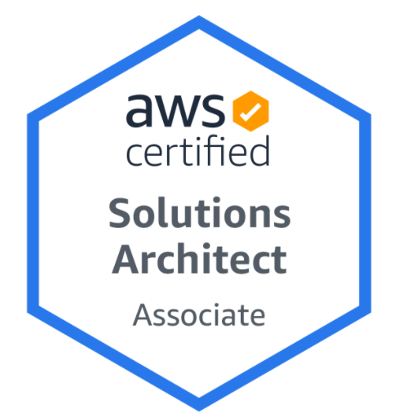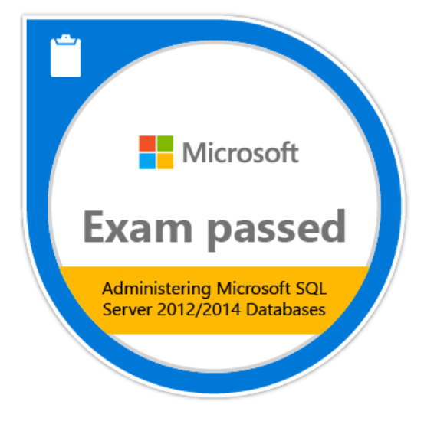


Summary:
Over 11 years of total experience which includes AWS Consultant/ Engineer& Lead & Architecture along with SQL SERVER Database administration experience handling administration and Cloud Automation activities
- Working as AWS Cloud Architect services on compute, storage, and network (EC2, S3, VPC, Auto scaling, Lambda, Load balancer, VPC peering, Route 53, RDS, CloudWatch, Event trail, Cost estimations) and work with product teams during the on-premises to cloud migration mostly on RDS services.

- Terraform on AWS services using GitHub, Jenkins pipeline and Redshift.

- Constantly exploring latest AWS resources (WorkDocs, Backup services, EC2 Image Builder etc.) and features which are introduced and creating automations to support the existing and newly migrating teams to AWS cloud.

- Good Knowledge and experience in SQL Server – Installations, configuring, administering, Maintenance Jobs, DTS package monitoring, backup and restore strategies.

- Experience on AlwaysON, Replication, Database Mirroring, Log shipping, clustering.

- Developed inhouse project for migrating the member data from on-prim SQL server database to AWS SQL RDS database with the help of python code.

- ITIL certified and have good knowledge and experience in ITIL processes.

- Creative, unconventional, pragmatic, quick learner, strong teamwork abilities.

Certification:
- AWS certified solution architect – Associate.
- SQL Server 2012 Database administration Certified.
- Oracle Certified Associate (OCA 9i) Application developer.
- Oracle Certified Professional (OCP 10g) Data Base Administrator.
- ITIL v3 Certified (IT Infrastructure Library).

Professional Experience:

Employment details:

April 2022 – Till Present AWS Cloud Architecture

Tonik Bank, Chennai.
Team: Cloud Consultants.
Products supported: Tonik Bank Core banking
Team size 4

April 2019 – March 2022 AWS Cloud Architect & Senior SQL database Lead,
Optum Insight
Team: Cloud Center of Excellence.
Products supported: Crimson Managed Services (CMS), Data Hub (DHA), Data platform services (DPS), Crimson Quality Reporting (CQR).
Team size 6

Roles
AWS Cloud Architect role involves identifying solutions for different teams and developing modules with latest AWS features.

Working with product teams during on-premises to cloud migration and directly worked into migrating SQL server RDS instances.

Develop Terraform modules for creating latest AWS resources based on different scenarios and demonstrate to the product teams to get it incorporated within the account.

Worked using Github as a code repository tool and have integrated it with Jenkins for deploying code into the AWS account and redshift.

Developed python scripts based on requirement for migrating the SQL server databases from on-premises to AWS RDS cloud.

Identifying and documenting Proof of concepts on upcoming AWS resources and features and explore the opportunities to incorporate in the existing environment.

Managing and Providing L3 support for multiple products within the organization.

Managing over 400 plus SQL Server Instances in three different domains.

As the organization is inclined towards migrating to cloud, currently working more into migration the SQL server database to Amazon redshift cloud.

As a senior DBA concentrate more into automating daily repeated DBA activities which includes Backup report, DR Log shipping, latency report, Server reboot report, Cluster failover notifications, and capacity planning report.

Prepare the SQL server licensing for all our production instances and work in automating the license sheet preparation which would be shared with top management regarding renewals with Microsoft.

Working in major projects which includes Data center migration of all the staging, loading, testing and production servers.

Migration project involves complete SQL server end to end setup starting from planning, designing, building the SQL server clusters, DR solution, migrating the databases, DBA job & applications jobs, linked server dependencies, logins, roles, permission, and performances.

Feb 2015 – March 2019 AWS Cloud Engineer and SQL Server Consultant,
Hexaware Technologies, Chennai.
Department Name: Infrastructure Management services
Projects worked: Manpower infrastructure services, Career Education Corporation (CEC), Inland reality groups, Gate group services.
Team size: 8
Roles: Deploying, managing, highly available and fault tolerant systems on AWS Cloud Infrastructure.
Monitor Jenkins builds and follow up with developers on the failures.
Setting up DevOps Environment for every release (includes DB refresh, DB update, Code Refresh, setting up app and web server).
Monitoring and debugging application logs. Follow up with the respective teams on issues.

Take care of Backend issues and debugging logs.
Production health check monitoring from AWS cloud watch and Event trail.

Closely worked in migrating on-premises SQL server databases to AWS SQL RDS.

Automated the manual activities of backing up, uploading to S3 bucket and restore from on-premises to cloud.

Managing and Providing L3 support for Manpower group Infrastructure Servers.

Managing over 550 plus SQL Server Instances in three different domains.

Automating daily repeated DBA activities which includes Backup report, DR Log shipping, latency report, Server reboot report, Cluster failover notifications, and capacity planning report.

Setting up SQL SERVER new cluster and standalone installation, post install activities, patch activities, install service packs & security updates.

Ad-hoc backup and restore activity performed based on user requests.

All SQL Instances being monitored by Site scope manager on data file size, Glue, disk space, availability of servers etc.

Configured the Always on setup as per customer requirement for the upgraded SQL instances.

Database migration from SQL 2008/R2 versions to SQL 2012 and SQL 2014 versions. Upgraded multiple SQL 2008 r2 to 2012 version.

Create maintenance plan and develop sql agent jobs for monitoring the performance related issues like blocking and deadlock.

Configuring high availability tasks like Mirroring, Log shipping

December 2010 – October 2013 ITO Service Delivery Consultant,
Hewlett Packard Co, Bangalore.
Department Name: Enterprise Service Management - Best Shore ITO Services.
Roles:
- Active member of Database administration team of size 12.
- Currently providing L2/L3 support for Pacific Brands Standard Register and HP-Dearborn Internal Infrastructure Servers.
- Managing over 150 SQL server Instances.
- Tickets and Daily user request using OVSD (HP Open View Service Desk) and HPSM (HP Service Manager).
- Daily backup monitoring and effective recovery on data loss.
- SQL Server\DB Migration based on customer requirement.
- Configured IBM Tivoli Storage Manager for SQL backup and restore from disk and tapes.
- Upgrade from previous versions, Applying latest patch in QA & production environment.
- Handling high severity issues like SQL Server down, database crash, application connection failure by working with various teams which includes network team, storage teams.
- DB archiving and purging meeting the disk utilization thresholds.
- Performance tuning on slow responses – Index check, rebuild and reorganize.
- Data and log files management – Restricting, adding new log\data files, creating new file group & moving the files between the file groups.
- Database mail and job alert configuration.
- Involved in change activities involving Migrating stand-alone SQL Servers to Active\Active and Active\Passive clusters.
- Co-ordination with various teams like Citrix, Wintel, Network teams in case of troubleshooting root cause for the issues.
- On call support during the weekend activities on production upgrade and maintenance.

December 2009 - November 2010 Junior Technical Consultant,
Temenos India Pvt Ltd.
Department Name: Model bank.
Domain: Banking
Client: HLB - HL Bank Singapore, Commercial Bank of Africa, Sumitomo Mitsui Banking Corporation-Japan, BM – Bank Muscat- Oman, UNBC - Union National Bank CAIRO etc.
1. PROJECT NAME: MODEL BANK REFERENCE BUILD.

TECHNOLOGY USED: SQL, PLSQL, ORACLE 9i, JBASE
OPERATING SYSTEM: Windows 2000, XP.
TEAM SIZE: 4
ROLE: Active member of SQL SERVER database administration team also developing and modifying SQL/PLSQL scripts as per the requirement. Run the reference build scripts to generate various modules to develop prototype of banking software with various logics building. Developing shell scripts for setting up the environment and internal purpose.

Personal details:

DOB : 24th April 1987
PAN Card number : AVSPP5368B

Declaration

I hereby declare that all the information provided above is true to the best of my knowledge.

(S.PRAVIN KUMAR)

