Aditya Gokhru aditya.gokhru@gmail.com
Phone: +91-9049854501

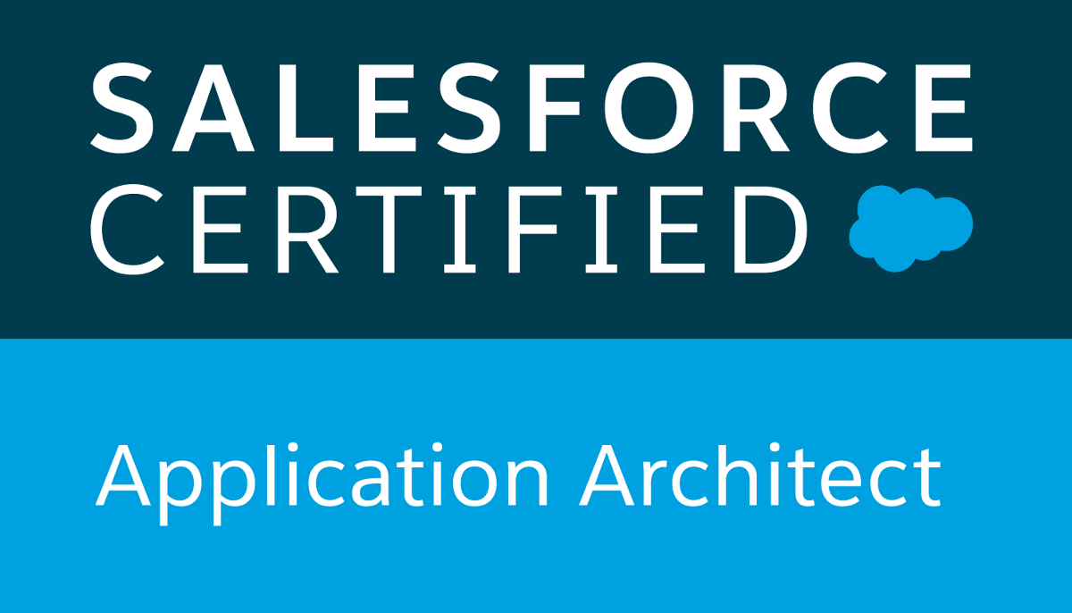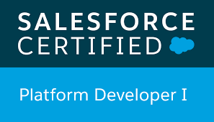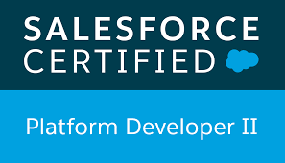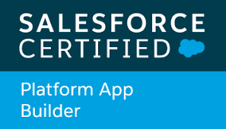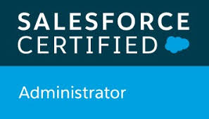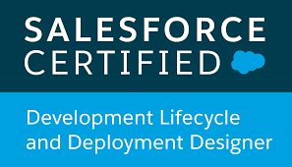

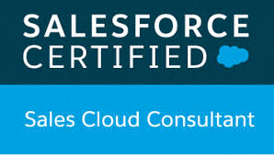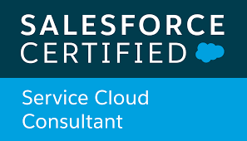

CAREER OBJECTIVE:

To establish myself as salesforce developer/architect with an integrated enterprise business solution through a long-time commitment where I can utilize my past professional experience and my technical skills in a challenging environment that utilizes team work for developing, learning and researching, contributing to the company growth and in turn ensuring my personal and professional growth within the organization.

SUMMARY:

- Having 6.5+ years of experience in Salesforce.com and total IT experience 9 years.
- Experience in Configuration and Customization in Salesforce.
- Experience in SOAP and REST integration.
- Designed various Lightning Applications, Visual Force pages for functional needs within Salesforce.com.
- Developed Apex Triggers and Apex Classes for various functional needs in the application.
- Loading data using Apex Data Loader.
- Workflows, process builder, visual force pages, validation rules, test classes.
- Developed batch apex and worked on remote calls.
- Developed lightning components for lightning applications.
- Awarded with ACE certificate and Bravo Certificate for key player in the project.
- Certified on Salesforce Administrator, Sales Cloud, Service Cloud, App Builder, Platform Developer -1, Platform Developer -2, Salesforce Certified Application Architect, Salesforce Certified Sharing and Visibility Designer, Salesforce Certified Data Architecture and Management Designer, Salesforce Certified Development Lifecycle and Deployment Designer.

Technical Profile:

Programming Languages: APEX, JAVA Script

Web Technologies: VISUALFORCE, HTML, CSS, ANGULAR

Operating System: Windows Family

Education Summary:

Degree and Date: Bachelor of Engineering, 2011

Institute: Ramrao Adik Institute of Technology, Mumbai University

Specialization: Computer Science

Employment Summary:

- Working as Senior Consultant in Infosys, Pune From March’2019 till date.
- Worked as a Tech Lead in Accenture, Pune From June'2016 to March’2019.
- Worked as a Salesforce developer in Cognizant Technology Solutions, Pune From June'2014 to June’2016.
- Worked as a Software Engineer in Infosys, Pune From Sep’2011 to June’2014.

Projects Overview:

Project # 1

Project : Chablis
Technologies : Salesforce.com
Role : Salesforce Designer/Senior Developer

Description:

- For leading telecom service company specialized in fixed and mobile telephone services, implemented sales and service cloud.

Responsibilities:

- Understand pain points of business/client SMEs, perform requirement gathering in the form of user stories.
- Provided estimations using scientific estimators and came up with high level solutions.
- Did integration with OFS through REST.
- Developed Lightning Components, Lightning Customer Community, Visualforce Pages, Controller Classes and Apex Triggers for various functional needs in the application.
- Setup OMNI channel for live chat.
- Accountable for regular business cadences, understand business impacts and Business priorities which includes extensive Business interaction.

Project # 2

Project : Pharma Modernization
Technologies : Salesforce.com
Role : Salesforce Designer/Senior Developer

Description:

- For leading health care services company specialized in distribution of pharmaceuticals and medical
products implemented pharma modernization using sales and service cloud.
- Created custom order entry functionality to place orders in salesforce using custom VF pages and
real-time integration with SAP.

Responsibilities:

- Understand pain points of business/client SMEs, perform requirement gathering in the form of user stories.
- Provided estimations using scientific estimators and came up with high level solutions.
- Developed Visualforce Pages, Controller Classes and Apex Triggers for various functional needs in the application.
- Did real time integration with SAP through continuation.
- Perform code review, peer review, enforce best practices of quality like deployment checklists etc.

Project # 3

Project : Price Desk Modernization
Technologies : Salesforce.com
Role : Salesforce Designer/Senior Developer

Description:

- For leading health care services company specialized in distribution of pharmaceuticals and medical
products implemented price negotiation module for price desk team.
- It gives them ability to approve/ reject quote price or counter quotes with their recommended prices.
Integrated with SAP to get real time pricing and inventory details for a product.

Responsibilities:

- Requirement gathering, created high level solution.
- Estimations using scientific estimators.
- Developed Visualforce Pages, Controller Classes and Apex Triggers for various functional needs in the application.
- Use of external objects to get the data from SAP HANA.
- Perform code review, peer review, enforce best practices of quality like deployment checklists etc.
- Did unit testing to cover all the requirements.

Project # 4

Project : User Access Management
Technologies : Salesforce.com
Role : Salesforce Designer/Senior Developer

Description:

- Created user access management application to enable business users to create, update, deactivate single or multiple users using mirror (existing) user. Provided excel upload functionality to perform these applications in bulk. Email notifications are sent using visual force email templates to admin and end user.

Responsibilities:

- Proactively understood problem cause and came up with high level solution for the requirements
- Developed Visualforce Pages, Controller Extension Classes, Email templates as part of solution.

Project # 5

Project : Private Sharing Model
Technologies : Salesforce.com
Role : Salesforce developer

Description:

- The business objectives of this project, to modify client current public sharing model to private sharing model in Salesforce instance. Redefining the sharing model from Public to Private (configures Sharing rules, build new security and sharing model, configure different accesses)

Responsibilities:

- Involved in Requirement gathering.
- Setup security model, users, profiles, public groups and sharing settings in destination org.
- Developed Sharing Rules, public groups.
- Creation of new page layouts.

Project # 6

Project : Flow
Technologies : Java
Role : Java Developer

Description:

- Flow is heart of orchestration for Open Reach Products such as PSTN, LLU and ISDN & most critical in strategic architecture. It is developed on a BT proprietary tool & technologies. Flow involves multiple complex interfaces with various upstream and downstream journeys. It primarily interacts with CRM, Billing & Inventory management (CSS Databases) for ensuring automation throughout the order journey.

Responsibilities:

- Analyzed the requirement and live defects.
- Involved in development, documentation, support.
- Did unit test plan design and unit testing.

PERSONAL DETAILS

- Name : Aditya Gokhru
- Father’s Name : Mr. P.S. Gokhru
- Marital Status : Married
- Date of Birth : 26th April 1989
- Passport Number : K2387331
- Nationality : Indian
- Languages Known : English, Hindi

