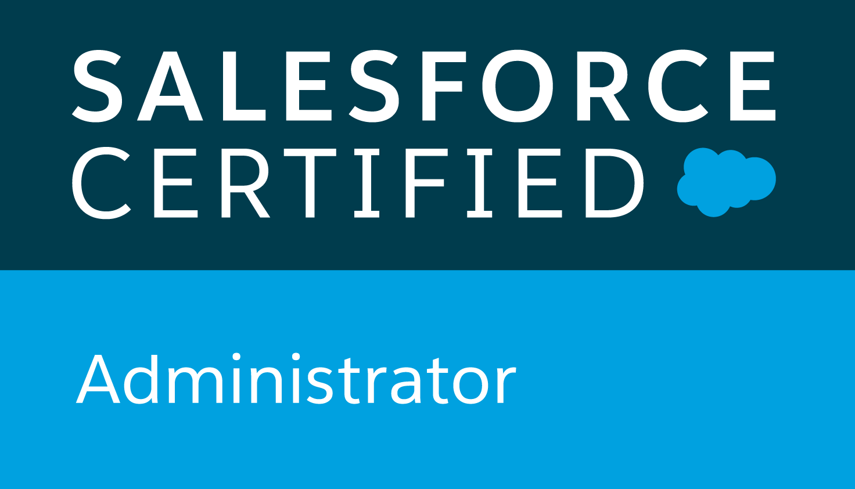 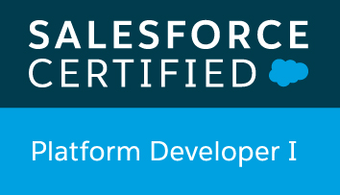

**Sushma**

**PROFESSIONAL SUMMARY:**

7 years of overall experience in various application designs and development in various capacities and 4 years of experience in Salesforce platform. Expertise in Developing and administrating Salesforce applications and Web Applications based on MVC Model and OOPs concepts.

* 4 Years in Salesforce CRM and Force.com platform. Implemented Sales, Service Cloud and custom applications.
* Experience in SFDC Development using **Apex and Visual Force.**
* Developed Triggers, Inbound Email Services, Batch Programs etc
* Developed Integrations using Web Services both **SOAP and REST API**.
* Strong hands on experience with developing complex Visual Force using Apex Controllers.
* Strong hands on experience with Salesforce Security setup using Profiles, Permission Sets, OWD, Role Hierarchy, Sharing Rules
* Developed SFDC Configurations/Customizations – User Interface, Page Layouts, Tabs, Custom fields, Custom objects, Record Types etc
* Extensive experience in creating **workflows, approval processes, validation rules**
* Working knowledge in generating **Reports, Dashboards,** customized reports and analyzing the data in SalesForce.
* Used different data tools – **Apex Data Loader, Import Wizard, SFDC Data Export, Mass Delete** etc.
* Proficient in **Data Migration** from Traditional Applications to SalesForce Using **Data Loader** Utility. Data Load for SFDC Standard objects and Custom objects
* Experience in managing Sandboxes.
* Working knowledge in **VisualFlow**, **Process Builder**
* Working knowledge in Salesforce **Communities**
* Working knowledge in Salesforce **Sites**
* Strong Knowledge in **App Exchange** Applications for integrating with Third Party Applications.
* Experience in Object Oriented Analysis / Design / Development / Testing and Implementation, Client/Server Architecture.
* 2+ Years of Experience working on **Salesforce Lightning** version
* Working knowledge on creating **Lightning Components, Java script**
* Have experience working on Third party Java Script Libraries (Ex: Vue.js, Datatable.js etc.)
* Have working Experience on both **Sales cloud** and **Service Cloud**
* Experience in Integrating internal and External Applications with Salesforce
* Having work experience in AGILE Methodology and Waterfall Model. Familiar with all AGILE Ceremonies.
* Can work on time critical projects and customer facing projects.
* Participated in Business requirement meetings and finalizing specification document. Have experience in working with Business directly (If needed)
* Have working experience in converting **Salesforce Classic to Lightning.**
* Familiar with Salesforce DX
* Experience in co-ordination with offshore team and have experience working with remote teams.
* Experience working with small teams and large teams.

**TECHNICAL KNOWLEDGE**

1. **SalesForce CRM**: SalesForce CRM, Force.com, SOAP and REST API, Java,

Work Bench, Eclipse, Lightning Components, Java Script, Apex, Visualforce,

Salesforce DX, Copado, Jenkins

1. **EAI and ETL Tools:** Informatica Power Center 9.1, Dell Bhoomi
2. **Operating Systems:** WINDOWS XP/NT/2000/98/95, UNIX.
3. **Languages**: Apex, Java Script
4. **Other Tools:** TOAD, MS Visio, MS Office, Erwin

**CERTIFICATIONS:**

* **Salesforce Certified Platform Developer I** – License Number (18559971)
* **Salesforce.com Certified Administrator (ADM 201)-** License Number (18286255)

**EDUCATION**

* Master of Science in **Software Engineering** from International Technological University, San Jose. (2013)
* Bachelor of Technology in **computer Science** from Vinayaka Missions University. (2009)

**PROFESSIONAL EXPERIENCE**

**Main Street Launch June 18 – Till Date**

**Location: Oakland, CA.**

**Role: Salesforce Developer**

**Environment: SalesForce CRM, Apex, VisualForce, SalesForce lightning, Data Loader, Eclipse, JavaScript.**

Main Street Launch accelerates effort to support diverse entrepreneurs and the businesses and local jobs they create, using business investment as a primary strategy for creating opportunities for low-to-moderate income.

**Responsibilities:**

* Led efforts for development, customization and integrations for entire application
* Converted Application from Classic to Lightning.
* Involved in Salesforce.com Application Setup activities and customization to match the functional needs of the organization.
* Implemented the requirements on Salesforce.com platform using APEX, Visual Force, Lightning Components , XML, HTML, Jquery, Javascript
* Worked with various salesforce.com objects like Leads, Accounts, Contacts, Opportunities etc
* Implemented Application Security
* Developed various Custom Objects, Tabs, Components and Visual Force Pages and Controllers.
* Developed Apex Classes, Triggers, and Controller Classes for various functional needs in the application.
* Developed integrations using SOAP Web Services.
* Developed Visual Force Pages for Wizard Style Screens
* Developed and deployed workflows and approval processes for opportunities and products/assets management.
* Developed and configured various Custom Reports and Report Folders for different user profiles based on the need in the organization.
* Performed the roles of Salesforce.com Analyst/ Developer and Administrator in the organization.
* Worked in Data Migration from Traditional Applications to SalesForce.
* Used the sandbox for testing and migrated the code to the deployment instance after testing.
* Interacted with the Salesforce.com premium tech support team on a regular basis.

**Liberty Power** **Aug 16 – Mar 18**

**Location: Fort Lauderdale, FL**

**Role: Salesforce Developer**

**Environment: SalesForce CRM, Apex, VisualForce, Data Loader, Eclipse, C#, ASP.NET, XML, HTML, , Agile**

Liberty Power is the largest independent retail electric provider and 13th largest non-residential retailer in the United States. Liberty Power Currently serving hundreds of thousands of accounts in 14 states, Liberty Power continues to provide low-cost electricity and exceptional customer service to its customers.

**Responsibilities:**

* Web to Case and Email to Case Management
* Led efforts for development, customization and integrations for entire application
* Design and developed Call Script developed entirely in Visual Flow
* Involved in Salesforce.com Application Setup activities and customization to match the functional needs of the organization.
* Implemented the requirements on Salesforce.com platform using APEX and VisualForce.
* Worked with various salesforce.com objects like Leads, Accounts, Contacts, Opportunities etc
* Implemented Application Security
* Developed various Custom Objects, Tabs, Components and Visual Force Pages and Controllers.
* Developed Apex Classes, Triggers, and Controller Classes for various functional needs in the application.
* Developed integrations using SOAP Web Services.
* Developed email Services for inbound email processing.
* Developed Visual Force Pages for Wizard Style Screens
* Developed and deployed workflows and approval processes for opportunities and products/assets management.
* Developed and configured various Custom Reports and Report Folders for different user profiles based on the need in the organization.
* Configured the Analytic Snapshots to load the data on regular basis for the sales performance and lead generation statistics.
* Created and used Email templates in HTML and Visual Force.
* Performed the roles of Salesforce.com Analyst/ Developer and Administrator in the organization.
* Worked in Data Migration from Traditional Applications to Sales Force Using Data Loader Utility.
* Used the sandbox for testing and migrated the code to the deployment instance after testing.
* Interacted with the Salesforce.com premium tech support team on a regular basis.
* Internal Community setup and Customization

**Cintel Systems INC** **May 14 –June 15**

**Location: Dublin, CA.**

**Role: SalesForce Developer/Admin**

**Environment: SalesForce CRM, Apex, VisualForce, Data Loader, Eclipse, C#, ASP.NET, XML, HTML, Microsoft Visual studio**

**Responsibilities:**

* Worked with Business Users and Business analysts for requirements gathering, analyzing the requirements.
* Created data model using various standard salesforce.com objects**,** Account, Contact, Case, Activities. In addition, created around 25 custom objects to support this business process.
* Used **Salesforce.com** platform, **Force.com IDE** for development for Visualforce Pages, Apex classes, Triggers
* Developed Apex Triggers, Apex Classesfor various Business/functional requirements.
* Developed Web Service Callouts from SalesForce to External Applications using SOAP and REST API
* Developed Custom Web Services in SalesForce and published for External applications
* Written **SOQL, SOSL** query language necessary for the application in Apex Classes and Triggers.
* Developed complex VisualForce Pages using **MVC** with **Salesforce.com**.
* Used various visualforce components like ActionFunction, PageBlock, InputField, ActionSupport, DataTable, Datalist, CommandLink, and CommandButton etc.
* Worked with **Visualforce Controllers (Standard, StandardList, Custom, Extension Classes)**.
* Created **Page Layouts** and assigned different layouts based on Record Types.
* Developed **Workflow rules, Field updates, Email alerts** to implement the business logic for Standard and Custom Objects as per the business needs.
* Prepared data mapping document to map source and target system fields.
* Used **Dataloader** to bulk load data into Salesforce.com.
* Configured/Created **Profiles, Roles, and Permission Sets** for the organization and setting up Field-level, Object-level security rules for the application.
* Developed Apex Test Classes for unit testing to ensure at least 75% of code coverage is met.
* Deployed application from Sandbox to different other Sandbox as well as into Production environments.
* Developed Test classes to support Code Coverage for deployment to production and performed smoke tests before QE Validation.
* Involved in Data Migration Activities to handle bulk loads using APEX Data Loader.
* Created Page Layouts, Record Types, and Search Layouts to organize fields, custom links, related lists, and other components on record pages.
* Performed deployments using Change Sets and Eclipse IDE as needed and validated the components before deployment to ensure a smooth process.

**Radiance Info System, India**  Sep **09 -** **May 11**

**Role: Web Developer**

**Environment:** Java, JSP, HTML, CSS, and Java Script

**Responsibilities:**

* Developed the web pages using JSP, CSS, and JavaScript.
* Developed Business logic on Java beans and setup connection with database.
* Written Store procedures and designed the database tables.
* Involved in the security issues of SSO.
* Involved in the data modeling, analysis of data, creation of database schema, tables.
* Have worked on the development of reports and charts.
* Parameter passing between different components in the provider objects.
* Content Management of the Prime Sourcing Portal pages.
* Creation of web and business components.