
PRIYANK NAGAR
nagar.priyank@gmail.com
+91-9766393404
Key Skills  Siebel CRM  Development and Support  Client Management  Designer and Architect  Stakeholder Management  Excellent Troubleshooting Ability  Agile & Waterfall | CRM Delivery Lead
 | Profile Summary
- CRM expert with overall 14 years of experience

- CRM Delivery Lead with exposure to all aspects of project lifecycle in both agile and waterfall methodologies

- Leading a team of 80+ members for Vodafone UK as Siebel CRM Delivery Lead; delivering a portfolio of new products/functionality to market in monthly releases

- Delivered key automations for the client:
  - Inhouse Self-serve tool to automatically deliver product designs
  - Siebel Transaction Log Analyzer for Performance Test using Python
  - SQL Analyzer for Siebel logs to highlight non-performing SQLs using Python

- Have worked closely with client for 3 years at onshore for requirement gathering, estimation and architecture design along with delivery and support activities

- Excellent problem solving, debugging and analytical skills. Team leading ability, positive attitude and result oriented approach; quick learner and willing to adapt to new challenges & technologies.
Career Timeline
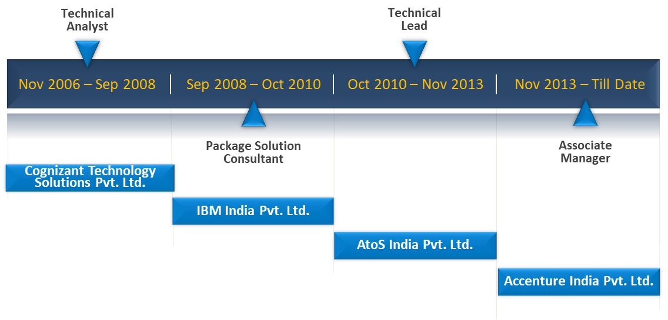
Technical Skills | Domains Telecommunication, Public Sector and Pharmaceuticals  Project Management Tools Jira, Kanban board, Rational Jazz  Software Configuration Management Tools GIT, SVN, Rational Clear Case, Microsoft VSS  Build Automation Tools Jenkins, Chef  Static Code Analysis Tool SonarQube  Defect Management Tools HP Quality Center, Rational Clear Quest  Technology Siebel CRM (v 7.7, 7.8, 8.0, 8.1, 8.2, 15.0, 20.0), Siebel Open UI, JavaScript, HTML, CSS, jQuery  Integration Technologies Siebel EAI, REST APIs, Web Services, XML, SOAP, VBC, EBC, HTTP  RDBMS Oracle 9i, 11g  Operating Systems Windows, Linux
Work Experience | NewCo - Vodafone UK, Pune/Newbury  - Managing CRM delivery as well as L3 support from offshore for major and minor releases  - Managing forecast, cost, estimation and capacity for the team  - Managed Agile and Waterfall delivery along with migration from waterfall to agile  - Delivering a diverse portfolio across mobile, fixed telephony and broadband domains  - Worked closely at onshore pre and post Go-Live of the system with L1 & L2 support teams  - Delivered automation using various DevOps tools e.g. Jenkins, Chef, SonarQube  - Leading troubleshooting, incident response, and critical go-live issues in a timely manner  DWP - Department of Works and Pension (UK), Pune/Runcorn  - Identify and Define Business Process with Business Analysts  - Created Technical Design Document Template, Siebel Configuration & Coding Guidelines, Integration Control Document Template and Peer review templates  - Analyze, estimate and design Siebel CRM Technical Solutions for the given business processes  - Lead offshore team and help team members by resolving technical queries and issues.  - Involved in training and support to Users at onshore  CamLite R12.3 - Department of Works and Pension (UK), Pune  - Lead offshore team and help team members in technical queries and issues  - Design Siebel technical solution for the given business processes  - Involved in documenting Technical Design for various modules  - Involved in tech design reviews and code reviews  Sales Force Automation - Vodacom (South Africa), Pune  - Client interaction regarding production issues and bug fixes  - Involved in configuration, scripting, workflows, business services, EAI (web services), order management, smartscripts and email functionality  - Involved in documenting Technical Design for various modules.  - Implementing Change Requests  Solution Center - T-Mobile (Germany), Pune  - Client interaction regarding production issues and bug fixes  - Involved in configuration, scripting, workflows, business services, EAI (web services), order management, smartscripts and email functionality  - Involved in documenting Technical Design for various modules.  - Implementing Change Requests  Electronic Customer Management System - Pfizer (UK), Mumbai  - Configuration and development of the core and localized requirements for different languages  - Preparing and executing the Unit / Integration test plan
Associate Manager
Accenture
Nov’13 – Till Date
Team Size: 86

Team Lead
AtoS
Jul’12 – Nov’13
Team Size: 10

Team Lead
AtoS
Apr’12 – Jul’12
Team Size: 6

Senior Software Engineer
AtoS
Nov’10 – Apr’12

Package Solution Consultant
IBM
Sep’08 – Oct’10

Technical Analyst
Cognizant
Nov’06 – Aug’08

Education   Certifications  Personal Details | - Bachelor of Engineering (B.E.) in Electronics and Communication with 65% from IPS Academy, Indore (affiliated to RGTU Bhopal) in year 2006  Microsoft Certified: Azure Fundamentals  Date of Birth: 17-Dec-1984  Gender: Male  Languages: English and Hindi  Address: Flat 403, Building A2, Kumar Purab, S.No. 256, Near TVS Showroom, Hadapsar, Pune - 411028  Passport: Available

