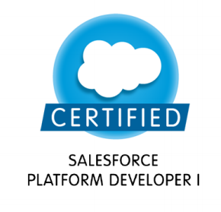
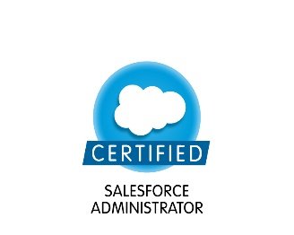
Sravanthi R
927-472-4480
Madison WI
sravanthirt59@gmail.com

Professional Summary:

- Certified Salesforce Consultant (Platform1 and Admin 201 certification) with over all 4.5 years of experience in Salesforce.com.
- Have exposure to all stages of Software Development Life Cycle which involves requirement gathering, requirement analysis, design, development, testing.
- Have an experience with lightning component framework and classic version.
- Ability to decide simplified solutions choosing between out of box functionality and coding techniques
- Experience with Data management activities like data cleansing, data mapping, migration by using tools such as data loader, dataloader.IO, workbench
- Experience with administration in maintaining user management, concepts like process builder, workflows, escalation rules, validation rules.
- Extensive experience in implementing apex concepts like batch, schedule apex, triggers, REST api, platform events, aura components
- Experience with UI such as HTML, CSS, JavaScript, visual force, lightning design system
- Experience with unit, integration, regression, bulk testing to make sure once its coded and moved to various level of sandboxes before going to Prod.
- Experience in database like sql server and salesforce communication through DBAmp, writing ssis packages to load data into sql server
- Keeping current releases always in track by doing trailhead modules, maintaining certification credentials released by salesforce.
- Worked with tools like Force.com IDE, visual studio code, soap ui, postman, workbench.
- Good experience using in continuous development/Integration tool like AUTO RABBIT.
- Ability to adapt learn quickly, self-motivated and a team player.
Technical Skills:

Force.com Tools: Data loader, Force.com, Apex, Force.com Migration Tool, Aura framework
Operating Systems: Windows NT / 2000 / XP Pro / Vista, Windows Server 2000 / 2003 / 2008.

Databases: SQL server, Oracle, MS Access
Web Technologies: Visualforce, JavaScript, HTML, CSS
Languages: Apex, Java.

Professional Experience

CUNA MUTUALGROUP, Wisconsin
Nov 17 - till date
Salesforce Developer

Description: CUNA mutual is an insurance company that provides financial services to cooperatives, credit unions, their members, and other customers worldwide provides retirement plan services to small businesses and credit union employees.
Responsibilities:
- Developed apex classes, triggers, during new implementation as well as to support enhancements.
- Having an experience in creating components, events, server-side controllers to support lightning components
- Experience in Lightning using aura framework, lightning design system to follow UI best practices
- Good experience with data integration tool DBAmp to connect salesforce and sql server
- Having experience working with Agile methodology like Scrum meetings, code review sessions, involved in sprint sessions.
- Worked on staging tables, sql stored procedures for bidirectional integration from sql Server to Salesforce.
- Worked on Lead process in classic version as well as lightning version.
- Developed platform events to consume data in batch and real time process
- Experience in deployment process to move changes to different sandboxes, production using Eclipse IDE, changesets,AutoRabbit.
- Experience in following best techniques for data cleansing and data mapping activities
- Hands on experience in webservices using REST api and testing using tools like SOAP UI, Workbench, Postman

Environment: Eclipse IDE, Apex Data Loader, DBAmp, JavaScript, Apex Explorer, DCS, Apex, CSS, Lightning, Visualforce, Workbench, SOQL, SOAP UI, Postman.

PCORI, Washington D.C Nov 14 – Dec 15
Salesforce Developer/Admin

Description: PCORI is a funding organization to fund research that can help patients and those who can take better decisions about healthcare choices. It will recruit and train reviewers to serve on panels based on their level of experience and expertise. Review process is distinguished by the participation of Scientists, Patients and other stakeholders

Responsibilities:
- Prepared design and admin documents for migration and integration of organization’s legacy systems to Salesforce.com.
- Worked on various email templates like text, HTML for merit review users.
- Used the sandbox for testing and migrated the code to the deployment instance after testing.
- Data replication is made with Cvent tool and salesforce for creating events and surveys for end users.
- Worked on data cleansing, data mapping, loading data from Survey gizmo, and Fluxx to salesforce in different stages from development environment to prod.
- Experience in making callouts from salesforce to external system using REST api.
- Developed custom pages for customers in the community
- Worked on test classes to cover code coverage during deployment
- Successfully moved the sessions and batches from the development to production environment
- Worked with JAMA tool to fix the issues that are tracked by testing team.
- Explorer for soql consideration to governor Limits for data manipulation needs of the application.
- Performed unit testing (UT), integration testing, bulk testing, staging and user acceptance test (UAT) in full sandbox.

Environment: Salesforce.com Unlimited edition, Eclipse IDE, Apex Data Loader, Apex, Visualforce, SOQL, HTML, Chatter, salesforce, CSS, JavaScript, communities, Cvent, Data.com, Jama, MS Visio.

Education:
- Bachelors in Electronic and Communication Engineering from JNTU University, India

