Rajamohan Vakati
Salesforce Architect
(215) 915 5090
rajamohanvakati@gmail.com
OBJECTIVE:  Highly accomplished professional with in-depth knowledge of product development and customer relationship management (CRM) in the Cloud computing space with a wide range of technical, management and architectural experience. Hands-on experience in developing product as well as designing, delivery, prioritizing Prototyping and product scoping. Experienced in maintaining client and consultant relations while performing in deadline driven environments.  EXPERIENCE  June 2018 to Present Visa Inc., Austin, USA –Salesforce Architect  Feb 2017 to June 2018 Forescout, San Jose USA –Salesforce Architect  July 2016 to Feb 2017 Move Inc., Santa Clara USA –Lead Developer  Nov 2014 to July 2016 Birla soft Inc., Pennsylvania, USA – Salesforce Architect  Mar 2012 to Oct 2014 Yash Technologies, Bangalore India –Sr. Developer  Mar 2011 to Mar 2012 Ericsson India Global Services, Chennai, India – Developer  Aug 2010 to Mar 2011 Polaris software labs, Mumbai India –Developer  Nov 2009 to Aug 2010 ITC InfoTech India, Bangalore India –Developer  EDUCATION  May 2004 to April 2008 JNTU Hyderabad, India — Bachelor of Technology  CERTIFICATIONS  - Salesforce Certified Integration Architecture Designer  - Salesforce Certified Development Lifecycle & Deployment Designer  - Salesforce Certified Data Architecture & Management Designer  - Salesforce Certified Community Cloud Consultant  - Salesforce Certified Identity and Access Management Designer  - Salesforce Certified System Architect  - Salesforce Certified Force.com Developer  - Salesforce Certified Administrator  - Salesforce Certified Pardot Specialist  - Salesforce Certified Platform App Builder  - Salesforce Certified Platform Developer I  - Salesforce Certified Platform Developer II  - Salesforce Certified Sales Cloud Consultant  - Salesforce Certified Advanced Administrator  - Salesforce Certified Administrator  - Oracle Certified Professional, Java EE 5 Web Component Developer  - Oracle Certified Professional, Java SE 6 Programmer  TECHNICAL SKILLS  Salesforce Salesforce CRM, Sales Cloud, Service Cloud, APEX, Visual force, Web Services, Streaming API, REST API, Streaming API, Bulk API, Metadata API, Salesforce 1, Lightning,LWC, Tooling API, SOAP, ANT, Heroku, Database.com, Force.com, Sales force, Mobile development, Service Max, Zuora, Apttus, DocuSign, Map Anything, Cloud Craze , Lightning ,Salesforce Wave ,IoT , salesforce Einstein , salesforce community cloud  Programming Language / Web Technologies Java, Adobe Flex, Action Script 3.0,Adobe AIR, JavaScript, HTML, XML, JQuery, JQuery UI, JSON, Ext JS, Angular JS, React JS, Vue Js ,Backbone JS, PURE CSS, Bootstrap, Ionic ,Spark ,Scala ,Python ,R  J2EE Technologies Servlets, JSP, JSTL, EJB 2.x, EJB3.0  Frameworks Spring, Struts1.3 and JSF.  ORM Hibernate 3.0 and JPA  Web Servers Apache Tomcat, Web Logic Application server  I.D.E /Tools Eclipse, Force.com IDE, Adobe Flex Builder, Force.com Migration tool, data loader, Jitter Bit Data loader, Force.com Migration tool  Databases Oracle9i, MySQL.  Data Science / Data Analysis Machine Learning ,Statistics and Statistical Modeling ,Big Data & Hadoop , Text Mining , Data Visualizations using Tableau , Tibco Spotfire and R Studio , Power BI , Optimization Techniques , Programming knowledge on Python , R , SQL ,, numpy , pandas ,scipy , SymPy, Data Visualiaztion ,Data Cleaning ,Matplotlib ,Seaborn , Data cleaning, Data preprocessing, Generating New data, Statistical modeling, Statistical significance testingStatistical Analysis,  Computer Vision OpenCV, PyTorch  Machine Learning Scikit Learn , Tensor flow , Pytorch , CNTK ,  Natural Language Processing NLTK  Deep Learning Keras ,Theano  Big Data Hadoop , MapReduce, HDFS , Hive, Pig, Sqoop, Flume ,Apache HBase , Spark ,Scala, Cassandra , Couchbase , Kafka  ETL Informatica ETL, Power Center, Informatica On demand, Cast Iron, Snap Logic  PROJECTS  Project Name # Data Products / Visa Predictive Models  Duration: November 2019 to till Date Client: Visa  Location: Austin  Environment: Python, SAS, Tensorflow  - Application fraud risk is on the rise and card issuers need more comprehensive risk assessment at the application stage to combat the loss. AI model captures underline hidden risk patterns that traditional model and business rule might miss. The model build on VISA ICS data has the capability to capture fraud patterns across issuers with the most complete and up-to-date bankrupt, application fraud information and PII validation indicators..  - Validating Model/ data generation code  - Supporting Model implementation on AIP  - validate implementation results  - Build monitoring report on the input features and the output scores.  Project Name #GCCS  Duration: June 2018 to till Date Client: Visa  Role: Salesforce Architect  Location: Austin  Environment: Saleforce.com platform, Apex Language, Visual Force Pages, Lighting,  Service Cloud , Lightning Web Component , Lightning Component , SOAP API, REST API , Securities , Genesys ,Pointel , Integrations , Java ,.Net ,Data Power  - GCCS (Global Customer Care service) is a unified CRM that provide one-stop solutions to visa cardholder with wide range of services like Account Released to emergence visa card printing to cash delivery to the location. GCCS is heavily integrated with the all the visa internal and external systems.  - Implemented Lighting Service cloud to provide global customer case for visa which include emergency card and card replacement  - Integrated with many of the visa internal systems to fulfil the cardholder needs.  - Implemented multi-channel service cloud  - Implemented Securities  Project Name #FEMS  Duration: Feb 2017 to June 2018 Client: Fore Scout  Role: Salesforce Architect  Location: San Jose  Environment: Saleforce.com platform, Apex Language, Visual Force Pages, CPQ, Lighting, Communities, IoT Cloud, Rest API, Integrations, NetSuite  - Implemented Customer based Community based on IoT.  - Centralized Licensing and Modularization though salesforce customer communities  - Salesforce ,NetSuite ,EMS integration  Project Name #Move Pre Sales  Duration: June 2016 to Feb 2017 Client: Move, Inc.  Role: Lead Developer  Location: Santa Clara  Environment: Saleforce.com platform, Apex Language, Visual Force Pages, Data Loader, Workflow & Approvals, Reports, Custom Objects, Custom Tabs, Email Services, Security Controls, Zuora, Oracle CPQ, DocuSign  - Implemented continuous release management process and Version Control  - Implemented Integrations between Zuora, CPQ, DocuSign and Salesforce  - Implemented UX and UI Architected and design reviews.  - Implemented Lightning and Salesforce Mobile development.  Project Name # GE Water & Process Technologies  Duration: Nov 2014 to June 2016 Client: GE Water  Role: Solution Architect  Location: Trevose, Pennsylvania  Environment: Service Max Product Suite, Data Loader, Web Services, Saleforce.com platform, Apex Language, Visual Force Pages, Data Loader, Workflow & Approvals, Reports, Custom Objects, Custom Tabs, Email Services, Security Controls, Map Anything.  - Architect and design the solutions / integrations using scalable design patterns and services like SOAP and REST protocols  - Manage Data Migration and Data Integration activities across platforms  - Define, measure and track business and performance metrics of the solution  - Implement the change management process suitable across all initiatives  Project Name # Sales Enablement  Duration: Dec 2013 to Oct 2014 Client: Monsanto  Role: Sr Developer  Location: St Louis, MO  Environment: Sales force CRM, APEX, VISUALFORCE, Data Loader, Web Services, Saleforce.com platform, Apex Language, Visual Force Pages, Data Loader, S-Controls, Workflow & Approvals, Reports, Custom Objects, Custom Tabs, Email Services, and Security Controls  - Used Salesforce.com to facilitate Campaign Management, Dashboard/Reports development, Lead Management, Content, Contracts, and Customer Service/Cases.  - Implemented Salesforce Service Cloud including Customer Portal, Knowledge, Entitlements, and Service Console.  - Created SFDC sites to provide public access to VisualForce pages and allowed Customer Portal users to login or register.  - Worked with Cast Iron APEX API and Web Services.  - Migrated massive amounts of data from DB2 staging tables into Salesforce.com on a daily & weekly basis so it's available to the sales/field representatives.  Project Name# Top Producers  Duration: Sept 2012 to Nov 2013 Client: Monsanto  Role: Sr Developer  Location: St Louis, MO  Environment: Sales force CRM, APEX, VISUALFORCE, Data Loader, Web Services Saleforce.com platform, Apex Language, Visual Force Pages, Data Loader, S-Controls, Workflow & Approvals, Reports, Custom Objects, Custom Tabs, Email Services, Security Controls  - Developed Apex Classes, Controller Classes and Apex Triggers for various functional needs in the application.  - Design/Develop the Force.com database model, Apex and Visualforce User Interface Code.  - Worked on the Geolocation based application.  Project Name # FBN Sales force Reports  Duration: Mar 2012 to Aug 2012. Client: FBN  Role: Sr Developer  Location: Bangalore, India  Environment: Sales force CRM, APEX, VISUALFORCE, Report Builder Saleforce.com platform, Apex Language, Visual Force Pages, Data Loader, S-Controls, Workflow & Approvals, Reports, Custom Objects, Custom Tabs, Email Services, Security Controls  - Perform detailed analysis of business and technical requirements and designed the solution by customizing various standard objects of SalesForce.com (SFDC) and other Platform based technologies like VisualForce, Force.com API, and Web Services.  - Implement Service Cloud Customer Portal for One Step application to cut down the service cost.  - Extracted the data from salesforce.com application into the external databases (Oracle 10g) for generating large data reports using the Informatica on Demand.  - Integrated the web services by generating the necessary stubs from the WSDL files for extracting the data from external systems to display in the pages of salesforce.com.  Project Name #: eStore (Ericsson Application Storage Service) SaaS  Duration: Mar 2011 Mar 2012 Client: Ericsson  Role: Sr Developer  Location: Chennai, India  - Written SQL scripts. Debug the implemented code as per the code design.  - Designed Hibernate mappings, associations and relationships between business objects.  - Designed and developed a number of Restful web services that support JSON for other developers to access to speed up development within the United Federation of Teachers using Spring MVC, Spring Web Services, JSON, Log4J, Restful, MySQL, DB2 and Maven.  - Designed and developed a number of applicants for the United Federation of Teachers in IntelliJ IDEA using Spring 3, Spring Security, Spring WebFlow2, Hibernate, Dojo, Ajax, HTML, JSP, JSTL, JSON, JQuery, Log4J, Restful, MySQL, DB2, and Maven.  Project Name # FCSS (Funds Control Shared Service)  Duration: Aug 2010 to Mar 2011 Client: Barclays  Role: Sr. Developer  Location: Mumbai, India  Environment: Salesforce CRM, Apex, Visualforce Saleforce.com platform, Apex Language, Visual Force Pages, Data Loader, S-Controls, Workflow & Approvals, Reports, Custom Objects, Custom Tabs, Email Services, Security Controls  - Developed the Apex Triggers to ensure the correct data entries in to the system.  - Designed and maintained different environments included Development, Test, UAT and Production.  - Developed custom S-Controls with java Script and Apex Web services.  - Developed Salesforce.com ETL processes using Cast Iron, Java and Sales force Web Services Java API.  Project Name# Sales & Marketing  Duration: Mar 2010 to Aug 2010 Client: Creed Engineers  Role: Developer  Location: Bangalore, India  Environment: Salesforce CRM, Apex, Visualforce Saleforce.com platform, Apex Language, Visual Force Pages, Data Loader, S-Controls, Workflow & Approvals, Reports, Custom Objects, Custom Tabs, Email Services, Security Controls  - Integrated the Web Services for extracting the data from external systems.  - Provided ongoing Salesforce.com maintenance and administration services including periodic cleansing, custom objects and workflows.  - Implemented Security access to the user profiles by creating Object level security, field level security and record level security.  - Developed Apex Triggers, Apex Classes and Test Methods.  Project Name # CRM for Sales Force Automation  Duration: Dec 2009 to Mar 2010 Client: Sterlite Industries Ltd  Role: Developer  Location: Bangalore, India  Environment: Salesforce CRM, Apex, Visualforce Saleforce.com platform, Apex Language, Visual Force Pages, Data Loader, S-Controls, Workflow & Approvals, Reports, Custom Objects, Custom Tabs, Email Services, Security Controls  - Developed Apex Classes, Controller Classes and Apex Triggers for various functional needs in the application.  - Used SOQL & SOSL for data manipulation needs of the application using platform database objects.  - Used Data migration tools and de-duplication.  - Experienced in Unit Testing, for the customizations and developments done during the project.  - Involved in the Data Transformation and Data Cleansing activities while transferring the data to the external system using Informatics on Demand. | ABOUT ME  I am a 16X salesforce certified architect who is passionate in building productive applications .I have architected and built horizontally scalable end-to-end applications on salesforce, salesforce Mobile, Lightning, Web Application and Java /J2EE. Good Knowledge on Data Science , Machine Learning , Deep Learning , Artificial Intelligence , Neural networks, Natural Language Processing with Python , R  CERTIFICATIONS  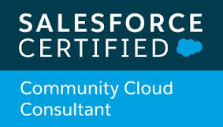  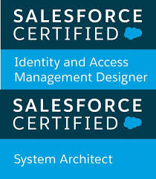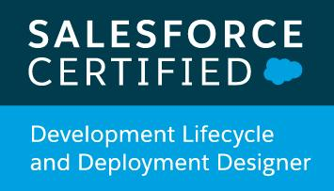  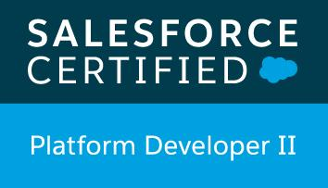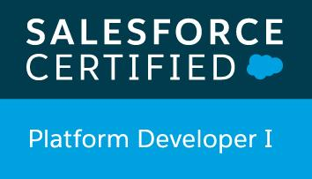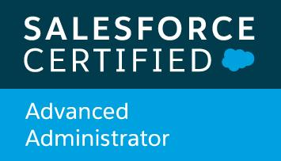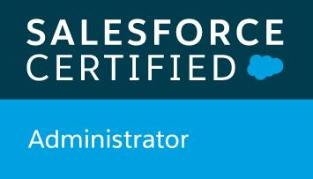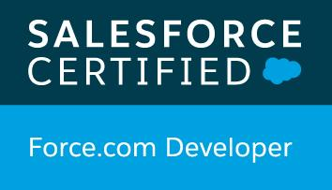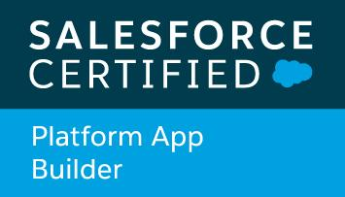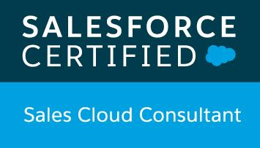  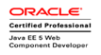  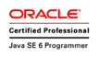  SOCIAL  Gmail: rajamohanvakati@gmail.com  Skype: rajamohanvakati  METHODOLOGIES  Software Development Life Cycle (SDLC), Agile Software Development, MVC

