Sumit Jain  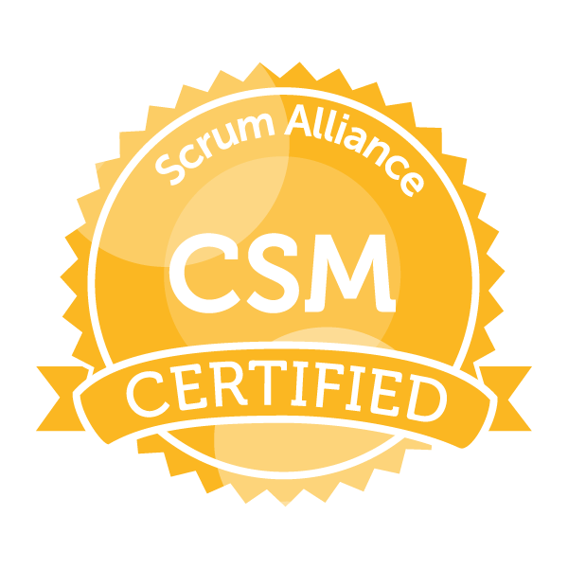

Professional Preface

Actively looking for a Scrum Master Position to utilize my knowledge of Scrum Principles and Value while exposing the abilities in Industry that offers security and professional growth while being resourceful, innovative, and flexible. 11+ years of IT experience (SAP Domain) including 2 years as a Scrum Master (Certified).

- Experienced in driving the Agile/Scrum adoption and enforcement of Scrum values and rules, removing impediments, and fostering self-organization.
- Building a trusting and safe environment where problems can be raised without fear of blame, retribution, or being judged, with an emphasis on healing and problem solving.
- Providing all support to the team using a servant leadership style whenever possible and leading by example.
- Plan & Strategy to set up SAP System Landscape.
- Liaison between the customer, Pre-sales, and project teams.
- End-to-End implementation of SAP ERP 6.0.
Employment Scan

S.No | Organizations | Tenure | Job Role/Designation
1. | Bristlecone India Ltd., Bengaluru | April’2015 to June’2018 | Scrum Master and SAP BASIS Lead Consultant.
2. | Capgemini India Pvt. Ltd., Mumbai | December’2013 to January’2015 | Sr. SAP Consultant
3. | TATA Consultancy Services Limited, Mumbai | January’2013 to November’2013 | System Engineer
4. | Future Focus Infotech Pvt. Ltd., Mumbai | October ‘2011 to January’2013 | SAP BASIS Consultant
5. | JV Software Consultants, Faridabad | November ‘2006 to September’2011 | IT Support Engineer & SAP BASIS Support engineer

Project Experience

1.
Organization | Bristlecone India. Ltd.
Client | SAP India Pvt. Ltd. ( Managed Cloud Delivery-- HANA Enterprise Cloud)
Role | Scrum Master & SAP BASIS Project Lead
Duration | From April ‘2015 to June’2018

Accountabilities

- Running Sprints proficiently organized and facilitated daily scrum meetings.
- Collaborated closely with Product Owner on backlog grooming to keep product backlog relevant and prioritized, ensuring acceptance criteria were agreed upon and stories were ready for sizing.
- Identify and Remove impediments to allow the team to deliver the business objective manage and monitor dependencies on other teams and external projects/teams to ensure potential issues are resolved.
- Guiding the team on self-organizing to fill in the intentional gaps left in the Scrum frameworks.
- Facilitator of scrum ceremonies like sprint planning, sprint reviews, and pleasant experience in conducting the retrospectives.
- Effectively tracked team progress including burn down, velocity, facilitating the team to update the JIRA board.

- Effectively managing an SAP BASIS team of six members in different clients.
- Escalation Management: identity, manage and lead escalations.
- Proactively and reactively, look for solutions to prevent complex problems from occurring across teams/technologies.

2.
Organization | CAPGEMINI INDIA Pvt. Ltd.
Client | Glenmark Pharmaceuticals Ltd. & TATA Power Company Ltd.
Role | SAP BASIS Support Consultant
Duration | From December ‘2013 to January’2015

Accountabilities

- Installation, Administration & Support of SAP as Standalone and Distributed Systems and Dialog servers.

3.
Organization | TATA Consultancy Services Limited & Future Focus Infotech Pvt. Ltd.
Client | TATA Communications
Role | SAP BASIS Implementation Consultant
Duration | From October ‘2011 to November’2013

Accountabilities

Installation, Administration & Support of SAP as Standalone and Distributed Systems and Dialog servers.
- Working on Tickets/Requests/Cases, which are raised through the help desk system (Internal Tool).
- Coordination with special projects team for resolving MOM.

4.
Organization | JV Software Consultants
Role | IT & SAP BASIS Support Engineer
Duration | From November ‘2006 to September ‘2011

Accountabilities

- Performing daily monitoring tasks includes Monitoring and Analyzing ABAP dumps, System logs, System locks, Updates, Background jobs, Work processes, OS Level Monitoring.

Technical Skills/Certifications

ERP | SAP ERP 6.0; BOBI; PO; Fiori; WPB; S4HANA; DMO
Database | Oracle; HANA; Sybase
Operating System | SUSE Linux (Cluster environment);
Certifications | Scrum Master; HANA; Migration; S/4 HANA

Scholastics

Level | Bachelor of Technology (B.Tech) in 2006.
Field of Study | Computer science & Engineering.
University | Punjab Technical University.

Personal Dossier

Email Id | sumit.shine@yahoo.co.in
Date Of Birth | 10.10.1983
Passport No. | J8035352 | Valid Up to: 24/07/2021  (mm/dd/yyyy)
PAN No. | ARKPJ3936H
Current City | Bengaluru
Contact Number | Mobile: +91-9538431309

