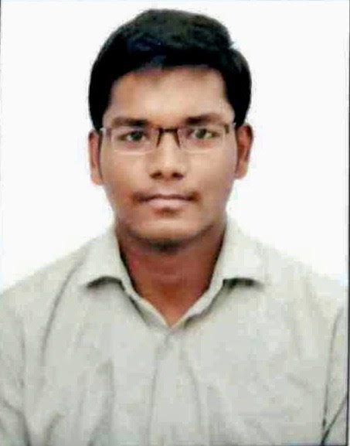

**Venkata Avinash Gangisetty| Avinash**

**Location: Hyderabad**

**Telephone: +91- 9885027274**

**Email: gangisettyvenkatavinash@gmail.com**

Professional Summary

Passionate Programmer Analyst with two years of experience in Python and measurement tools. Proficient in Machine learning process and procedures. Eager to learn new technologies. In previous role, I have Leveraged AWS skills for stakeholder website products and enhanced existing product offerings. I have built tool to automate SME process. Out of my personal interest I am working on a personal project, “Face Recognition Attendance System” using CNN architecture.

IT/Technical skills

|  |  |  |
| --- | --- | --- |
| * Python programming proficiency * Postgrade SQL * MySQL * Numpy * Pandas * Agile(SDLC) framework understanding | * Statistical analysis * Data mining * Machine learning * AWS-Lambda function * AWS(Amazon web services) * Object-Oriented Programming (OOP) | * Team building * Data Warehouse domain * Oracle 12g * Informatica 10.2 |

Career summary

**April 2018 – Present Cognizant Technologies and solutions**

**Programmer Analyst**

**Key responsibilities**:

* Worked with designers and content producers.
* Worked with users from identifying conceptual system requirements through completion.
* Worked with middle-tier developers to integrate back-end database code with business applications.
* Plan, design, schedule, write, and debug software for web sites.
* Plan, design, schedule, write, and debug database stored procedures and complex queries to extract, calculate or manipulate information.
* Analyse allocated task and understand low level and high level design of module level data models.
* Awareness & understanding of the different methodologies (SDLC, Agile).

**Key achievement/projects:**

**Pfizer Pharmaceutical Company (Project in Cognizant):**

* Effectively managed stakeholder relationships, ensuring agreed service obligations were consistently met.
* Work in an Agile SDLC (Software Development Life Cycle).
* Hands on experience of experience developing in Python.
* Hands on experience in developing enterprise grade API integration layer, web application using Python technologies with AWS lambda, MYSQL.
* A deep understanding of application architecture and development in Service Oriented models
* Applied knowledge of data modeling and statistical analysis to note trends and draw conclusions.
* Collected Database and Big data information from diverse sources.
* Experience programming and delivering in a production environment.
* Proficiency in object-oriented programming and experience applying modern design patterns.
* Expertise working with data structures and algorithms.
* Mapped processes to holistically examine business flow and identify improvement opportunities.
* Investigated and addressed database job issues to enhance usability and improve functionality.
* Collaborated closely with upper management to drive strategy through development and implementation of new processes.
* Administered, supported and monitored databases by proactively resolving database issues and maintaining servers.
* Consulted with engineering team members to determine system loads and develop improvement plans.
* Collected Database and Big data information from diverse sources.
* Built tools to automate processes such as SME processes.
* Identified new problem areas and researched technical details to build innovative products and solutions.
* Transformed raw data to conform to assumptions of machine learning algorithm.
* Leveraged artificial intelligence and machine learning algorithms for standalone products and enhanced existing product offerings.

**JP Morgan & Chase (Project in Cognizant):**

* Mapped processes to holistically examine business flow and identify improvement opportunities
* Provide process improvement analysis using process modeling and simulation techniques to understand the impact of process changes
* Works within IT team to follow the full lifecycle development process working with development and technical operations
* Work with other team members in establishing and sharing design and development techniques of the ETL process
* Collected Database and Big data information from diverse sources
* Coordinated with project management staff on database development timelines and project scope
* Built tools to automate processes such as SME processes

Education and qualifications

* **Artificial intelligence and machine learning, Certification** – December, 2019 to April, 2020
* **Electronics and Communications Engineering, Electronics, UnderGraduation(UG) –** Prathyusha Engineering College(PEC) **–** CGPA- 7.16/10, May, 2017
* **High Secondary, High School –** Narayana Junior College **–** Percentage-86.6%,March, 2013
* **Secondary, Schooling –** Narayana Concept School **–** Percentage -73.16%,April, 2011

References:

* **Linkedin:** <https://www.linkedin.com/in/gangisettyavinash-7511b293/>
* **GitHub:** <https://github.com/Avinash-Gangisetty>