Benjamin LaGrone

Houston, TX
(832) 722-8581 | benjaminlagrone@gmail.com | https://github.com/benlagrone/

Solution Architect, Product Owner, and Delivery Lead who takes an empirical approach to AI, Data Science, IoT, Industry 4.0, Machine Learning, Data Science, Automation, Mobile/Web, UI/UX, Project Delivery, and Cloud Product Management.

Manages US & overseas teams for on-time and successful delivery of project objectives.

Architect enterprise solutions and presentations to C-Level executives in Oil & Gas, Manufacturing, Healthcare, Finance, Startups, Insurance, Education and Secure contracts.

Strives to improve systems with groundbreaking new features and innovative techniques.

Education
- Bachelor’s of Science in Economics - University of Houston; May 2001
- MIT - User Innovation - Dec 2015

Publications
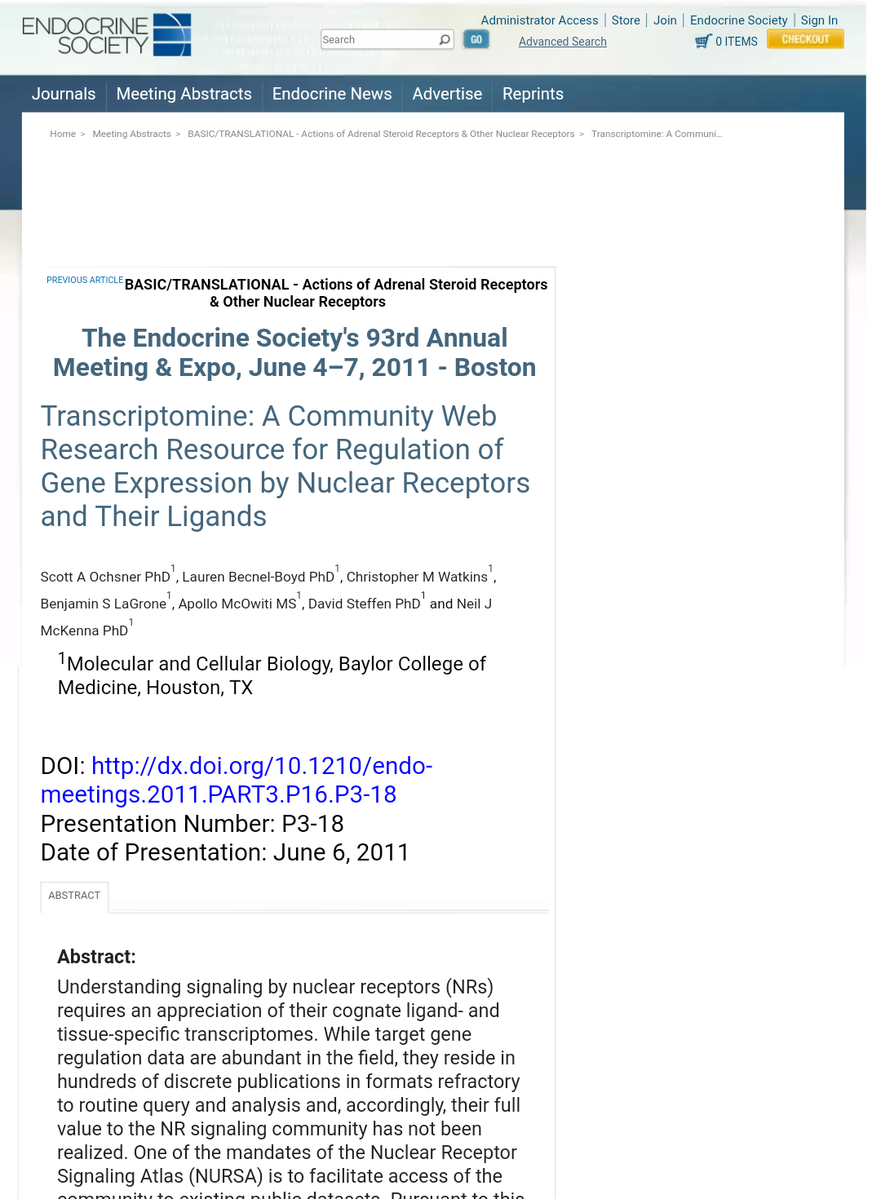 | Transcriptomine: A Community Web Resource for Regulation of Gene Expression by Nuclear Receptors and their Ligands http://press.endocrine.org/doi/10.1210/endo-meetings.2011.PART3.P16.P3-18
 | Molecular Endocrinology (MolEndo) Magazine - Tissue-Specific Transcriptomics and Cistromics of Nuclear Receptor Signaling: A Web Research Resource - 2013 http://press.endocrine.org/doi/abs/10.1210/me.2010-0216
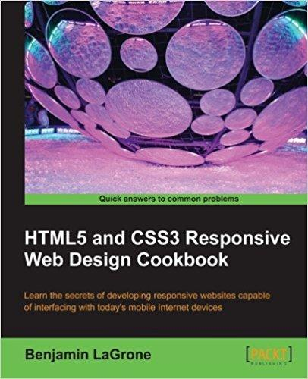 | HTML5 and CSS3 Responsive Web Design Cookbook ISBN 978-1- 84969-544- 2 - 2013  https://www.amazon.com/HTML5-CSS3-Responsive-Design-Cookbook/dp/184969544X/ref=sr_1_1?ie=UTF8&qid=1515096584
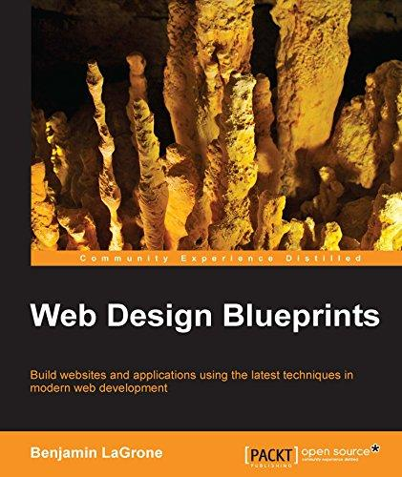 | Web Design Blueprints (Title TDB) ISBN 978-1- 78355-211- 5 - 2016  https://www.amazon.com/Web-Design-Blueprints-Benjamin-LaGrone-ebook/dp/B01A8T8YN2/ref=sr_1_3?ie=UTF8&qid=1515096584
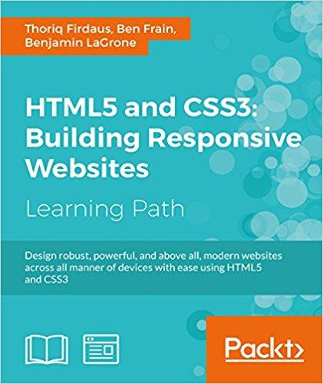 | HTML5 & CSS3: Building Responsive Websites (Title TDB) ISBN 978-1787124813 - 2016 https://www.amazon.com/HTML5-CSS3-Building-Responsive-Websites-ebook/dp/B01MPXN0JC/ref=sr_1_2?ie=UTF8&qid=1515096584
Industries
- IoT, Sensors, EDGE Devices & On-Prem Data Ingestion
- Artificial Intelligence, Machine Learning, Data Science
- Finance - Portfolio Valuation modeling
- Oil Gas & Manufacturing- Schlumberger, BP, McDermott, ARC
- Medical - MD Anderson, Baylor College of Medicine
- Education - Houston Independent School District, American Academy
- Entrepreneur - LeCrown Development
- Start-Ups - Empyrean Benefit Solutions, QiO

Functional Abilities
- Product Owner
- Solution Architect
- Quality Governance/Assurance
- Business Interfacing, Client Relations
- AGILE SCRUM
- User Experience (UX)
- Business workflow and process design
- Product management
- Constituent Usability Testing
- CI/CD / Automated Testing
- Product backlog, and Acceptance Criteria development

Specializations
- Industrial Automation, Industry 4.0, Digital twin, predictive maintenance
- Solution Architecture, Architecture Diagrams, Solution Design
- Mobile first development, Responsive design, Mobile web, IoT, Connected Devices
- Data Visualization & Data Science
- User Experience (UX) Architecture, User Interface (UI), Web Services
- Agile Software Development lifecycle, PBI & User Story Development
- Object Oriented Development
- Product Lifecycle, Feature Development & Release
- Web Application Usability Principles, Usability Testing, User Metrics
- Scientific and Enterprise development and deployment environments
- Bioinformatics, Robotics, Oil & Gas, Energy, IoT, IoTT

Mobile / Internet Technologies
- Azure Cloud Service, Google Cloud, AWS
- CI/CD pipeline, PowerApps, AppCenter.ms managed mobile deployments, VMWare Hub
- Kubernetes, Docker, Artifact Management
- Nifi, Jupyter, Spark, Kafka
- PAAS, IAAS, SAAS, Data Bricks
- Object oriented Programming (OOP) Angular 2/6+, Full Stack, MEAN Stack, HTML5 & CSS3, ECMA, JavaScript, Kendo, DOJO, ARC GIS, Google Maps API, API Development, Web Services, AJAX, REST, SOAP, XML, JSON, MVVM Patterns, SPA Online/offline
- State managed application workflows
- Telerik, HighCharts, Highmaps, D3, Superset
- IoT, Connected Devices, MQTT, Modbus
- Responsive Web Design, Mobile First Design
- JavaScript, Angular, React Native, Python, R, C# .NET MVC with Telerik and Kendo UI, PHP, Java Groovy/Grails, Native Applications: iOS & Android, PERL, C/C++, Arduino, AVR Libc
- SQL: MySQL, Microsoft, Oracle, Flat DB, MongoDB, NoSQL, PostGRES SQL
- Unit & Integration Testing

Productivity Software
- AGILE SCRUM: VSTS, Azure DevOps, Jira
- OS: iOS, Android, OSx, Windows, Linux: Red Hat, Ubuntu and Centos, VMWare
- Axure, Basalmiq Mockups, proto.io, Wireframing tools
- IDE: VSCODE, Visual Studio, NetBeans, Eclipse, Xcode, VIM, Webstorm, Android Studio, Atom
- Code Repository: GIT, GITLab, SVN, TFS
- Microsoft Office: Project, Visio, Access, Excel, FrontPage, PowerPoint
- Adobe Creative Suite: Photoshop, Illustrator, Indesign, After Effects
- CAD & CAM: Rhino, AutoCAD, Blender, CamBam, Mach5
- Servers: LAMP, Windows IIS Servers; Enterprise Server

Experience

July 2020 - Dec 2020
Solution Architect, SCRUM of SCRUMS, Deployment & Support Management, Product Manager US, Quality Automation - PTG for Shell Hydrogen Energy
- Problem resolution of poor customer experience in H2 fueling sites via data analysis
- Management of development team vendors for multiple H2 value chains
- Delivery of mobile payment application POC to MVP
- Solution Architect for H2 Data Reliability Platforms in Azure & AWS
- Creation of Support Workflows in Product lifecycle
- Creation and implementation of Test Strategies for multiple delivery chains
- Creation of strategic analysis & presentations to H2 business leaders
- SCRUM & Kanban management of multiple value chains in Azure DevOps
- Azure CI/CD Pipeleine, DevOps management & configuration

March 2019 - July 2020
Delivery Lead, Technical Lead, Solution Architect, Quality Governance - PTG for Shell Oil Unconventionals iShale
- Created quality governance, SDLC for Connect Field Workers program for offshore development contractors
- Turned around poorly performing CFW program in Upstream
- Implemented strategic control of field operations analytics program from consulting companies
- Created technical solution architecture document and designs for onshore and offshore delivery teams
- Migrated Shell Unconventionals program to Azure DevOps to facilitate team conversion to AGILE work cycles
- Led AGILE teams onshore and offshore for timely delivery of new features and inherited regressions
- Managed CI/CD cloud and mobile deployments of application releases, and provided quality governance of Release Candidates
- Application Development in PowerApps Platform, MS AppCenter
- Solution Artchitecture of Mobile & Cloud platform products

September 2018 - March 2019
US Solutions Architect, Account Manager, Oil & Gas for QiO
- Architected solutions for production control transformation
- Client’s first point of contact
- Created pilot programs that scaled into large-scale company transformations
- Implemented Data Science & Machine Learning from Physics based model applications
- Wrote and presented proposals to clients and JV partners
Feb 2018 - September 2018
McDermott (Technical Delivery Lead), for QiO
- Technical Delivery Lead for international teams in India, Russia, Europe for cloud data cluster projects for clients in Oil & Gas
- Led large successful and visible project in automation of subsea construction vessels and Digital Yard pilots using RTLS
- Delivery team lead Lead integration of new client features and technologies into core product technology
Jan 2017 - Feb 2018
BP, Schlumberger (Senior Consultant, Principal Consultant, Lead), for Avanade, Accenture
- UI / UX Team Lead, Architect, Front-End Developer, People Manager
- Team lead for Avanade contractors at Schlumberger BP
- Developed forecasting applications for upstream and downstream spectrums
- Built visual analytics for large data lakes
- Front-end Applications Architect
- Build and published shared NPM packages for development teams
- Re-architected Angular 2 application from Angular 2 RC1 to Angular 4
- Developed and deployed first cloud computing projects for Schlumberger to prove successful model of SaaS for leadership

April 2014 - Jan 2017
MD Anderson, Digital Experience
Web Developer Lead (Mobile Developer), User Experience, Principal Business Systems Analyst
- Led projects in AGILE SCRUM methodology
- Led mobile projects from client meetings to User Experience architecture to full stack development
- Led client need discovery, presented wireframe and iterated to project delivery
- Created reusable component packages and style libraries for other developers to utilize in development
- Worked directly with faculty stakeholders to create new workflows and processes for new applications
- Created mobile development standards documents and mentored junior devs on mobile development, standards and strategy
- Initiated and led creation of new collaboration tools to increase teamwork and knowledge dissemination
- Collaborated with multiple institutions to deliver new innovative projects outside of software development, including 3D Printing & Bioprinting

May 2013 - April 2014
LeCrown Development for Client, InfiniteGIS
Project Manager, User Experience Architect (UX), User Interface (UI) Developer, Mobile
Solution Architect Developer
- As Product Owner, worked with stakeholders to create product backlogs
- Initiated AGILE SCRUM into teams
- Architected Technical Solution and User Experience for workflow application
- Responsible for coordinating stakeholder and user discovery and testing interviews
- Created comprehensive layout, architecture and visualization designs for GIS integrated application that managed complex structures in land data
- Designed and Developed Responsive Web Application using mobile first methodology, optimized for multiple viewport sizes
- Application features workflow states to make the application easy to use by Connected Field Workers

June 2013 - October 2013
LeCrown Development for Client, Houston Independent School District
User Experience Architect (UX) Lead, User Interface (UI) Developer, Mobile Solution
Architect Developer
- Responsible for coordinating stakeholder and user discovery and testing interviews, creation of user personas, and journey maps, AB testing
- Responsible for creating and testing business workflows, unified software layouts
- Responsible for creating Human Performance Measures & Development Portal Architecture, workflows, and UI Data widgets
- Created Tablet-first responsive layout designs for mobile applications
- Created comprehensive layout, architecture and UI designs for Human Performance and Development Portal

June 2011 - June 2013
Empyrean Benefit Solutions
User Experience Architect (UX), User Interface Architect (UI), Mobile Developer
- Developed Mobile web version of MAP (Management Application Portal) for HR administrators. The Mobile MAP tool delivers a set of HR Benefit Administration tools optimized for mobile device delivery.
- The web software was developed using responsive, mobile-first design to deliver optimized presentations to all screens.
- Reworked login page for Employee Self Service site; reducing call center volume by 12%
- Built UI for 834 Carrier builder application, reduced business process from 40 hours to a three-hour task.
- Led product branding, company branding and new company website
- Led team to create online Benefits Marketplaces
- Created Wellness Applications - Gamification of wellness programs

January 2010 – June 2011
NURSA, Baylor College of Medicine
User Experience/Bioinformatics Developer | NURSA.org (Nuclear Receptor Signaling Atlas)
- Led changes to website user interface (UI) to update usability based on UX principles, analytics, usability and SEO standards. Updated website elements such as footer, and menu to extend information presentation and search engine indexing
- Developed menus to logically navigate deep Ajax filled molecule pages, using Java, Groovy/Grails, XML, YUI, JavaScript
- Developed new Molecular Navigation Interface tool using Google Maps API, Web Services, Groovy/Grails & Java as a tool to aid cancer research *Published in MolEndo Magazine
- Used Google analytics to propose and empirically argue changes to website user interface (UI) to increase targeted traffic, time on site, and reduce bounce rate

2008 - Present
LeCrown Development
Project Manager, Product Manager, Developer | LecrownDevelopment.com
Project Management
- Web Application Developer, Internet Marketing, Ecommerce
- Developed Internet Applications and Content Management Systems
- Mobile Apps - Objective C iOs
- Lead offshore teams for development of client projects
- Provide Product Planning, Backlog Grooming, Quality Governance
- Solution Architecture

2007 - 2008
Horizon Developers
Project Manager, Business Development
- Managed Projects and coordinated subcontractors to project completion Project manager and Business Development for Katrina Recovery project in Mississippi
- Built web application of real estate market, demographic, and employment research using PHP, Java & MYSQL Content Management System for marketing
- Deployed document management server for multi-location spur offices
- Work with local development boards to establish infrastructure surrounding Horizon project

2004 – 2007
Anthem Services
Principle, Project Manager
- Managed Projects in full development lifecycle
- Designed and deployed web applications and CMSs to meet client needs
- Used LDAP, scripting/shell programming and Group Policy Objects to provide secure environments and support for desktops, servers, and VPN connections
- Acted as business Analyst and managed development of .NET LDAP integrated software for sales engineering team to manage sales life-cycle
- Managed employees, business development, sales, marketing, and project accounting

1998 – 2004
American Academy
IT Director
- Managed IT staff to architect and deploy IT infrastructures and align IT goals with organizational goals
- Developed user account management software to automate user management
- Designed online and print marketing collateral for marketing campaigns
- Deployed Open Source Intranet / Internet Content Management System for document content management and led migration of content

Electrical Engineering/Robotics IoT
- Arduino Micro controller for water flow and thermal control
- Arduino Micro controller automatic Container Gardening
- Raspberry Pie connected Interfaces using Microsoft Luis Cognitive Services
- Custom sensor development

