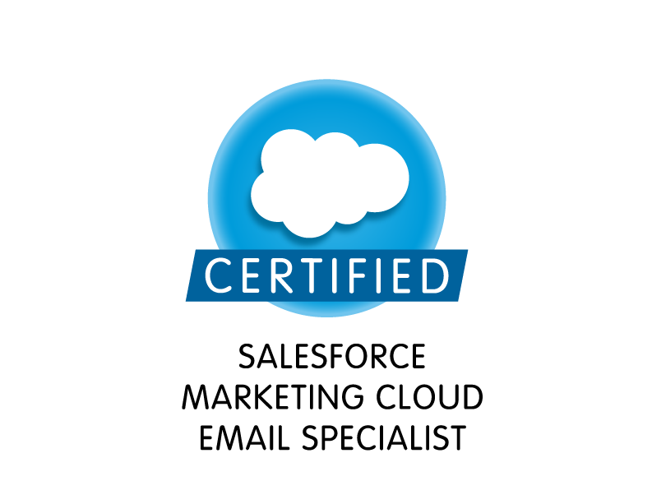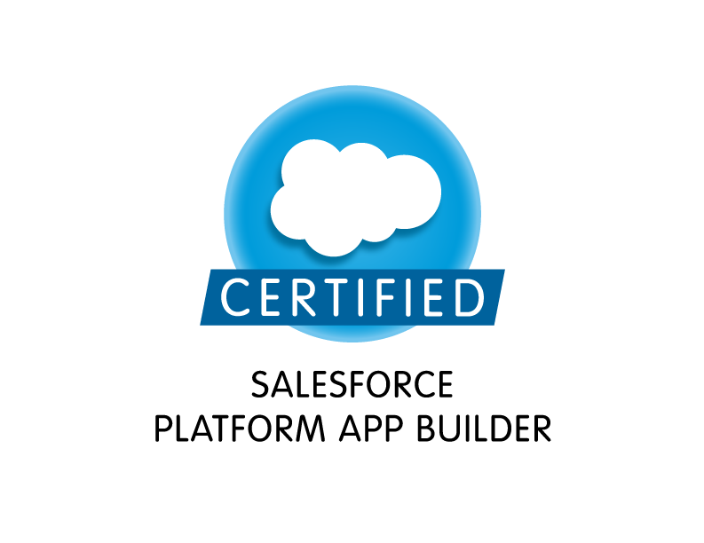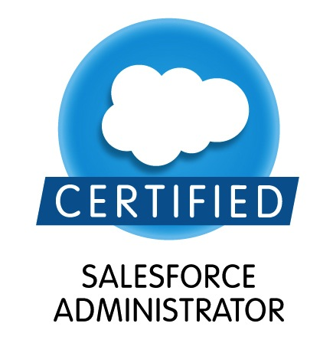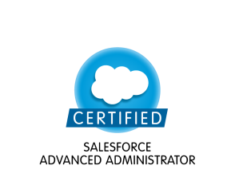

|  |  |
| --- | --- |
| **Divya Sahu**  [sahu.divya@outlook.com| +919403073925 |https://www.linkedin.com/in/divyasahu836972b](mailto:%20sahu.divya@outlook.com|%20+919403073925%20|https://www.linkedin.com/in/divyasahu836972b) |  |

**Professional Qualification**

* Salesforce Certified Marketing Cloud Email Specialist (SU16)
* Salesforce Certified Administrator (ADM 201)
* Salesforce Certified Advanced Administrator (ADM 211)
* Salesforce Certified Platform App Builder (SU15)

**Work Experience**

**Compucom Systems| Office Depot**

Duration: 22nd July 2019 Till Present

Designation: Marketing Cloud Developer

Project Name: Office Depot OfficeMax

**Roles & Responsibilities:**

* Developing and Maintaining large volumes of deadline-driven email campaigns using a Journey builder.
* Used SOQL for data manipulation needs of the application using synched database objects.
* Building Automations to make sure the quality control of the data flowing through different campaigns at required interval of time.
* Worked on creating the process for **CCPA** (California Consumer Privacy Act) for **Office Depot**.
* Integrated with Salesforce by using Marketing cloud connector.
* Coordinated with the business to understand the business and structure and resolve the issues.
* Handle all basic administrative functions including user account maintenance, reports and dashboards, routine tasks.
* Worked on AMP scripts while creating the Email templates.
* Worked on Lead creating process in Salesforce Using marketing cloud journey builder.
* Created Account, Data Extensions, Users, Roles under Administration Settings.
* Worked on Unit testing for the customizations and developments done during the project.
* Used AGILE methodology during all the phases of System Development Life Cycle (SDLC), and analysis artifacts such as use cases
* Worked on the knowledge article management.
* Working with product managers contributing to blueprints, and assisting with planning of feature sets that impact multiple platforms

**Accenture**

Duration: 24thDec 2018 To 19th July 2019

Designation: Application Development Senior Analyst

Project Name: Cardinal Health

**Roles & Responsibilities:**

* Working on end to end management of the territories for the product establishment in salesforce org.
* Handle all basic administrative functions including user account maintenance, reports and dashboards, workflows and other routine tasks.
* Coordinate the evaluation, scope and completion of new development requests.
* Work independently with members of the user community to define and document development requirements.
* Implemented pick lists, dependent pick lists, lookups, master detail relationships, and Record Types to enforce data quality Setup Marketing Campaigns, Assignment rules, Web-to-Lead and Auto-Response rules.
* Working on JIRA to complete the day to day task for the implementation.

**Symantec Software Solutions Private Limited**

Duration: 12thMarch 2018 to 17thDecember 2018

Designation: Salesforce Administrator (CRM Domain)

**Roles & Responsibilities:**

* 1st level SFDC Support that is handling email requests and resolve them.
* Responsible for analyzing market trends and building a business strategy in Coordination with Business Development team.
* Manage SFDC cases User Account set-up, support queries around discounting (NSP, DART), SymART (contracts), and data uploads that come from Renewals admin.
* Enabling SFDC sales users to use SFDC effectively.
* Support L3 with new releases of SFDC/IT and efficiently roll out new features.
* User provisioning of sales users.
* Maintain Approval matrix.
* Support and assist 2nd Level of support with analysis while escalating unresolved queries.
* Sales Coverage data management and Data Migration.
* Support project in providing mappings for the Rep to Territory file
* Opportunities ownership updates when the sales coverage model changes
* Work extensively with Sales Finance on issues or discrepancies in the coverage model
* Maintain fields, views, reports, dashboards, campaigns and other [salesforce.com](http://salesforce.com/) objects and functions.
* Running reports to enable reps to self-serve on opportunity cleanup and hygiene
* Support on usage of the quoting tool (BMI)
* Adding custom SKUs for reps
* Subject Matter Expert testing for User Acceptance Testing, representing EMEA on all SFDC interfacing tools. ( DART, SymART, BMI etc.,).

**Cognizant Technology Solutions**

Duration: 1st February 2016 – 6thMarch 2018

Designation: Salesforce Administrator (CRM Domain)

**1). Sales and Service Cloud**

Job Responsibilities:

* Primary job is to understand client’s Business requirements and provide apt solutions.
* Handling CRM Configuration issues, analyzing business requirements and building custom logic.
* Creating custom Apps, Objects, Tabs, Fields, Custom Field Relationships, Custom report types.
* Handled issues with Data Sharing, Data Security, Permissions and profiles.
* Supporting issues with Workflows, Approval Processes and Validation Rules.
* Supporting issues with Flow and Process Builder, Creating processes as per business requirement.
* Creating and Modifying Record types and Page Layouts.
* Handling issues related to Data Management such as Bulk Import, Export, Update and Delete Data.
* Creating Custom reports and Dashboards.
* Have an idea of Apex and Visual force.

**Environment**: Salesforce.com platform, Marketing Cloud, Data Loader, Workflow & Approvals, Reports, Custom Objects, Custom Tabs, Email Services Security Controls, Reports, Dashboards, Custom Objects.

**2). Marketing Cloud Email Specialist**

Job Responsibilities:

* Brief Knowledge about Email studio**,** Journey builder, Campaign Management, Social studio, Mobile push.
* Profound knowledge of Integration of Marketing cloud and Sales cloud.
* Work with triggered sends and automations.
* Creating Landing pages and web forms.
* Supporting issue related to Reply Mail Management, profile Centre, sender profile.
* **Handling complete Salesforce Marketing cloud deployment for clients.**
* **Main area of working includes: Account and business units set up, users, roles and permission, Building HTML email and templates, Trigger, Transactional email and triggers, Subscribers and Contacts segmentation, Automation set up and deployment, SQL Queries, Automation Studio, Journey set up and deployment, Journey Builder, Campaigns, Tracking and Reporting, Social Studio, Integration with Salesforce CRM, API build to get data in Salesforce marketing cloud data extensions etc.**
* **Help and Handling team of 10 members as an SME.**

**Environment**: Salesforce.com platform, Marketing Cloud, Job Explorer, App log, SQL query.

**SNG IT Solutions Pvt Limited**

Duration: 14thAugust 2014 – 25thJanuary 2016

Designation: Salesforce Administrator

**Roles & Responsibilities:**

* Support multiple client organizations through the Salesforce software and applications.
* Design CRM strategies by working closely in a team with colleagues and representatives from various clients.
* See projects through their entire life cycle and maintain contact with clients and superiors throughout the process.
* Deliver effective results to clients while working under a deadline, then analyze those systems for effectiveness after implementation.
* Worked for the integration of Sales cloud and Marketing cloud.
* Efficient in creating the workflows and process builder.
* Also provided KT for the integration part.

**Performance and Awards Achievement**

* Awarded as one of the “Top Performers” on the floor and awarded with the title of “Shining star” and “Spotlight award”.
* Created knowledge Base Article for Salesforce.
* Achieved required C-Sat, Quality & Closure targets consistently for 6 months.
* Working as a “Subject Matter Expert” in Marketing Cloud Team.

**Educational Background**

* Completed B.E in Information Technology from Oriental College of Technology in May 2014 with an aggregate of 82 %
* Developed Security system based on time coded access.