Karthik Deenadayalu
Karthik.deenadayalu@gmail.com
Ph-2105081986
Salesforce Technical Project/Program Manager

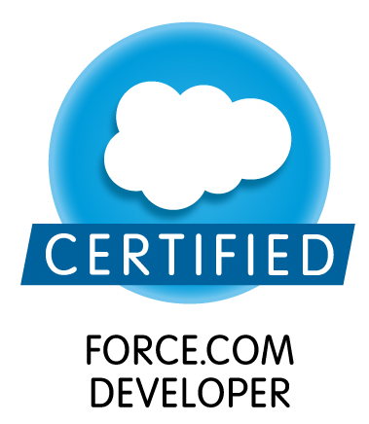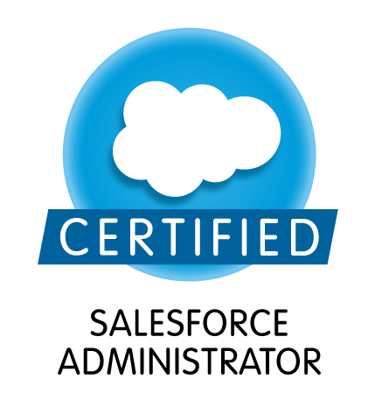
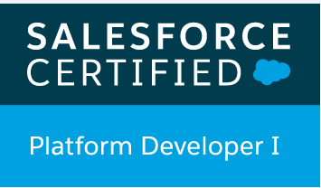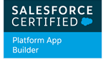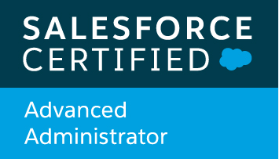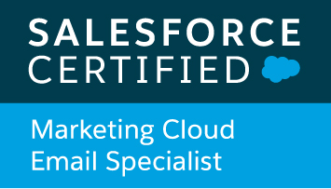

PROFESSIONAL SUMMARY:
- Manage the overall business partner relationship with a full understanding of business strategy, processes, goals and gaps and drive Salesforce product enhancements to fulfill business needs.
- Experienced in planning and executing projects using Agile methodologies.
- 8+ years of experience implementing Salesforce.com and 10+ years of IT experience.
- Salesforce.com Application Architect experience.
- Experienced in designing and implementing solutions by mapping customer’s business processes to Salesforce.com features like Sales cloud, Service cloud and Marketing Cloud.
- Experienced in Pre-sales activities such as RFPs, solution design & effort estimation.
- In-depth understanding of the capabilities and constraints of the SFDC CRM application coupled with good understanding of the business processes (Sales, Marketing, etc.)
- Solid understanding of and detailed experience with Salesforce.com architecture.
- Creating Salesforce product roadmap, maintain product backlog and drive prioritization with business partners.
- Managed escalations from external partners and internal business stakeholders to successful resolution.
- Collaborate with IS development team, QA and other Product Managers in the planning, design, development and deployment of projects & product enhancements.
- Keep abreast of new Salesforce.com and related applications features and functionality and provide recommendations for best use of the platform.
- Proactively identify and implement operational improvements, enhancements, and system customizations that meet business requirements
- Possess excellent written and verbal business communication skills to communicate and make executive level presentations to the organizational leadership.

IMPLEMENTATION & INTEGRATION EXPERTISE
- Implemented Sales Cloud
- Implemented Sales Console
- Implemented Community Cloud
- Implemented Marketing Cloud
- Implemented Marketing to run email campaigns and eliminate paper mailing.
- Integrated Enterprise systems with Salesforce using Salesforce Connect POC.
- Integration of Enterprise systems with Salesforce using Informatica Cloud POC.
- Callidus Cloud for commission POC in Progress
- Implemented Service Cloud
- Integration of Sales force Application to Learning Management System

SALESFORCE EDITIONS WORKED
- Unlimited
- Enterprise
- Developer
DOMAIN KNOWLEDGE
- Healthcare
- Banking
- Insurance
- Enterprise Corporate Business
- Digital marketing
- Sales and Service of Health care.
MANAGEMENT ACTIVITIES
- Salesforce Contract Management
- Working in tandem with Enterprise security norms with that of Salesforce security.
- New products part of Salesforce is reviewed and based on the need they are purchased.
- Coordinate with legal teams on either side and make sure all the legal requirements are met.
- License management and lead the governance committee
- Lead the release management team.
MEMBERSHIPS
- Active member with Salesforce Twin Cities user Group
- Active member with Salesforce Nebraska user Group
- Active member with Salesforce Developer Nebraska user Group
- Success Community Member
- Dream Force – 2016
- Destination Success -2017

TECHNICAL EXPERTISE

Languages: Apex, SOQL, Triggers, Lightening Component UNIX Scripting, Java (1.5), VB Scripting, PLSQL, Progress4GL.
Databases: Oracle, My SQL, DB2
Database Tools: Oracle SQL Developer, Squirrel SQL, MYSQL
IDE Tools: Salesforce, Eclipse, Unifi, Webi (Business Objects), SharePoint, Marketing Cloud
Version Control Tools: JIRA Cloud, Copado, JIRA,RTC, Dream Factory Snapshot, Salesforce Change Set.
Other Tools: MS Office, MS Visio.

Education

Master of Business Administration, Creighton University, Omaha, Nebraska, USA -2019
Bachelor of Engineering, Mechanical Engineering, Visveswaraiah University, Bangalore, India, 2008.

Experience Summary:
1yr of Technical Program Manager Experience (St Paul, Minnesota– United States of America).
3yrs of Program Manager Experience (Omaha, Nebraska/San Antonio, Texas – United States of America).
2yrs of Nearshore Technical Manager Experience (Guadalajara – Mexico)
4yrs of Offshore Developer/Technical lead Experience (Chennai India)

Certifications Completed
- Salesforce Certified Advanced Administrator
- Salesforce Certified Platform Developer I
- Salesforce Certified Platform App Builder
- Sales force Developer Certified- DEV401
- Salesforce Administrator Certified – ADM201
- Salesforce Certified Marketing Cloud Email Specialist
- Sun certified Java programmer – SCJP 1.5
- DB2- Family Fundamentals- Certified

PROJECT EXPERIENCE
Project Title: Salesforce Projects for Boston Scientific Corporation Sep 2017 – Till Date
Organization: Boston Scientific Corporation
Role: Salesforce Technical Program Manager
Project Description: Primary point of contact for implementing Projects for WATCHMAN Salesforce division.

Projects Implemented:
- Implementing Lightening version of Salesforce to WATCHMAN division and providing required training to users.
- Implemented Service cloud (Lightening version) and eliminated vendor call center application.
- Implemented Community cloud (Lightening Version) and eliminated vendor WMU who were maintaining count of procedures, implants and dashboards for partner organizations.
- Implemented Marketing cloud and eliminated the need of vendor organizations who were managing WATCHMAN division digital marketing efforts.
- Designed Marketing journeys targeting WATCHMAN patients. DTP effort (Direct to Patient)
- Designed Marketing journeys targeting WATCHMAN Implanters and Cardiologist who can refer patients to WATCHMAN product. DTR effort (Direct to Referrer).

Project Title: POC for Integration of Salesforce Individual Org and Group Org Sep 2016 – Aug 2017
Organization: Blue Cross Blue Shield of Nebraska
Role: Salesforce Program Manager
Project Description: Integration of Individual Salesforce org and Group Salesforce Org.

Responsibilities:
- Project aims at maintaining only one Salesforce Org for Blue cross and Blue shield of Nebraska.
- BCBSNE recently upgraded Individual Salesforce Org to unlimited edition and purchased extra security package – Salesforce Shield.
- Plan is to merge all the changes from Group Org to Individual Org.
- Impact analysis of the group components are analyzed.
- Triggers and apex classes are being analyzed to check all the code standards are followed and the test coverage is in place.
- Project plan and estimation is in progress.

Project Title: Integration of Salesforce with Formassembly Feb 2017 – May 2017
Organization: Blue Cross Blue Shield of Nebraska
Role: Salesforce Program Manager
Project Description: Renewal emails and survey were sent out electronically using Formassembly and Salesforce Integration

Responsibilities:
- Designed emails and survey templates in Formassembly and Salesforce.
- Connected Salesforce to Formassembly using the connector.
- Mapping of Salesforce fields with template fields, such that the response can be read directly in Salesforce.

Project Title: Informatica Cloud Connector POC Jan 2017 – March 2017
Organization: Blue Cross Blue Shield of Nebraska
Role: Salesforce Program Manager
Project Description: POC for Integration of Salesforce with other Enterprise systems using Informatica Cloud Connector

Responsibilities:
- Use cases for the Salesforce integration were documented.
- All the available tools and practices for the integration were reviewed.
- Informatica Cloud connector was selected for the POC as we at Blue Cross and Blue Shield of Nebraska use Informatica for our ETL practice.
- Trial version of Informatica Cloud Connector was signed on.
- Took a use case and connected Salesforce Sandbox to connect with enterprise database.
- Mapped all the required attributes and chose a schedule run to get the data flow.

Project Title: Small mod and enhancement work in Group Org August 2016 – Aug 2017
Organization : Blue Cross Blue Shield of Nebraska
Role: Salesforce Program Manager
Project Description: Small mod and enhancement work in Group Org.

Responsibilities:
- Small mod was implemented for adding Broker relations to Salesforce.
- Small mod was implemented for adding Case Install information to Salesforce.
- Small mod was implemented for adding Sold cases to Salesforce.
- Small mod was implemented for adding Group Renewal information to Salesforce.
- Several automated work flow rules and process and flows were designed part of the above efforts.

Project Title: Implementation of Sales Console May 2016 – Aug 2016
Organization: Blue Cross Blue Shield of Nebraska
Role: Salesforce Program Manager
Project Description: Sales Console is available for free from the Spring 16 release and it adds lot of values to the sales team.

Responsibilities:
- Project aims at enhancing Salesforce product to get the best results.
- Thorough Impact analysis of AS-IS system with the Sales console features.
- Implementing Sales Console in the Sandbox and execution of end to end testing with the help of actual sales agent.
- Documenting the all the best practices used to implement Sales Console.
- Training sessions conducted to the end users explaining the features of Sales Console.
- Rolling out the functionality in pilot mode, first with few users based on the feedback next set of users will get the access to Sales console.

Project Title: Implementation of Marketing Cloud 2016 Mar – 2017 Aug
Organization: Blue Cross Blue Shield of Nebraska
Role: Salesforce Program Manager
Project Description: Go paperless project was goal and notion was to eliminate the usage of papers and go digital.
Responsibilities:
- Analysis of the mails that go out of Blue Cross Blue shield of Nebraska.
- Understanding of each domain under which we send out mails i.e EOB, Billing and prospective mails.
- Cost that is spent on the mails that we send out and how go digital can help us cut down the cost.
- Started reviewing the applications in the market which can help to run the email campaigns, journeys as and when required by the organization and also track each campaign ROI.
- Determined Marketing cloud would be the best fit and started implementation with being a primary stake holder for the project and monitoring the project under each stage.
- We are building the product to our need, this will continue need by need basis.

Project Title: POC for Integrated Enterprise systems with Salesforce using Salesforce Connector 2016 Jan – 2016 June
Organization: Blue Cross Blue Shield of Nebraska
Role: Salesforce Program Manager
Project Description: Data feed to Sales cloud box were all manual upload, irrespective of new prospects added to the Salesforce system or existing member data used to service and sell new products.
Responsibilities:
- Identified the data hubs in the enterprise responsible for the primary data required by the CRM system.
- Requested a centralized data hub, which can collect all the date from different data hub’s from the enterprise perspective and house the collective data.
- Analyzed the direction or mode to integrate Salesforce with centralized data hub.
- Selected Salesforce connector over informatica to be more advantageous to integrate Salesforce to Centralized data hub.
- Implementation was carried out after thorough impact analysis and following the best practices applicable to both internal systems and Salesforce.
- Monitored the implementation during all phases of project.

Project Title: POC for Salesforce Broker Portal 2016 Feb – 2016 May
Organization: Blue Cross Blue Shield of Nebraska
Role: Salesforce Program Manager
Project Description: Broker and associated agency information that we do business were manually entered and data collected from the broker was also manually entered, which was causing duplication, also each individual data typed it all different, so we decided to implement a digital broker portal and choose “Vlocity”.
Responsibilities:
- Documented the process of capturing broker data, agency data and data collected from the broker on new business.
- Analyzed on number of duplication in the system and number of folks working on this exercise.
- Time consumption were measured and turnaround time for each RFP “Request for Proposal” were measured.
- Started reviewing products to meet our needs to implement the broker portal for our organization.
- Documented the best practices for implementation.
- Rolled out a plan for implementation and monitored the implementation during all phases of project.

Project Title: POC for Callidus Cloud Commission system 2016 Jan – March 2016
Organization: Blue Cross Blue Shield of Nebraska
Role: Salesforce Program Manager
Project Description: Primary goal of implementing Callidus Cloud was to eliminate the commission errors that were very frequent in the organization, which was done in the form of excel sheets and have the process automated.
Responsibilities:
- Commission payment process had to be understood.
- Number of folks that were paid commission individual and group data were collected.
- The loss ratio due to following excel format was presented to the higher management.
- Finally implemented a digital system which yielded more value to commissioning.

Project Title: Sales Cloud Implementation enhancement 2016 Jan – 2017 Sep
Organization: Blue Cross Blue Shield of Nebraska
Role: Salesforce Program Manager
Project Description: Setting up Sales cloud box and mapping out the business process to run a complete CRM.

Responsibilities:
- Understanding the business process, sales process and marketing strategy of the organization.
- Transforming business process into CRM language using Salesforce.
- DML definition with index and unique keys per object.
- Management of the entire implementation across all the phases of the project.
- Primary owner for the escalations during the project implementation.
- Responsible to make sure that team follows all the best practices defined for the implementation.

Project Title: Corporate Services Front Door Application 2014 Sep – 2015 Dec
Organization: USAA, United States of America.
Role: Salesforce Program Manager
Project Description:
As part of this project we developed Visual forces pages for the Front Door request, completely customized workflow design with multiple trigger point’s based on the status of the request.
Responsibilities:
- Managed all the phases of the project as a Program Manager with continuous tracking.
- Managed escalations from external partners and internal business stakeholders to successful resolution.
- Collaborate with IS development team, QA and other Product Managers in the planning, design, development and deployment of projects & product enhancements.
- Maintained product backlog and priorities for the project.

Project Title: Implementation of Service Cloud Application 2013 Mar – Aug 2014
Organization: USAA, United States of America
Role: Salesforce Program Manager
Project Description:
As part of this project we implemented Case Management, knowledge management, record types were used to display the Category, Sub-category, Topic and Sub-topic based on which the case would be initiated by the requestor.
With the help of the portal page, Case management system and Solution management system was available to the customers of USAA.
Responsibilities:
- Performed the roles of Salesforce.com Program Manager for this project.
- Manage the overall business partner relationship with a full understanding of business strategy, processes, goals and gaps and drive Salesforce product enhancements to fulfill business needs.
- Acted as a primary liaison between System Integrator, Engagement Manager and Project Manager.
- Maintained product backlog and priorities for the project.

Project Title: ITBETS Survey – Sales force Application 2012 April – 2013 Feb
Client: USAA, Guadalajara, Mexico
Role: Technical Project Manager
Project Description:
ITEBTS Survey Application, was the application developed to track the health of the complex tickets worked under the “IT Trouble Shooting team”, high priority tickets were randomly picked and a survey was posted on that particular ticket using this application, which would signify the timeliness and the accuracy of the solution provided, which in turn would provide the knowledge gap if any, majorly the application serves as an Audit repository.
Responsibilities:
- Performed the roles of Salesforce.com project manager.
- Involved in the design review and code review
- Managed and participated in all phases of the project, including Project Plans, Documentation, and Configuration.
- Responsible for making sure that developers followed the best practices for the Code development.
- Responsible to timely knowledge transfer to service tem after the roll out of project.

Project Title: Defects Scoring Tool – Sales force Application 2012 Jan –2012 March
Organization: USAA, Guadalajara, Mexico
Role: Technical Lead / Senior Developer
Project Description:
Scoring tool Application, will list down a set of questions to the analyst or triage team, to answer the same for a particular defect, based on which a score will be derived and based on the score the priority and severity is defined for the defect.
Responsibilities:
- Performed the roles of Salesforce.com Analyst/Developer and Administrator in the organization.
- Developed Apex Classes, Apex Triggers, Components, Visual force Pages and Controller classes for various functional needs in the application
- Created workflow approval, validation rules and formulas with Salesforce administrative tasks and creating reports, modifying data developing USE case scenarios.
- Customize Salesforce.com with custom fields, links, objects, page layouts, buttons, and record types, s-controls, to meet specific business requirements.

Project Title: Assessment Application – Sales force 2010 July – 2012 Jan
Organization: USAA, Chennai India
Role: Technical Lead / Senior Developer
Project Description:
There are about 15 verticals/domain and sub domains under which the IT trouble shooting/Support team work, and every quarter there is a new addition of resource, which requires training, these trainings where published to them in the form of quiz questions, which were developed in sales force. Trainee to take the quiz, results on the submission and suggestion for the topics to be concentrated in which the trainee has scored less and report generation.
Responsibilities:
- Performed detailed analysis of business and technical requirements and interacted with various business user groups for gathering the requirements for Salesforce implementation and documented the Business and Technical Requirements.
- Managed and participated in all phases of the project, including Project Plans, Documentation, and Configuration.
- Administering users in salesforce.com with focus on set up, profiles, roles and user management, Console Apps
- Implemented Apex Classes, Controller Classes, batch classes, schedulable classes, future methods, test classes and Apex Triggers for various functional needs in the application and linked them to manage the workflows implemented in the system.
- Refactored apex code to improve the performance and followed best practices using maps, taking out SOQL and DML in loops to avoid hitting governor limits.

Project Title: Geek/Week Meeting Minutes Application – Sales force 2010 Jan – 2010 June
Organization: USAA, Chennai India
Role: Technical Lead / Senior Developer
Project Description:
Geek/week Application was created to take notes from major project kick off meetings, this application would track the
Key players of the project, i.e Project Manager, Business Manager, Tech lead, Test Lead and Analyst, also the key points of conversation, scope of the project in brief and budget allocated.
Responsibilities:
- Involved in requirement gathering sessions.
- Preparation of design documents, functional specification documents, technical specification documents, use case diagrams, activity diagrams and implementation plans.
- Construction of the functionality.
- Unit testing using Test class (Salesforce).
- Report generation.

Project Title: Loan Origination System Phase2, Compliance Mortgage 2009 July – 2009 Dec
Organization: USAA, Chennai India
Role: Senior Developer/Module Lead
Project Description
Loan origination system (LOS-Unifi) is the Mortgage loan origination system, that our client’s uses, which deals with origination, processing, funding, closing, and secondarymarketting and closing.LOS system required various customization as part of business needs and also Compliance needs by the federal law, which were implemented part of this project.
Responsibilities:
- Analysis and creation of Design documents for various components involved.
- High level and low level design of Application flows.
- Integration with the Vendor inTernthinx.
- Working On Production Defects and Outages.

Project Title: Loan Origination System Phase I 2008 Dec – 2009 June
Organization: USAA, Chennai India
Role: Developer
Project Description
Loan origination system (LOS-Unifi) is the Mortgage loan origination system, that our client’s uses, which deals with origination, processing, funding, closing, and secondarymarketting and closing.LOS system required various customization as part of business needs and also Compliance needs by the federal law, which were implemented part of this project.
Responsibilities:
- Interaction and meetings with Business Managers to gather system requirements
- Analysis and creation of Design documents for various components involved.
- Documentation of requirements, preparation of design documents, functional specification documents, technical specification documents, use case diagrams, activity diagrams and implementation plans
- Nearshore-Offshore-Onsite co-ordination.

