**VENKATA RAMI REDDY CHILUKURI**

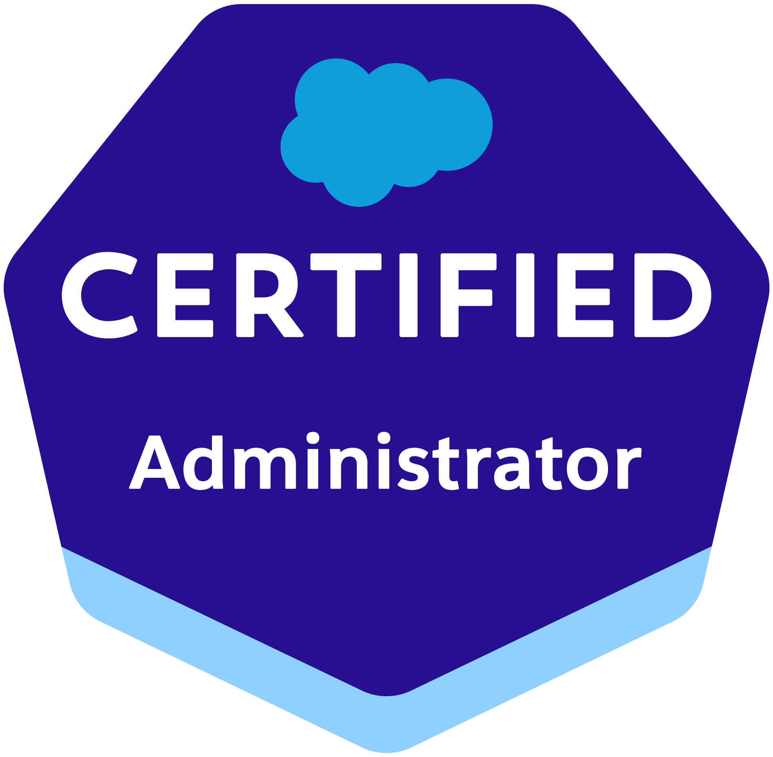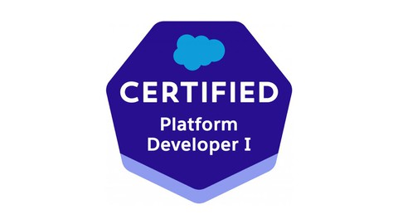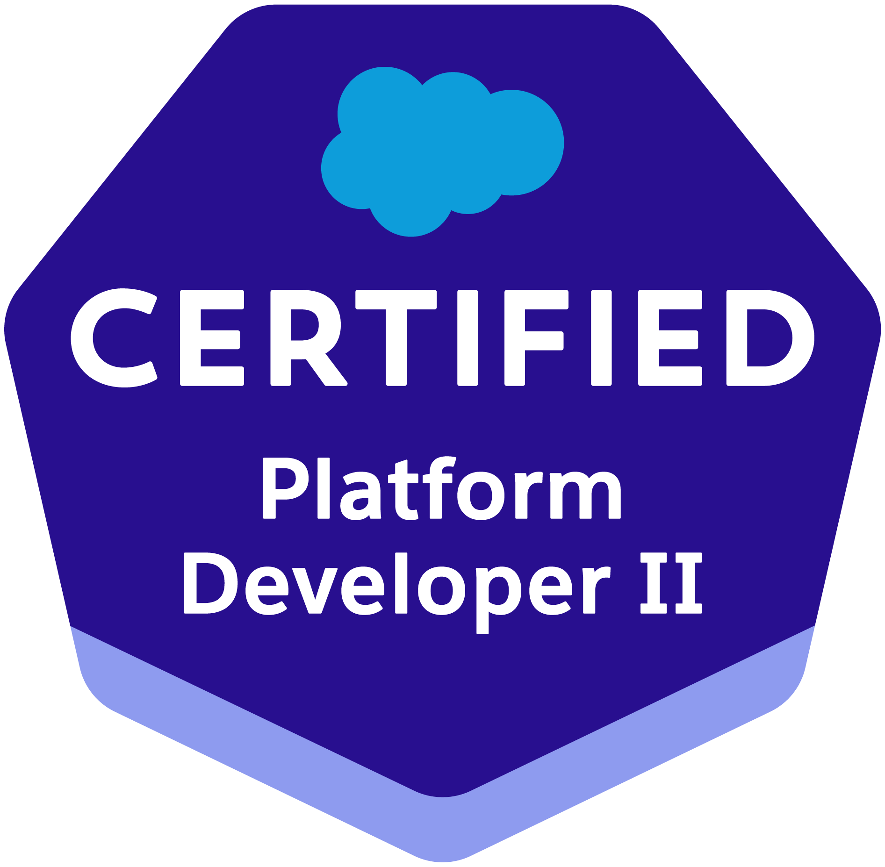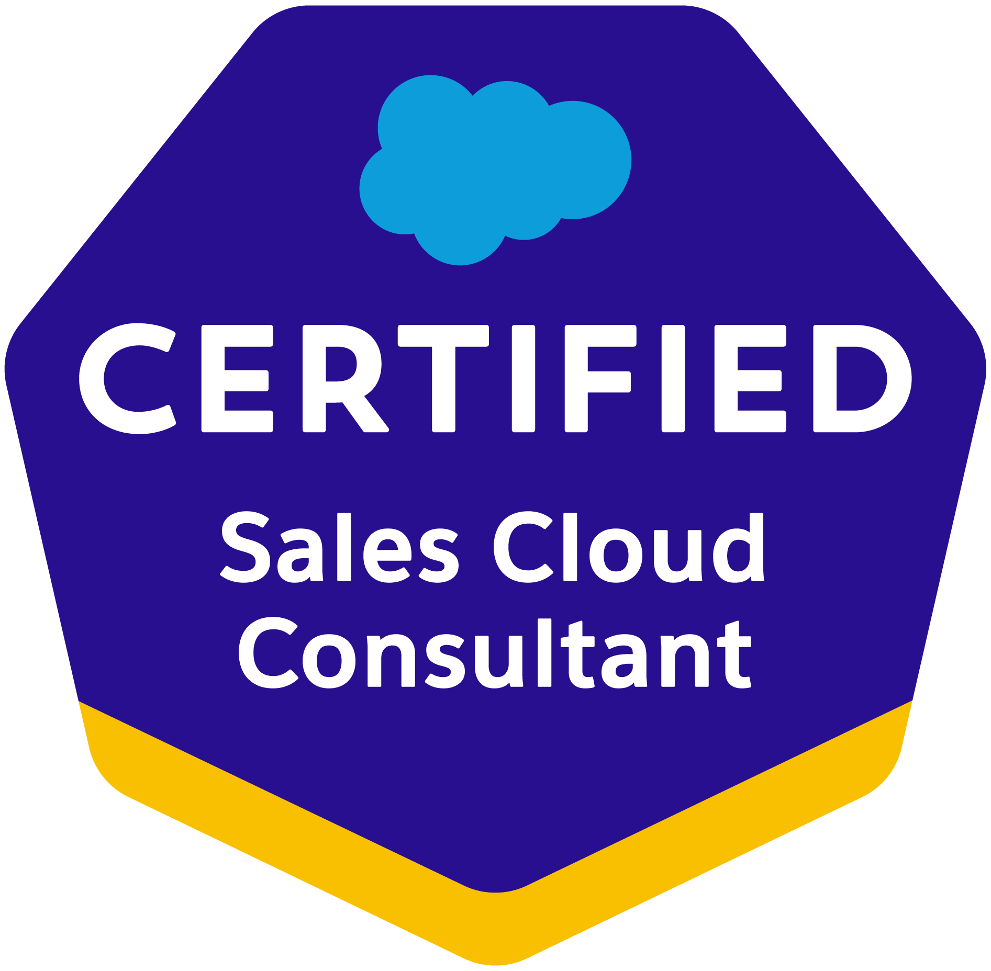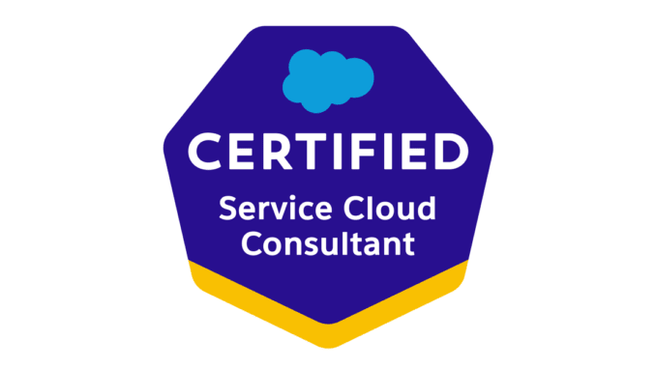

***(Salesforce Developer)***

**Email:** Chilukuriv9@gmail.com

**Phone:** (802-289-8183)

**PROFESSIONAL SUMMARY:**

* Certified 9+ years Salesforce developer with 5 years of experience in Salesforce.com CRM platform using administration, development, integration, deployment, communities, lightning component development, lightning design system and classic to lightning migration. And 4years of experience in JAVA/J2EE.
* Experience in Administration, Configuration, Implementation, Lightning, and support experience with the Salesforce platform.
* Experience in SFDC development using Apex classes and Triggers, Visual Force, S-Controls, Force.com IDE, SOQL, SOSL.
* Experience in Salesforce Customization, Security Access, Workflow Approvals, Data Validation, data utilities, Analytics, sales, Marketing, Customer Service, and Support Administration.
* Hands on experience in building apex triggers, apex classes, batch apex, scheduled apex, future methods, and queue able interface.
* Expertise in SFDC Development using Lightning Application, Apex Language, Visual Force Pages, Classes, Controllers, Triggers, Indexes, Locks Web Services, Components, Tabs, Apex Web services, Custom Objects, Reports, Analytic Snapshots and Dashboards, Profiles, Creating Roles, Page Layouts, Org - Wide default, Sharing rules, Workflows.
* Implemented Salesforce Lightning Web Components for a small set of users within the organization.
* Tested apps by appending multiple Lightning Web components to a Lightning Application thereby deploying Applications from Sandbox to Production.
* Created many Salesforce Lightning Web Components and server-side controllers to meet the business requirements.
* Experienced in migrating the standard and custom objects in standard experience to lightning experience.
* Created multiple Lightning Web Components and added CSS and Design Parameters that make the Lightning component look and feel better. Leveraged APEX Controller to make a call for external requests to retrieve data from various APIs and displayed them on to the component.
* Worked on both lightning frameworks Aura and LWC.
* Developed re-usable Salesforce Aura Lightning components.
* Worked on aura framework to define a method as part of a component’s API.
* Worked on aura method simplifies the code needed for a parent component to call a method on a child component that it contains.
* Worked on Migrating from Salesforce Classic to Lightning Experience for some users in the organization.
* Experience in building Lightning Components, Lightning Events, using Lightning Base Components, Lightning UI components, and Aura Framework.
* Experience in Apttus CPQ Configuration and involved in quoting and pricing, order management, product configuration.
* Created Custom objects for Quote and Quote lines and captured quote information for CPQ
* Worked with client-side developers and business analysts in developing configuration models in the CPQ workflow.
* Experience with Apttus CPQ for subscription, billing, invoicing and can take control of sales process from Quote to Cash. Generated Revenue recognition status automatically with Apttus CPQ.
* Experience on Salesforce CRM platform Worked on different environment of SFDC such as Sales Cloud, Marketing Cloud and Service Cloud.
* Involved in end to end QA and UAT testing and validation of CPQ including Products, Pricing, and Quoting etc.
* Customization of Apttus product by using Salesforce features like triggers, VF pages.
* Used data migration tools such as Apex Data Loader, Salesforce Import and Export Wizard, and Force.com Migration tool.
* Proficient with Sales Cloud, sales, web service, Rest-API, Soap-API, Force.com App-exchange packages, and Salesforce Metadata-API, Partner WSDL &Salesforce Enterprise WSDL.
* Involved in defect resolution as part of QA testing, and UAT testing and involved in resolving production issues, and did post-implementation support.
* Have good experience in Trigger, Test Methods, and writing SOQL and SOSL queries.
* Involved in handling the lower-level environments and deployments using Jenkins and Git Lab as code
* repository
* Expertise in developing and implementing automation process using Jenkins pipeline scripts.
* Created and maintain fully automated CI/CD pipelines for salesforce code deployment using Jenkins groovy, Gitlab, yml and gi tops automated code promotion.
* Participated in all stages of Software Development Life Cycle (SDFC) i.e., System Analysis, Design, Development, and Testing Expertise.
* Experience in using Data Loader for insert, update and bulk import or export of data from Salesforce.com Objects.

**EDUCATION:**

* Bachelor of Science in Acharya Nagarjuna University, India,2010.
* Master’s in Business Analytics from University of North Texas, 2012.

**CERTFICATIONS:**

* Certified Salesforce Administrator
* Certified Salesforce Platform Developer- I
* Certified Salesforce Platform Developer- II
* Salesforce Certified Sales Cloud Consultant
* Salesforce Certified Service Cloud Consultant

**TECHNICAL SKILLS:**

|  |  |
| --- | --- |
| **Salesforce CRM** | Apex Language (Classes, Trigger, Batch, Schedule), SOQL & SOSL Language, Visualforce Pages, Components, Sales, Service, Ant based Force.com Migration Tool, Workflow rules, Approval Process, Profiles, Permission Sets, Role Hierarchy, Validation Rules, Custom objects, Relationships, Page Layouts, Search Layouts, Record Types, Reports, Dashboards, lightning, lightning Components, lightning design systems, Web Services (Rest, Soap), Jitter bit, |
| **Force.com Tools** | Developer Console, Force.com IDE, Visual Studio. Force.com Explorer, Workbench, Data Loader, Eclipse. |
| **Web Technologies** | JavaScript, jQuery, XML, XSL, HTML, XHTML, CSS, AJAX. |
| **Databases** | Oracle 10g/9i, SQL Server 2008/05/2000, MYSQL, DB2. |
| **Versioning** | Git, SVN, Bit bucket |
| **Programming Languages** | C/C++, Java, J2EE, JDBC, JSP/Servlets, Struts, PL/SQL, Apex. |
| **Web/Application Servers** | Apache, Tomcat 5.0, JBoss, WebLogic, IBM Web Sphere, IIS. |
| **Operating Systems** | Windows 8/7/XP/2000/NT, Red Hat Linux 7.x/9.0, Unix. |

**WORK EXPERIENCE:**

**Client: CGI Technology and Solutions, Sacramento, CA. |Aug 2021 to till now**

**Role: Salesforce Lightning Developer**

**Responsibilities:**

* Optimizing and enhancing Salesforce CRM platform, process clean up like consolidating works to process builder and flows, decommissioning workflows, apex classes, executing SOQL for data validation.
* Developed **Apex Classes**, Controller Classes, and Apex **Triggers** on **Force.com** for various functional needs in the application and experienced in creating lighting pages inside lighting Community builder.
* Develop Apex triggers, apex classes, batch apex and schedule apex to automate the business processes.
* Leading and single-handed migrating Salesforce Classic to Lightning user interface.
* Designing, and developing pick lists, dependent picklists, lookups, look up filters, master detail relationships, validation rules, roll up summary field and formula fields on custom objects
* Customizing objects, tabs, page layouts, field and record level and field level security, permission set, sharing rules
* Streamlining the approval process across multiple organization’s department likes claims, packaging, damages
* Engaging with the business executives and stakeholders to gather business and user requirements
* Generating custom reports, dashboards, and analytic snapshot for different line of business on Standard and Custom objects and implemented Dashboards specific to user’s department and profiles
* Setting up customer portals and communities and administrating and creating custom dashboards for community managers
* Writing data validation rules and formulas as per business requirement and creating workflow rules to automate tasks, email alerts, field updates and time-dependent actions
* Developed, implemented, and maintaining multiple Lightning and Classic apps for various line of business and configured Salesforce mobile app for customers and partners.
* Created multiple Lightning Web Components, added CSS and Design Parameters from LDS (Lightning Design System) that makes the Lightning component look and feel better.
* Experience in Force.com Apex Classes, Apex triggers Integration, Visualforce, and Force.com API. Development using custom lightning web components (Aura and LWC).
* Configured and implemented 3 customer community and 2 partner community portals for vendors and business partner organization
* Closely worked with Salesforce.com consultants for implementing the business solutions for their client requirements, using APPTUS CPQ within the exclusively developed framework.
* Involved in CPQ (Configure, Price& Quote) design, mapped to the Salesforce custom objects, and involved in Apttus Advanced Workflow Approvals.
* Executed workbench and data loader to verify Product/Pricing staging data in SFDC/CPQ.
* Developed Asynchronous process such as batch apex and future methods to handle volume and governor limits.
* Maintaining Production and Sandbox with regular updated, back up in Salesforce DX using VS Code
* Implemented custom my domain and multifactor authentication for data security, and Salesforce-Gmail integration
* Creating technical and functional documents training videos and user manuals for users, hosted in google classroom as per organization’s standards for existing and new on-boarding users
* Updating Salesforce.com from QAD ERP with Items, Item Price, Invoice History and Claims in Quick Sense.
* Integrated the **SOAP and REST** based **Web Services** for extracting the data from external systems to display in the pages of salesforce.com.
* Created **REST API** using **RAML** and developed flows using **APIKIT Router**.

**Environment:** Salesforce.com Platform, Aura, Lightning Experience, Lightning Web Components, Apex classes and Controllers, Data Loader, REST, SOQL, SOSL, Scrum, Sales Cloud, Service Cloud, Asynchronous process, Custom objects, Custom fields, Web Services, Oracle, SOAP and REST, Visual Studio, Change Sets, Windows

**Client: Union Bank, San Diego, CA. | Mar 2020 to Jul 2021**

**Role: Salesforce Developer**

**Responsibilities:**

* Created page layouts, search layouts to organize fields, custom links, related lists, and other components on record pages.
* Used APEX coding techniques to develop custom visual force pages along with Apex Classes for the business requirements.
* Developed APEX Triggers to support complex business process and Custom Buttons.
* Developed visual force page with apex controller, batch apex, Triggers and Schedule apex.
* Created multiple Lightning Web Components, added CSS and Design Parameters from LDS (Lightning Design System) that makes the Lightning web component look and feel better.
* Built customized Lightning web components replacing the existing ones, using JavaScript on the client side and Apex on the server side.
* Enabled Aura Framework, by adding Aura Attributes and Aura Handlers for Events to focus on Logic and Interactions in Lightning Applications.
* Configure security to grant/limit access to users (Sharing Settings, Profiles, Permission sets)
* Code review for best practices and to avoid potential errors
* Work with business users to understand requirements
* I configured product and pricing setup using CPQ/Product consoles, which include price ramps, Price Matrix, Price Rulesets, price list items, tiered pricing, and asset pricing.
* Involved in CPQ (Configure, Price& Quote) design, mapped to the Salesforce custom objects, and involved in Apttus Advanced Workflow Approvals.
* Created CPQ process using Apttus CPQ and CLM AppExchange tool in Quote.
* Strong understanding of Salesforce standard objects and Apttus CPQ application.
* Involved in end-to-end testing and configuration enhancements for the CPQ and CLM functionalities.
* Created integration with Apttus CPQ and CLM applications and automating processes on Salesforce platform.
* Familiar with Steel Brick CPQ for subscription, billing, invoicing and can take control of sales process from Quote to Cash.
* Generated Revenue recognition status automatically with Steel Brick CPQ.
* Efficient in monitoring apex asynchronous processing using future methods, batch apex, controlling process with queueable apex and scheduling jobs using apex scheduler.
* Used SOQL & SOSL for data manipulation needs of the application using platform database objects.
* Implemented Salesforce Development Cycle covering Sales Cloud, Service Cloud, Call Center, Chatter & App-exchange applications Design tech solution and lead team to implement/develop applications
* Work with integration team to develop web services to exchange data between Salesforce and external systems like SAP/BizTalk/etc.
* Created SOAP API and REST API based service interfaces using Mule ESB Any Point Platform and delivered fast, reliable, and scalable integration API codes.
* Worked with Jira/Bitbucket for agile development and source control management.

**Environment:** Saleforce.com platform, Lighting, LWC, Sales Cloud, Service Cloud, Apttus CPQ, SOQL & SOSL, Batch apex, Schedule apex, Data Loader, HTML, Java Script, Workflow & Approvals, Reports, Custom Objects, Custom Tabs, asynchronous processing, Email Services, SOAP API, and REST API, Security Controls, Apex language, Visual Force, Bit Bucket, Jira,

**Client: Bright system, Indianapolis. | Nov 2018 to Feb 2020**

**Role: Salesforces Developer**

**Responsibilities:**

* Interacted with Salesforce.com premium tech support team on a regular basis.
* Worked on creating and maintaining various support cases and business processes on SFDC Chatter Plus.
* Interacted with various business user groups for gathering the requirements for salesforce.com CRM implementation.
* Worked with various salesforce.com Objects like Accounts, Contacts, Leads, Campaigns, Reports, and Dashboards.
* Designed and mapped CPQ objects to Salesforce custom objects and involved in Advanced Workflow Approvals.
* Functioned as an SME for the salesforce CPQ customization.
* Worked with native Salesforce quote to cash functionality such as Opportunities, Products, Price books, Quotes, Orders, and contracts.
* Coordinated with Legal, Business Operations, Orders and Finance teams to execute customer agreements, process purchase orders and renewal opportunities.
* Developed workflow rules and defined related tasks, time triggered tasks, email alerts, field updates to implement business logic.
* Worked with Sales and Marketing teams to understand the business process to elicit requirements for the

Salesforce customization.

* Integrated CPQ system with multiple CRMs like Salesforce and CRM On Demand.
* Supported and improved sales cycles by implementing CPQ solutions effectively.
* Involved in end-to-end QA and UAT testing and validation of CPQ including Products, Pricing, Quoting etc.
* Customization of Apttus product by using Salesforce features like triggers, VF pages.
* Design, develop and implement solutions for the Apttus CPQ system deployed on the Salesforce platform.
* Developed Quote documents using X-Author for word, also developed customized login screen for community user and functionality to redirect users from Salesforce to Apttus CPQ Quote creation using APTTUS API's, apex, VF pages and trigger.
* Managed salesforce application user profiles, roles, permissions, generating security tokens, validation rules.
* Developed test scripts and performed UAT testing and documented the same in JIRA.
* Developed Workflow Rules, Time-Dependent Workflow Actions, Email Alerts and Field Updates.
* Developed client-specific solutions on Force.com platform using Apex, Visual Force, Process Builder and Visual Flows.
* Integrated the **SOAP and REST** based **Web Services** for extracting the data from external systems to display in the pages of salesforce.com.
* Worked with Data loader for loading attachments into salesforce.com, related to Objects like Accounts, Contacts, Opportunities, and Activities.
* Created and maintained User Roles, Security, and Profiles that was required for Salesforce Knowledge implementation.
* Implemented and Consumed Knowledge Base Dashboards & Reports App Exchange for providing Reports and Dashboards that monitors Knowledge Base.
* Managed and implements customization requests by Business Users, including creating workflow triggers, workflow alerts, and automated email response.

**Environment:** Saleforce.com platform, Apex Language, CPQ, Visual Force (Pages, Component & Controllers), Pages, Data Loader, S-Controls, HTML, Java Script, Apex Triggers, Steel Brick, Web Services, Reports, Custom Objects, Custom Tabs, Email Services, Security Controls, Sandbox data loading, SOAP and REST.

**Client: Tableau, Seattle, USA. | Jul 2017 to Oct 2018**

**Role: Salesforce Admin**

**Responsibilities:**

* Developed Business Dashboards, Metrics and reports for management review and operational efficiency.
* Developed fields and page layout customization for the standard objects like Account, contact, Leads.
* Maintained security and permissions with sharing rules and sharing settings, roles, and Profiles.
* Worked on Record Types, Validation Rules, and Page Layouts.
* Developed various Custom Objects, Tabs, and relationships.
* Created approval processes and validation rules.
* Closely worked with other consultants while implementing the solutions for the requirements to ensure customer satisfaction and improve processes.
* Created sales processes and record types for new business lines.
* Handled on-going customization/alteration to processes that impact Salesforce org and related business systems (ERP, Call Center, Calendars)
* Worked with cross-functional stakeholders to clarify requirements, demo changes, and answer questions about system and improvements
* Managed multiple simultaneous projects and project-related tasks on time within an Agile development process Mentored junior members on the team.

**Environment:** Salesforce.com, Force.com, Apex Classes, Apex Triggers, Apex Controllers, Visualforce Pages, Eclipse, SOQL, SOSL, Service Cloud, Sales Cloud, Chatter, Data Loader, Data Migration, Page layouts, Roles, Custom Objects, Pick lists, Email alerts, Oracle, and Windows.

**Client: Hyundai, Fountain Valley, CA. | Mar 2015 to Jun 2017**

**Role: Java Developer**

**Responsibilities:**

* Involved in various activities of the project, like information gathering, analyzing the information, documenting the functional and non-functional requirements.
* Presented designs and concepts to Clients and the Management for review.
* Performed the validation and testing of the completed websites.
* Responsible for web hosting and the installation of e-mails and forms.
* Developed Message Driven Bean components in Web sphere MQ Series to manage the backend transactions and e-mailing (using JMS and IMAP).
* Developed beans for business logic and utility packs mapping database entities.
* Involved in analysis, design, development, and maintenance.
* Developed Session/Entity Beans and deployed on Web Sphere Application Server.
* Involved in writing SQL queries and stored procedures.
* Configured deployment descriptor specifying data environment.
* Documented, prepared help files, user guide and trained end users.

**Environment:** Core Java, J2EE, Servlets, JSP, JDBC, HTML, DHTML, AJAX, JavaScript, CSS, Single Pattern, Java Beans, JSTL, UML.

**Client: Ameriprise Financial Inc., Minneapolis, MN | Apr 2013 to Feb 2015**

**Role: Java Developer**

**Responsibilities:**

* Analyzed the business requirement and developed an app using Java and Mozilla XUL.
* Involved in development using spring, Hibernate and JSF Framework. Used ANT script for project deployment.
* Use case, design – class, sequence diagrams. User Interface design
* Data Modeling – logical and physical models
* Requirements gathering- Proto-typing, Walk-through to business groups and gap analysis
* Understand the business aspect of the application and convert it into requirements documents.
* Create POC for first time patterns and vendor integrations.
* Code review with the developers and delivery team
* Coordinate and manage Global Delivery teams at offshore locations.
* Schedule and organize weekly or daily stand-up meeting with the whole development teams both onshore and offshore.
* Develop Functional Requirements Specification (FRS)

**Environment:** Java, JSP, Servlets, HTML, JDBC, JDK, Waterfall Model, Tomcat, Windows XP.