SAI GOWTHAM 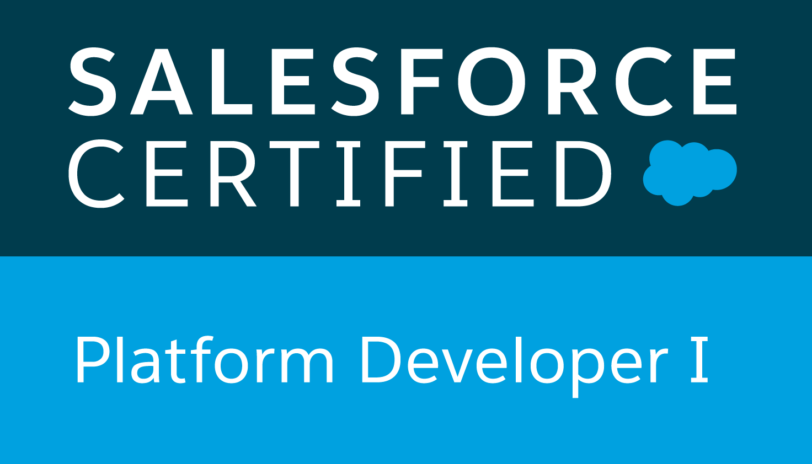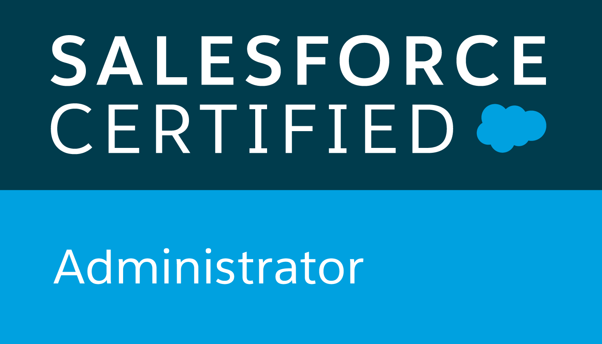
Email:saigowtham281@gmail.com
Certified Salesforce Developer/ Administrator
Ph#: (516) 828-2743
PROFESSIONAL SUMMARY:

- 9+ years of work experience with 7+ years of experience focused on Salesforce.com CRM platform and 2+ years on JAVA/J2EE.
- Experience working on various phases of Salesforce software development life cycle (SDLC) and project life cycle processes from analysis, design, development, testing, implementation and maintenance of standalone object-oriented enterprise applications.
- Experience with Salesforce implementation, design, configuration and customization. Worked on security access, workflow approvals, data validation, data utilities, analytics, sales, marketing, customer service and support administration in Salesforce.com CRM and Force.com Platform.
- Experience in Force.com Apex classes, Apex triggers, Visual force, Batch apex, Integration, REST, SOAP based Web Services, Force.com API, SOQL and SOSL, Salesforce App Exchange, JAVA and C# on demand.
- Hands on experience with Salesforce Lightning Builder and Salesforce lightning components. Worked on Process Builder, Lightning Flows and Workflow Rules for automation of business processes.
- Extensive business knowledge and customization experience on various Salesforce.com standard objects like Accounts, Contacts, Opportunities, Products and Price books, Cases, Leads, Campaigns, Forecasting, Reports and Dashboards.
- Experience in web technologies like HTML, XML, CSS, AngularJS, JavaScript, and SOAP API.
- Implemented security and sharing rules at object, field, and record level for different users at different levels of organization.
- Experience managing complex data and worked on integrating app exchange applications with Salesforce, Informatica on demand. Provided support for mass E-Mail Management, application management using Force.com Plug-in Eclipse IDE in Sandbox and production environments.
- Worked with different aspects of Web Services (S3, EC2, XML, WSDL, BULK API, SOAP API, REST API, SSI, AJAX) & web integration with SDFC.
- Expert in data migration from various systems into Salesforce CRM using ETL tools – Informatica Demand. Worked with Cast Iron (CI) to synchronize data between Sales.com and web service endpoints, Data Junction (Pervasive), Excel connector and DQC.
- In depth knowledge in CRM features and modules like Forecasting, Campaign management, Lead Management, Order Management, Account Management, Case Management (Email-to-Case and Web-to-Case).
- Good understanding of Salesforce.com Governor limits with an ability to optimize code to respect those limits. Strong Agile Methodology, Scrum Framework Experience.
- Customer centric with effective interpersonal, organizational and problem-solving skill.

PROFESSIONAL CERTIFICATIONS

- SALESFORCE.COM CERTIFIED ADMINISTRATOR (ADM 201)
- SALESFORCE.COM CERTIFIED PLATFORM DEVELOPER 1

TECHNICAL SKILLS

Salesforce Technologies | Custom Objects, Roles and Profiles, Workflows, Process Builders, Flows, Assignments, Approvals, Triggers, Record Type, Dashboard, Security, Field updates, reports, Visual Force Pages, Apex Classes, Apex Trigger, Salesforce Lightning (Components, Apps, Events).
Force.com Tools | Force.com Eclipse IDE, Force.com Apex Explorer, Single Sign-On (SSO), SOQL, SOSL, Service Cloud, Marketing cloud, Sales Cloud, Salesforce APIs.
Data Tools | Apex data loader, Excel connector, Import wizard, SFDC Data export.
Languages | Apex, Java, SQL, jQuery, C, C++, C# &.NET, R, SAS, Python.
Web Technologies | HTML, CSS, XML, JavaScript.
Java Technologies | JDK, J2EE, JSP, Servlets

PROFESSIONAL EXPERIENCE

Client: Alius Group, New York City, New York
Role: Salesforce Lightning Developer Jan, 2018 - Till Date

Description: Alius Group is a financial consulting firm which is focused on assessing and managing risks to achieve sustainable regulatory compliance for every client.

Responsibilities:
- Involved in various stages of Software Development Life Cycle (SDLC) including analysis, requirement engineering, architecture design, development, enhancements, testing.
- Developed various Visualforce Pages, Apex Triggers to include extra functionality and wrote Apex Classes and Controller to provide functionality to the visual pages.
- Designed and deployed Custom Tabs, Validation Rules, Approval Processes and Auto-Response Rules for automating business logic.
- Created Custom Objects and fields for transactional and contractual information.
- Designed, developed and deployed Apex Classes, Controller Classes and Apex Triggers for various functional needs in the application.
- Created Pick lists, dependent picklists, lookups, master detail relationships, validation and formula fields to custom objects.
- Created templates, approval page layouts and defined approval actions on them to automate the processes.
- Developed Custom Lightning Components using Standard Lightning Components, built Lightning Apps using Lightning App Builder and Lightning Pages using Lightning framework, aura framework and Lightning Locker Service.
- Created page layouts, search layouts to organize fields, custom links, related lists and other components on a record detail and edit pages. Created workflow rules and defined related tasks, time triggered tasks, email alerts, filed updates to implement business logic.
- Developed Apex Classes, Controller Classes and Apex Triggers for various functional needs in the application.
- Configured product and pricing setup using CPQ/Product consoles Formatted and migrated the user data into Lightning Experience.
- Created various reports (summary reports, matrix reports, pie charts, dashboards and graphics) and report folders to assist managers to better utilize Salesforce as a sales tool and configured various reports and for different user profiles based on the need in the organization.
- Developed Lightning apps using Lightning Components, testing and made them compatible with Salesforce1 mobile app.
- Retrieved some data and its functionality from Third-Party API's and displayed within the lightning component.
- Used Lightning framework to integrate with legacy systems like SAP, Microsoft and oracle
- Used SOQL & SOSL for data manipulation needs of the application using platform database objects.
- Used Force.com developer toolkit including Apex Classes, Apex Triggers and Visualforce pages to develop custom business logic.
- Created custom dashboards for the manager's home page and gave accessibility to dashboards for authorized people. Used Data loader to load the records on to the force.com platform.
- Made new feature enhancements on Service cloud console view and developed some Visual force components.
- Implemented Salesforce Development Cycle covering Sales Cloud, Service Cloud, Marketing Cloud, Call Center, Chatter & App-exchange applications.
- Performed Data Migration from home grown legacy system to Salesforce CRM.
- Extracted the data from Salesforce.com application into the external databases for generating large data reports using the Informatica on Demand.
- Implemented data migration using Informatica on demand and data loading using Data loader, import wizard.
- Experienced in Unit Testing, for the customizations and developments done during the project.
- Used sandbox for testing and migrated the code to the deployment instance after testing.
- Involved in the Data Transformation and Data Cleaning activities while transferring the data to the external system using Informatica on demand.
- Involved with Salesforce.com Premier Support and handled the support cases with the help of Salesforce.com support.

Environment: Salesforce.com, Force.com, Data Loader, Apex Classes, Controllers, Triggers, Visualforce, Sales Cloud, Marketing Cloud, Service Cloud, Data Migration, Rest API, Soap API, Informatica, SOQL, SOSL, Workflow & Approvals, Java Ant, Custom Reports, Dashboards, Oracle, Windows.

Client: Con Edison, New York City, New York
Role: Salesforce Lightning Developer Feb 2016 - Dec 2017

Description: Con Edison is one of the largest energies generating systems which provides electricity for New York City and Westchester County.
Responsibilities:

- Interacted with various business user groups for gathering the requirements for Salesforce implementation and documented the Business and Software Requirements.
- Developed Apex Classes, Controller Classes and Apex Triggers for various functional needs in the application.
- Worked on Force.com developer toolkit including Apex Classes, Apex Triggers & Visualforce Pages to develop custom Business Logic. Implemented Salesforce.com platform and Force.com IDE Plug-in using Eclipse.
- Migrated data from external sources and performed Insert, Delete, Upsert & Export operations on millions of records. Designed and developed Service cloud and Integration.
- Customized User Roles, Role Hierarchies, Profiles and Sharing settings to ensure that the protected data is available only to the authorized users.
- Created Templates, Approval Processes, Approval Page Layouts and defined Approval Actions on them to automate the processes. Created Workflow Rules and defined Related Tasks, Email Alerts and Field Updates.
- Designed and developed SFA based Application on Force.com platform in Salesforce.com environment with Apex programming language as backend and Visualforce Pages as user interface.
- Implemented Pick Lists, Dependent Picklists, Lookups, Master Detail Relationships, Validation and Formula Fields to the custom objects.
- Created Page Layouts, Search Layouts to Organize Fields, Custom Links, Related Lists and other components on a Record Detail.
- Worked with SOQL, SOSL queries with Governor Limitations to store and download the data from Salesforce.com platform database. Configured Chatter for the Users in the Organization for collaboration.Implemented Salesforce Service cloud and Opportunity Management (Case management, Entitlement management, Product & price book, High volume customer portal, Partner portal, Visual force sites) for business support and technical support for its channel customers.
- Conducted training sessions to the UAT users to use the Salesforce Knowledge application and developed a feedback custom report.
- Supported end users and helped them in getting used to the application, generated reports and saved them for further access to the users.
- Extensively involved in Data Migration from three legacy systems to Salesforce.
- Supported the Data Migration activities for migration the data from various business sources with the support of Salesforce.com. Migrated data from ACT CRM to Salesforce CRM using Informatica on Demand.
- Involved in data mapping and migration of data from legacy systems to Salesforce.com Objects and fields.

Environment: Salesforce.com, Force.com, Apex Classes, Apex Triggers, Apex Controllers, Visualforce Pages, Eclipse, SOQL, SOSL, Service Cloud, Sales Cloud, Rest API, Soap API, Marketing Cloud, Chatter, Data Loader, Data Migration, Page layouts, Roles, Custom Objects, Pick lists, Email alerts, Oracle and Windows.

Client: LPL Financial, Charlotte, North Carolina
Role: Salesforce Developer Dec 2014 - Jan 2016
Description: LPL Financial Holding Inc. is an independent broker dealer which offers an integrated platform of proprietary technology, brokerage, and investment advisors.
Responsibilities:
- Interacted with various Business Team members to gather the requirements and documented the requirements.
- Involved in project technical design plan, conversions, Mapping, configuration of portions of SFDC application.
- Performed Interface Designing using Visualforce Page and their supportive Controller Classes.
- Automated the functionality by writing Triggers and Apex Classes.
- Reengineered APEX code already in production to optimize trigger-based transactions for performance and speed as well as to work seamlessly with Governor Limits.
- Integrated external systems like Record Setter Data, Dodge MDM, MAS, PeopleSoft into Salesforce.com primarily used the partner and enterprise WSDL with J2EE technologies.
- Responsible for Unit testing and performance testing of SFDC API/Web Service.
- Responsible for Agile methodology testing package upgrades in Sandbox org and deploying in Production org.
- Created Public Websites and applications that are directly integrated with your Salesforce.com organization using sites. Developed an Analytic Snapshot on daily Dashboard that provides a 360-degree view of customers.
- Developed a unified view of all accounting data within Salesforce.com eliminating several hundred hours spent by Account Executives and inside sales reps in performing risk analysis on account holdings.
- Responsible for integrating Salesforce.com to risk manager desktop apps via Web Services API.
- Responsible for all managed Package Deployments and change management on the engagement.
- Assisted in merging of data between the applications for initial synchronization mapping and conversion of every Salesforce.com account to business objects. Developed Training Material for end users.

Environment: Force.com, Apex, Data Loader, Import Wizard, Eclipse IDE, Controllers, Visualforce Pages, Rest API, Soap API, XML & Triggers.

Client: CDK Global, Hyderabad, India
Role: Salesforce Admin Jan 2013 - Nov 2014
Description: CDK Global is a leading global provider technology solution to the automotive industry that optimizes, streamlines and assists daily operations.

Responsibilities:

- Involved in creating multiple analytical reports and report folders to assist managers to better utilize Salesforce as a Sales Tool.
- Developed and configured various reports for different user profiles as per the organizational needs.
- Performed day-to-day administrative tasks and addressed production support issues like unlocking/ resetting passwords, modifying data, and creating reports.
- Administered a Salesforce CRM application for sales, marketing and support departments.
- Worked with salesforce.com custom objects like accounts, contacts and solutions.
- Planned new Salesforce.com features and functions like new screens, workflow, force.com objects, and reports in response to business needs.
- Delivered support for salesforce.com maintenance and administration, including workflow, approvals and data cleansing.
- Ensured data is protected and available to authorized users by customizing roles, hierarchies and profiles.
- Identified and established sharing rules to restrict access to business objects such as opportunities, leads, and cases.
- Interacted with users during testing and analysis, designed and executed test plans and delivered a quality solution.
- Worked with different record types to setup page layouts based on profiles, used Apex Data Loader tool to perform DML operation using CSV files and used different deployment plans for each release and Sandbox refresh.
- Customized dashboards to monitor lead activities based on sales requirements.
- Developed, enhanced, and configured workflow rules, time triggered workflows, email templates resulting in actual web to lead communication with customers and partner portals; planned and executed custom formulas and validation rules to maintain data quality, approval process and auto-response rules to automate business logic.

Environment: Saleforce.com CRM, Force.com platform, Apex Triggers, Chatter, Controllers, Custom Objects, Custom Tabs, Email Services, Workflow and Approvals, Reports, Security Controls, Force.com IDE, Windows

Client: CDK Global, Hyderabad, India
Role: Java Developer (Intern) May 2011 – Dec 2012

Responsibilities:
- Worked on implementation of GUI module with Struts Framework and used CVS for version control.
- Used Java Database Connectivity (JDBC) to connect from the Java application to the Database.
- Designed and developed front end using HTML, CSS, JSP’s, Struts (tiles and tag libraries) and user validations.
- Developed the code using Agile methodology with daily meetings to keep track of the progress and issues pertaining to the project.
- Involved in implementing persistent data management using JDBC.
- Implemented the required Java Beans used by the JSP components.
- Involved in implementing front-end validations using JavaScript.
- Played an active role in testing the application by writing test cases for different.
- Involved in testing using Junit.

Environment: Java, J2EE, Struts, Servlets, JSP, JDBC, HTML, JavaScript, Eclipse, Microsoft Visio and Windows XP.

