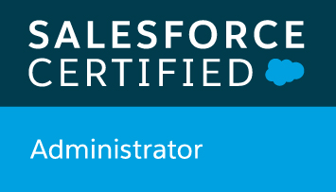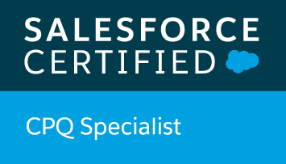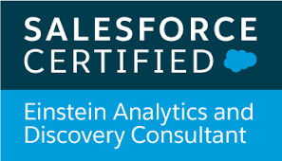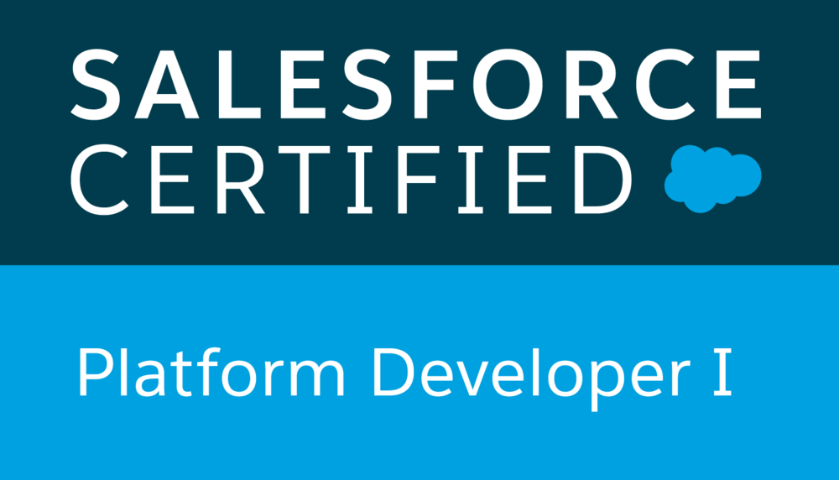

Deepti Mathew
+91-8690596014
deeptimathew9@gmail.com

Experience:

- Associate Consultant at Appirio – A Wipro Company [Aug 2019 to Current]

Responsibilities:

- Gathered user requirements and was involved in application design discussions and documentation.
- Have functional and working experience around CPQ components and service cloud. Have also completed Billing Specialist super badge.
- Worked in an agile-based scrum model, managed and coordinated with offshore team and got the user stories delivered to the client on time within the sprints.
- Developed apex classes, controller classes and apex triggers for various functional needs in the application.
- Create and manage custom objects, fields, formulas, validation rules, custom workflow, profiles, sharing rules, roles and process builders, as needed by the business.
- Design, build, test and deploy SFDC customizations which may include form layout changes, workflow triggers, workflow alerts, automated email responses, etc.
- Make recommendations for enhancements and modifications to improve system performance, efficiency, internal business process, and reporting
- Undergone 15 days training for LWC.

- Assistant Professor in iNurture Edu Pvt. Ltd Solutions [Sep 2018 to May 2019]

Responsibilities:

- Delivering lectures to students of BCA & B.Tech on different subjects such as Programming Principles and Algorithms, Internet Technology and Web Designing, DBMS, Core Java, UNIX and Shell Programming, and Fundamentals of Computer.
- Developing educational contents related to trending topics in IT

- Assistant Professor in Kanoria PG Mahila Mahavidyalaya, Jaipur [Oct 2017 to Aug 2018]

Educational Qualification:

- Completed MCA from International School of Informatics and Management (IIIM), Jaipur [2013-16]
- Completed BCA from S.S. Jain Subodh PG Girls College, Jaipur [2010-13]
- Completed Higher Secondary from G.B.I.A. Sr. Sec. School, Mahwa [2009-10]
- Completed Secondary from G.B.I.A. Sr. Sec. School, Mahwa [2007-08]

Skills:

- Highly innovative, flexible and self-directed - Strong organization skills
- Strong knowledge of SQL Server, MySQL, SOQL and SOSL, Visual Force Pages/Components, Workflow, Triggers & Apex
- Demonstrated organizational skills and detail orientation with ability to multi-task in a fast-paced environment with competing priorities
- Strong interpersonal skills. The ability to translate technical jargon into terms that business users can understand
- Excellent leadership, communication (written and oral) and interpersonal skills

Awards & Achievements:

- Salesforce Certified Administrator, Salesforce Certified CPQ Specialist, Salesforce Certified Einstein Analytics & Discovery Consultant and Salesforce Certified Platform Developer I
- Copado Certified Administrator and Copado Certified Developer
- Trailhead Ranger (https://trailblazer.me/id/missmathew)
- Business English Certification (Preliminary) by Cambridge English
- Presented a paper on “Learning Analytics Benefits & Challenges: A Literature Review” in ICMIT 2019 at ISIM, Jaipur
- Presented a paper on E-learning in ICMIT -2015 at ISIM, Jaipur
- A paper on “Value Education: Need of Nation, in this virtually connected yet physically disconnected world” got published in National Conference Abhyutthanam, 2017
- Presented a paper on “Payment Methods and Security in Mobile E-Commerce” in International Conference INSPIRA-IRA 2018 at LBS College, Jaipur
- A paper on “Quality Enhancement in Teaching, Learning and Evaluation” got published in National Conference on EMSS-2018 at Kanoria PG College, Jaipur
- A paper on “Payment Methods and Security in Mobile E-Commerce” got published in International Journal of research in Engineering & Technology (IMPACT), 2018

Date: (DEEPTI MATHEW)

Place: Jaipur

