**SANGEETH P M**  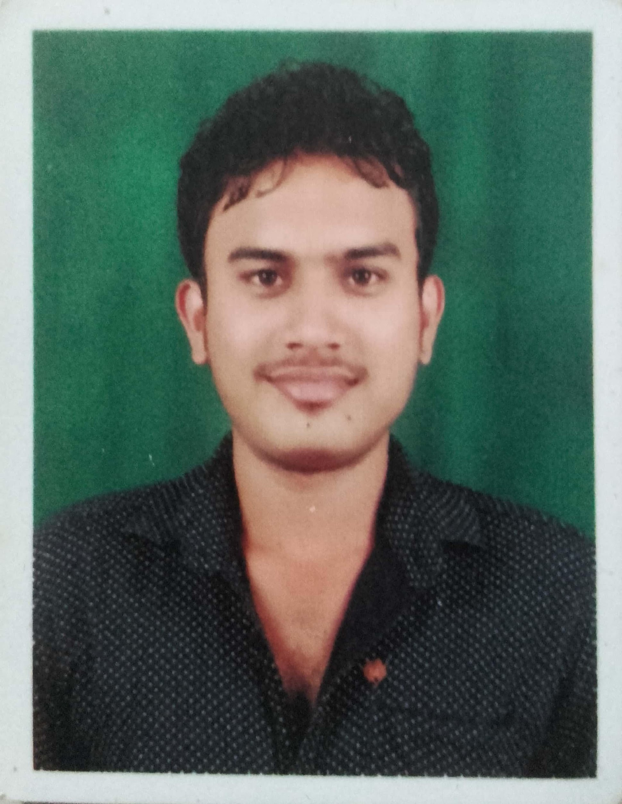

NO.51 Om shanthi nilaya

2nd block dandinpet

Kushalnagar

Kodagu-571234

Mail id: sangeethsangee96@gmail.com

Phone: 8123085098

**CAREER OBJECTIVE**

To secure a challenging position in a reputable organization to expand my learnings, knowledge, and skills.

**EDUCATIONAL QUALIFICATIONS:**

|  |  |  |  |  |
| --- | --- | --- | --- | --- |
| **Class** | **Specialization** | **Institute** | **Marks Obtained** | **Year** |
| PGDM | Finance  &  HR | Bhavans Priyamvada Birla Institute Of Management,  Mysore | 73% | 2017-19 |
| B.com | B.com | Bharath matha first grade college, koppa | 74.5% | 2014-17 |
| PUC | Commerce  (CEBA) | Bharath matha PU college, koppa | 80% | 2014 |
| SSLC | _____ | Bharath matha school, koppa | 73% | 2012 |

**INTERNSHIP PROJECT**

TITLE: “ **GENERAL STUDY OF FINANCE DEPARTMENT**” AT KARNATAKA SOAPS AND DETERGENTS LIMITED.

**PROJECT:**

TITLE: “A STUDY ON GREEN BANKING INITIATIVES BY SBI”

WORK EXPERIENCE

1. **Direct Title Operations** -- **Fidelity national Financial Bangalore**

* Working on direct title Operation where need to search their Property details & Make Necessary changes on various software.
* Working on CA log tool where need to the update the details on various billing process.
* Reviewed company software and business programmer to determine value.
* Collected, tracked and organized data to evaluate current business.

1. **Lead Development Consultant** 🡪**VAST TEC (Vendor/Partner : Hubspot)**

* Looking after the company’s social media profiles and presence, including Facebook, Twitter, LinkedIn, sales navigator and additional channels that may be deemed relevant.
* Monitor and engage in relevant social discussions about our company, competitors, and/or industry, both from existing leads and customers as well as from brand new audiences.
* Finding who is the Decision maker of that Company & Enriching the data
* Assigning & Enriching the the Companies territories In hubspot CRM
* Finding out the Companies Overview like Alexa Ranking, Industry, Technologies and Attributes Used by various Companies.

**AREA OF INTEREST:**

* Banking Related Services
* Finance

**STRENGTH:**

* Hard worker
* Good communication
* Helping nature
* Good planner

**HOBBIES :**

* Listening music
* Bike Riding

**PERSONAL DETAILS**:

Name : SANGEETH PM

Father’s Name: Manjunath PR

Date of Birth : 30-11-1996

Nationality : Indian

Marital Status: Unmarried

Gender : Male

Languages known : Telugu, English, Kannada, Malayalam, Hindi

**Declaration:**

I here by declare that the information furnished above is true to the best of my Knowledge.

Signature

Place: Mysore (SANGEETH PM )

Date: