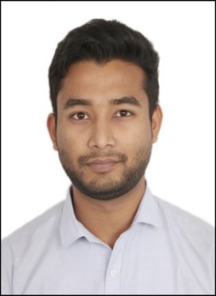**IMRAN ALI**

Mobile no: -9832968508

Email id: -[imranalieye@gmail.com](mailto:imranalieye@gmail.com)

**CAREER OBJECTIVE**

I want a highly rewarding career where I can use my skills and knowledge to help the company and my coworkers to be successful.

**WORK EXPERIENCE**

•Designation: -Data Analyst (From January 2020 to January 2021)

Company Name: - Mfine(Novo Cura Tech Health Services)

Closely working with developer team and linguistic team for changing language data for chatbot.

Handling large set of end-user's enquiry data.

Helping QA team for preparing test cases and end to end testing.

•Designation-Trainee Engineer/Data Analyst (From January 2019 to Nov 2019)

Company Name: -PACECOM TECNOLOGY PRIVET LIMITED

Project Title: Subaru Driverless Car

Worked with data analyst team. My role was to collect and convert the raw data with the help

of tools. Time to time reviewing the data labeler’s files.

**INTERNSHIP & PROJECT**

Six-month Internship under LPU (in a team of 4 people)

My role was client handling and understanding his requirements for the project.

Preparing monthly presentation and Work reports

Testing and Maintaining test cases.

Client: -Dr UTTAR kr.

PROJECT CMS (Clinic Management System): -It’s an offline application portal for a clinic, mainly three modules ADMIN, DOCTOR and STAFF.

**ACADEMIC DETAILS**

|  |  |  |  |  |
| --- | --- | --- | --- | --- |
| Qualification | Board/University | Institution | Year of Passing | Percentage  (%/cgpa) |
| MCA | LPU | Lovely Professional University | 2018 | 6.2 |
| BCA | PTU | Punjab Technical University | 2015 | 7.1 |
| 10+2 | CBSE | Kendriya Vidyalaya  Cooch Behar | 2011 | 64% |
| 10th | CBSE | Kendriya Vidyalaya  Cooch Behar | 2009 | 60% |

**SKILLS**

SQL, Database Management, Application Testing, Data mining/data cleaning, Data Visualization, Advanced Excel, Data Analysis, Data Manipulation, Manual Testing, Power BI.

**STRENGTHS**

Presentable, Self-Confident, Very good listener, Team player, Leadership quality, Quick learner.

**HOBBIES**

Net surfing, Listen to music

**PERSONAL INFORMATION**

NAME: IMRAN ALI

DOB: -29th OCTOBER 1992

FATHER’S NAME: - ECHHAB ALI MIA

SEX: - MALENATIONALITY: - INDIAN

PERMANENT ADDRESS: -VILL-TAKAGACHH PS-TAKAGACHH

DIST. – COOCH BEHAR (WB) PIN-736180

**DECLARATION**

I do hereby declare that all the statements stated above are true and complete to the best of my knowledge and belief.

**Imran Ali**

**Place: -Bangalore**

**Date: -**