

**Pranavi Padala**

FINANCE

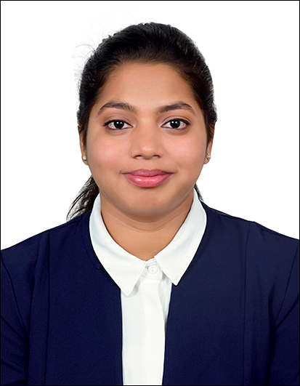

REFERENCES

**__________________________________________________________**

|  |
| --- |
| **Education Summary** |

|  |  |  |  |  |
| --- | --- | --- | --- | --- |
| **Degree|**  **Certificate** | **Stream |**  **Specialization** | **Name of Institution &**  **Board | University** | **YOP** | **Percentage** |
| MBA | Finance | Savitribai Phule Pune University, Pune | 2022 | Pursuing |
| M.Com | Advanced Banking | Andhra University, Andhra Pradesh | 2022 | Pursuing |
| B.Com | Commerce | Gayatri Vidya Parishad, Andhra Pradesh (SSC) | 2020 | 90.5 |
| Higher Secondary | Commerce | Sri Chaitanya Junior College, Andhra Pradesh (SSC) | 2017 | 87.8 |
| Senior  Secondary | All | Little Angels School, Andhra Pradesh (CBSE) | 2015 | 82 |

|  |
| --- |
| **Certifications & Training** |

* Tally ERP9 (8 weeks)
* Diploma in Financial Accounting and Taxation ( 12 weeks)
* Job Accounting (2 weeks)

|  |
| --- |
| **Personal Details** |

**Date of Birth :** 12th December 1998

**Languages Known :** English, Telugu, Hindi

**Home Town :** Visakhapatnam, Andhra Pradesh