Rajesh Bangi  Email: bangirajesh454@gmail.com  Mobile: +91 7259196363 | 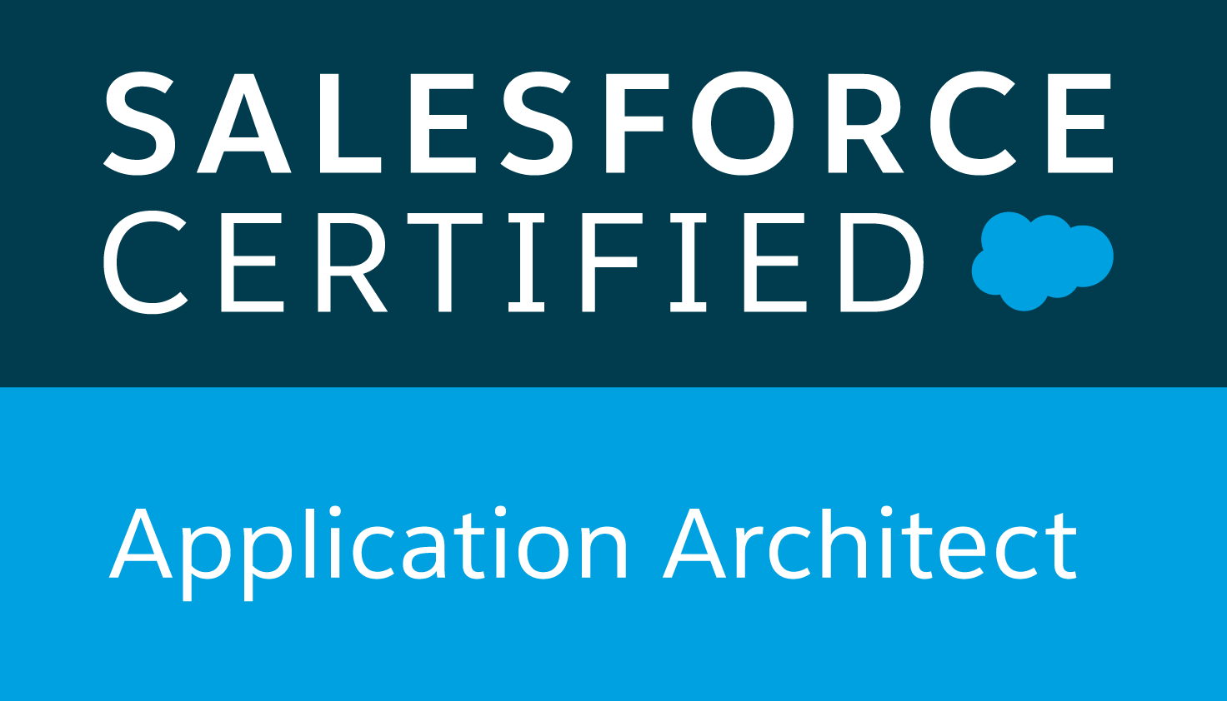  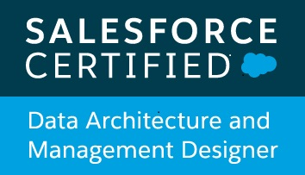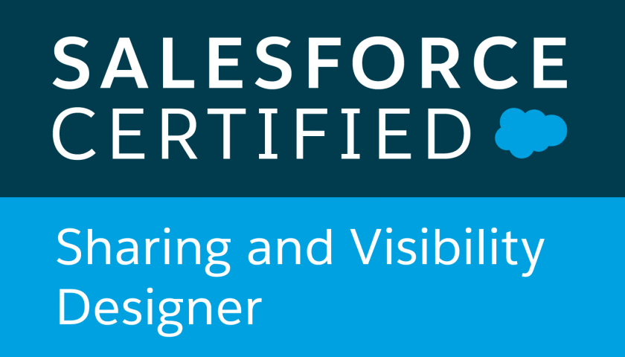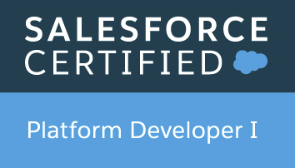  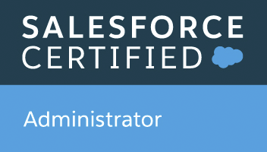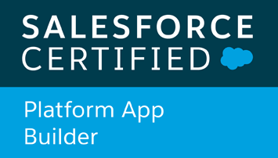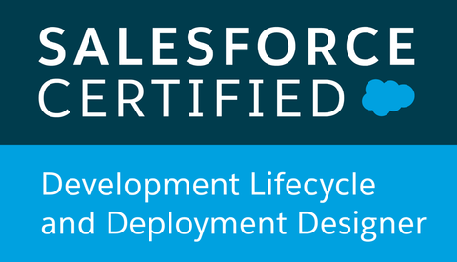
Profile Summary  - Around 7 years of work experience in I.T. with 2 years relevant experience as Salesforce Application Architect/Team lead.  - Around 5 years of experience on Salesforce.com Platform  CRM, Force.com, Apex, Triggers, lightning, Visualforce, Web Services, Workflows and Approvals, Community Setup, Test Classes, Deployment, Apex data loader etc.  - Experience in end-to-end product development on Force.com platform. This involves development, test classes, bug fixes.  - Experience as Tech Lead and Release Manager for end to end project.  - Experienced in Agile methodology, worked with the tools Bit bucket for version control and Jenkins for deployment.  EDUCATION  B. Tech in Electronics and Communication Engineering 2013  Sreenidhi Institute of Science and Technology  CERTIFICATIONS  Salesforce Certified Application Architect  Salesforce Certified Data Architecture & Management Designer  Salesforce Certified Sharing and Visibility Designer  Salesforce Certified Development Lifecycle and Deployment Designer  Salesforce Certified Platform Developer 1  Salesforce Certified Administrator  Salesforce Certified App Builder  Salesforce Certified Sales Cloud Consultant  Salesforce Certified Service Cloud Consultant  Salesforce Certified Einstein Analytics Consultant  Certified Conga Sign Admin  Certified Conga Contracts for Salesforce  EXPERIENCE  Cognizant Technology Solutions: Jan 2014 to Jan 2018  Capgemini Technology Solutions: Jan 2018  Jun 2018  Accenture Solution Pvt. Ltd.: Jun 2018  till date  PROJECTS  Accenture as Application Architect/ Team Lead  Duration: Jan 2019- Till Date  The scope of the project is to build Salesforce applications for end users in lightning. This project has many phase, Phase 1 is to develop the application UI, Phase 2 is to Integrate the commercial banking with their SAP Servers.  Responsibilities:  - Responsible to understand the business requirement and convert them into technical solution.  - Design & build User interface on Salesforce platform using LDS, tools and app exchange products.  - Creating data model, data structure and data flows to build the solution.  - Responsible to suggest app exchange products for implementation.  - To collaborate with Key Business Stakeholders to gather and analyze business requirements and proposed solutions  - Document requirements, performed gap analysis, create user stories.  - Responsible for continuous improvement, process improvement and suggest best practices for Technique and processes.  - Prepare test plans, provide estimates, develop and execute test cases, manage defect cycles and perform root cause analysis.  - Created user manuals, presentations, conducted demos, training sessions for Business end users.  - Worked towards preparation of requirements management plan, business and functional requirement documents.  Accenture as Senior Salesforce Developer  Duration: Jun 2018 - Dec 2018  The scope of the project is to build Salesforce applications for end users in Classic and Lightning. This project will help the end users to create/maintain the vendor data in salesforce.  Responsibilities:  - Analyze the Requirements and Object model set up for the same.  - Worked on Lightning Components  - Write secure apex classes, triggers, vf pages and package them.  - Setup Data model and Security access model.  - Worked on Managed Packages  - Integration with SAP Servers using Rest API.  - Defect fixes and deployments.  - Assist with project implementation and control monitoring process related to quality assurance (QA) and user assisted testing (UAT).  - Delegate project roles and managed deadlines.  Cognizant Technologies Solutions as Developer  Duration: Jan 2014 - Jan 2018  The scope of the project is to build a CRM Service solution for the client which is built on salesforce platform.  Responsibilities:  - Creation of fields, validations, workflows.  - Worked on Process builder, Approval Process, Profiles, Roles  - Setup Data model and Security access model.  - Write secure apex classes, triggers, VF pages and package them.  - Defect fixes and deployments.  - Worked on Data Loader and Workbench  - Worked on development activities and also was part of support activities |  | SKILLS  Salesforce.com  Lightning  Apex  Triggers  Visualforce  Workflows  Approval Process  Profiles  Apex Data Loader  Chatter  Process Builder  Org Security Model  Einstein Analytics  CPQ  Vlocity  Other  JavaScript  HTML  Tools  Eclipse IDE  Bit Bucket  Jenkins  JIRA  Design methodologies:  Agile-Scrum  Waterfall

