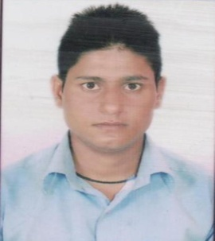 NEERAJ KUMAR KUSHWAHA

E-mail- [nkumar9309@gmail.com](mailto:nkumar9309@gmail.com)

Mobile- +91-7415457328

+91-8839584458

**Career Objective:-**

To seek a suitable platform where I can utilize and develop my skill in discipline manner

to prove my worth and become a good resource manager.

**Education Qualification:-**

B.E. from Jabalpur Engineering college, Jabalpur (M.P.).

**Academics:-**

|  |  |  |  |  |
| --- | --- | --- | --- | --- |
| **Examination** | **College/school** | **Board/University** | **Year of passing** | **CGPA/Percentage** |
| B.E. (IT) | Jabalpur  Engineering  College, jabalpur | RGPV, Bhopal | 2016 | 6.19 |
| Polytechnic | s.v.polytechnic college Bhopal | RGPV, Bhopal | 2013 | 65% |
| 12th | Nagar nigam kanya hr. sec school ghamapur , Jabalpur (M.p) | MPBSE, Bhopal | 2013 | 58% |
| 10th | Govt.  Hr. Sec. school,  jabalpur (M.P.) | MPBSE, Bhopal | 2009 | 45% |

**Technical Skills:**

1**. Coding Languages**:**:- php**  MVC Frameworks- Laravel.

2. **Web Technologies :-** HTML, CSS and JavaScript, JQuery, Bootstrap.

**3. Databases**: - MySQL.

**Projects and Training :-**

**MINOR TRAINING :-** Training on C language from CMC Academy, Jabalpur

**MAJOR TRAINING:-**Training on C language from CMC Academy, Jabalpur

**Digital Marketing:-** coriolee

**Work Experience : one year in PHP framework ( laravel) (7eye IT solution )**

**PERSONAL PROFILE**

Name : Neeraj kumar Kushwaha

Father name : Shiv Kumar Kushwaha

Sex : Male

Marital status : Single

Nationality : Indian

Hobbies : Badminton

Permanent address : House no 1131

Near bijashan mata mandir Road,

Suhagi, Adhartal , Jabalpur (m.p)

Phone no : 7415457328,8839584458

Date of Birth : 01-07-1993

**Declaration :-**

I hereby declare that all above information is true to the best of my knowledge and

belief.

Date: 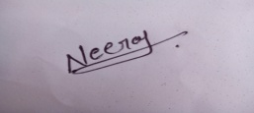

Place: Jabalpur

Neeraj kumar kushwaha