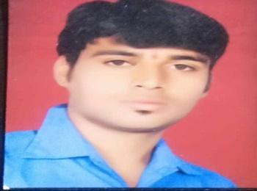
Pintu Rathod
E-mail :- Rathodpintu2996@gmail.com
Mobile :- 9399669189
Skype :- Pintu Rathod
LinkedIn :- https://www.linkedin.com/in/pintu-rathod-a19a19190

OBJECTIVE: -​ Looking for an organization where I can enhance my knowledge and from my academic learning give my best to the organization.
SCHOLASTIC
- Pursuing B.Tech from IT branch in Sushila Devi Bansal College of Technology.
- Complete 12^{t}​^{h} from M.P. Board 2015 with 6.8 CGPAS.​
- Complete 10^{t}​^{h ​}from M.P. Board 2013with 8.4 CGPA.
ACADEMIC PROJECTS
Project title: - ONLINE SERVICE MANAGEMENT SYSTEM.
Technologies: - Html, CSS, Boot-Strap, PHP, JavaScript.
.
TRAINING / CERTIFICATION / INTERNSHIP
- Completed Live Project Internship as Campus Ambassador under InternIn Enterprises in 2021.
- Completed Internship in Marketing and Sales under BuSkills Education in Dec 2020
- C and C++ training course with A+ grade from IITBOMBAYX in 2018.

TECHNICAL SKILL
- C and C++ Language.
- Python language.
- PHP
KEY STRENGTHS
Self-Motivated and Good listener.
EXTRA CURRICULAR ACTIVITIES
- Certificate of completion of Ethical Hacking and Internet Security workshop from Bolt online workshop program in 2020.
- Participation certificate of Python Webinar from SB InfoTech 2020.
- Participation certificate of Python workshop from Universal in the year 2018.
- Certificate of Interview skills - knockdown the lockdown from TCSiON in 2020.
- Got 2^{n}​^{d} Position in cheese in inter school competition.

PERSONAL SNIPPETS
Date of Birth: 02 - sept- 1995.
Father Name : Shantilal Rathod
Address: Badnawar, dist-Dhar (M. P.)
Languages Known: Hindi, English.
Hobbies: - Cricket, Listening to Music, Travelling.
Nationality: INDIAN.
SELF-DECLARATION
I hereby declare that the information mentioned here is true to the best of my knowledge.
PINTU RATHOD
Place: -​ Badnawar.
Date :-
Signature:-

