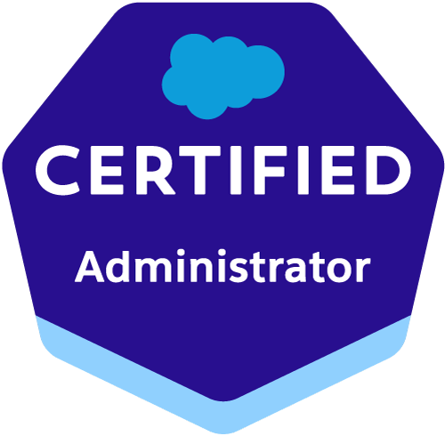  Profile  Salesforce CRM  Administrator | Arvind Kumar  Address: Vashu Vihar Colony Holambi Kalan New Delhi  110082  Contact No. +919761222227  Email: sainiak333@gmail.com
Professional  Summary  Skills | Cloud Salesforce CRM Administrator, App builder, Solutions focused and results-oriented Professional Experience of 3.3 years of successful career..  - Salesforce Lightning and Classic CRM Administrator  - Sales Cloud, Service Cloud  - Coordination Skills between Management and Development  - Verbal and written communication skills.  - Complete SFDC understanding  - Leadership  - SOQL, SOSL  - Apex, Triggers, Web services  - OOP’s
Role & Responsibilites  Experience | - Daily Routine, Weekly and monthly task on Salesforce CRM  - Work upon Leads, Campains, Account and Contacts Objects  - Customizing and Implementing Profiles, Roles, Security Settings, Sharing rules, Custom applications, Custom objects, Custom fields, Page layouts, Workflow, Process Builder, Validation rules, Dashboards, Reports creation.  - Develop and maintain administrator and user documentation.  - Work with end users to provide best practices and tips on Salesforce usage, including account management, training and coaching, documentation, and support as necessary.  - Provide guidance and advice to users who are developing and run daily/weekly/monthly reports to insure data and process integrity.  - Migrate data from using tools like data loader, import wizard to perform data migration.  - Development and Maintained various software, websites and services.  - Airnet Infotech Pvt. Ltd. Noida, India  Sep-2019 To till Now  Role – Salesforce Administrator  Project Deliver – Ericsson India Pvt. Ltd.  This project aimed to maintaninted Support and Services of Airtel LTE,VOLTE,GSM,CDMA.  - IWS Pvt. Ltd. Hyderabad, India  March-2018 To Sep-2019  Role – Salesforce Administrator  Project Deliver - Ericsson India Pvt. Ltd.  This project aimed to maintained Support and Services of Airtel LTE,VOLTE,GSM,CDMA.  B.Tech (Electronics & Communications Engineer) with First Division 2012-2016 from UPTU.
Education | - 12 th from UP Board- 2010.  - 10th from UP Board - 2007.
Certifications | - Salesforce Administrator Certification ADM 201
Achievements  Language Known  Personal Detail | - I have been awarded by Ericsson India Pvt. Ltd. company for my work and punctuality.  - English (professional), Hindi (professional)  - Nationality – Indian, DOB 03- 03-1991, Marital Status – Married.

