Summary:
- Carrying 10+ years of experience with fulfilling organization staffing needs with MBA in Human resource management.
- Hands on experience in end-to-end recruitment (Sourcing, screening, shortlisting, scheduling, interviewing, offering, onboarding).
- Working with multiple business units and stakeholders.
- Committed to maximize organizational goals, with managing external/internal hiring.
- Good experience with handling direct clients.

EDUCATION:
MBA – (HR & Marketing) at Karpagam College of Engineering Coimbatore. Full time
BBM – Bachelor of Business Management at SN College Kannur. Full time
XII - Sn Trust, Kannur. Full time
X- St. Michael’s Anglo-Indian high school, Kannur. Full time

Tools Used & Skills:
RippleHire, BrassRing, Kenexa, CRMT, Beeline, Synergy

Key Skills:
Sourcing, Screening, Shortlisting, Scheduling, Interviewing, Negotiating, Offering, Onboarding. team handling, onsite-offshore coordination, Vendor Management.

PROFESSIONAL EXPERIENCE:
Mphasis, Bangalore - FTE
Senior Analyst (Recruitment) (November 2018 – Present)
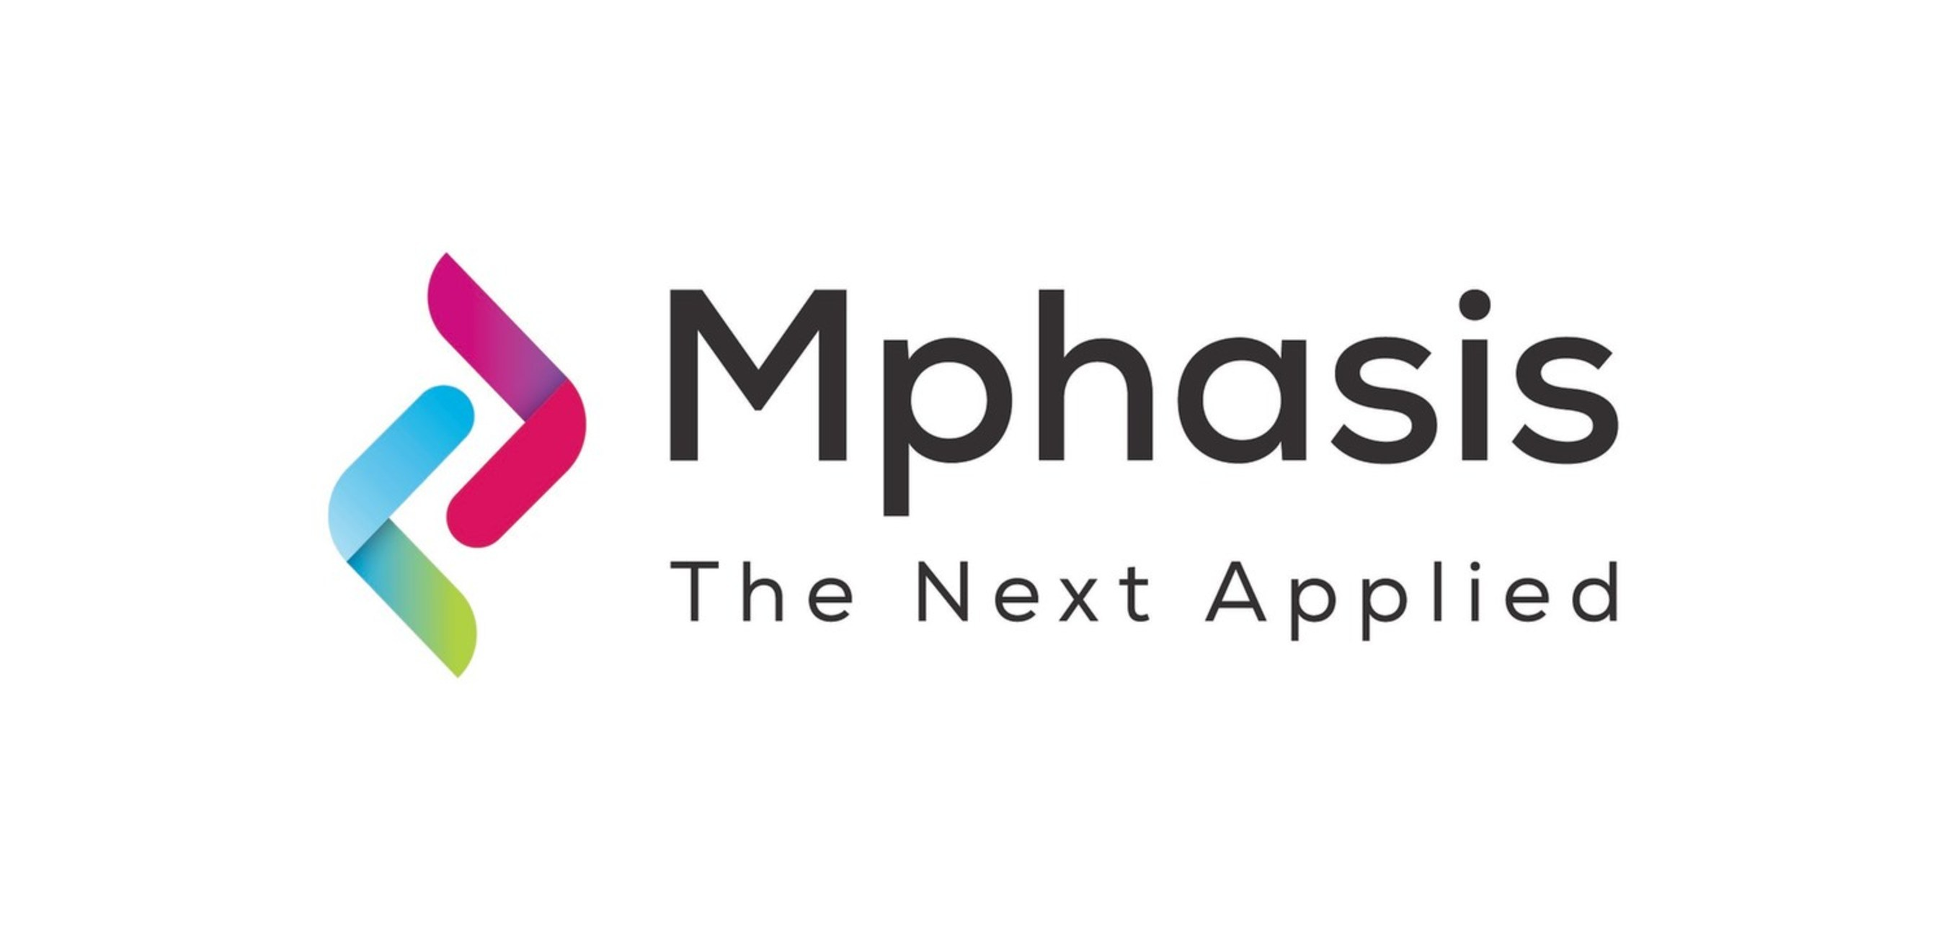
- Responsible for driving the end-to-end recruitment activities for multiple clients.
- Sourcing candidates form different Job boards, Social Medias, references
- Work closely with the different stakeholders / hiring managers to cover all the positions/requirement in their portfolio within given SLA.
- Working closely with candidates, panels, vendors/staffing agencies.
- Provide MI (Market Intelligence) to the hiring team to know the best rate available resources in the job market, creating, and maintaining the recruitment reports.
- Maintaining daily, weekly, and monthly reports.

Wipro Limited, Bangalore - Contract
IT Recruiter (September 2017 – November 2018)

- Responsible for all the BFSI IT requirements, working on Full time opportunities.
- Experience in sourcing and screening the profiles from different portals, Networking, Database & Social Networking Sites, managing End-to-End prospect of Recruitment activities.
- Work with hiring managers to maximize effectiveness of recruiting process by ensuring job requirements and expectations are clearly understood and candidates are assessed against appropriate criteria.

IBM, Bangalore - FTC
Recruitment Coordinator (May 2015 – May 2017)

  - Worked on all aspects of IBM internal/Offer process.
  - Main point of contact for hiring managers within a given business unit and offers advice and counsel on all aspects of the interview, offer and on boarding processes for the candidates, as well as Compensation, Benefits, EO requirements, Visa and Export Regulations.
  - Completing GEVS checks, checking the rehire status, BGV checks etc.
  - Generating offer letters, making welcome calls to all applicants prior to their scheduled start date, internal/external reporting.
  - Internal Quality Auditing for Recruitment Process.

Aditi Consulting, Bangalore - FTE
IT Recruiter (July 2014 – May 2015)

- Taking ownership of a new job/requirement and delivering within the industry standard time, thereby improving turnaround time.
- Exploring various web-based portals to pursuit the right candidates for the job.
- Bullhorn Applicant Tracking System to keep track of all candidates to build pipeline.
- Fulfilling the direct clients’ like eBay, Verizon.

CTSIT, Bangalore - FTE
Senior IT Recruiter (August 2013 – April 2014)
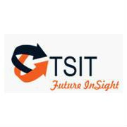
- Recruiting IT professional through Internet job boards (Dice.com, Monster.com, Career Builder, and Job diva), direct phone sourcing, and Social Networking sites.
- Worked on contract, contract-to-hire & full-time placements of IT professionals for direct clients.

Ionidea, Bangalore - FTE
IT Technical Recruiter (March 2011- June2013)

- Sourcing profiles through Internet job portals (Dice.com, Monster.com, Career Builder) combined with utilizing existing candidate relationships and referrals.
- Identified, qualified, and closed candidates using the Internet sites, Job Boards, database, and referrals.
- Worked with US Citizens, GCs, EAD, L2, TN Visas, H1B and OPT.

DECLARATION:
I hereby declare that the above-mentioned information is true to the best of my knowledge.
Place: Bangalore
Date: 07/12/2021
Nithin Jayachandran

