

**RESHMA DEEPAK LANGE**

**LinkedIn**: [www.linkedin.com/in/reshma-lange/](http://www.linkedin.com/in/reshma-lange/)

**Email**: [reshmalange@yahoo.com](mailto:reshmalange@yahoo.com)

**Phone No: 8850130264**

**EDUCATION**:

* *Master of Science in IT(2016-2018)*
* *Bachelor of Science in IT (2012 -2015)*
* ***Platform Developer I certified***

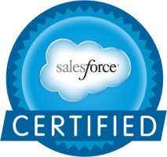

**SKILLS:**

* *Salesfoce Developer*
* *Salesforce Admin*
* *Business Analysis*
* *Quality Assurance and Control*
* *Cross Culture Management*
* *CRM Implementation*
* *Risk Analysis and Mitigation*
* *Verbal and written communication*
* *Team Management*

**TOOLS AND PRODUCTS:**

* *Salesforce (Sales, Service Cloud)*
* *JIRA*
* *Confluence*
* *Service Now*

# RESUME

I have always been fascinated to work in challenging environment with cross cultural people and teams. I want to invest my skills and expertise in a demanding project as Salesforce Consultant. I have the knack to build strong formal relationships with customers, which helps in improving the customer satisfaction index.

**ROLES AND RESPONSIBILITIES:**

* Developed Lightning Components.
* Developed Apex Triggers, Trigger Frameworks, Apex Classes and Test methods.
* Customized standard sales force objects Accounts, Contacts, Cases etc.
* Experience in REST API, Integration
* Worked on Reports & Dashboards to analyze the data.
* Involved in process like Refining, Designing, planning, building & testing.
* Created custom objects, formula fields, validation rules, Profiles, Permission Sets, Workflows and Approval processes, Process Builders. Custom settings, Custom Labels and Translations.
* Testing, reporting & resolving Bugs
* Handling client calls, client chats, sending and replying to client emails.
* Plan Business Analysis Process
* Validate Requirements
* Requirement elicitation and Documentation of the requirement.
* Identify system GAPS , or GAP Analysis
* Define the Functional Requirements and the System Specification Requirements
* Validate and analyze the Change Requests
* Drive UAT and closure
* Risk Analysis and Mitigation
* Change Management Processes
* Send weekly status report
* Coach and train the team members
* Conduct interviews to hire new team members
* Assign tasks as per the competency of the resources

**PROJECTS:**

* ***Saint-Gobain: BGE(Building Glass Europe)*** *Handling tickets, Providing support, Handling Sprints and Releases. Implementation in lightning.* ***(Duration: 1 Years)***
* ***Capgemini: Philips*** *Handling tickets, Providing support, Sprints and Releases, Apex and Triggers.* ***(Duration: 1.5 Years)***
* ***Capgemini: Micro Marketing budget Tool*** *Handling tickets, Providing support, Sprints and Releases* ***(Duration: 2 Years)***

**PROJECT METHODOLOGIES USED:**

* *Waterfall Model*
* *AGILE- SCRUM*
* *Prototype Model*
* *SCRUM of SCRUM*

**HOBBIES:**

* *Signing*
* *Travelling*
* *Socializing*

**OTHER DETAILS**

* *Current Location: Mumbai*
* *Marital Status: Single*
* *Date of Birth: 29th Dec 1993*
* *Language Proficiency: English, Marathi, Hindi.*

**EMPLOYERS**



**DURATION: March 2019 – CURRENT**

ROLES AND RESPONSILITIES:

* Salesforce Consultant
* Salesforce Admin / Developer
* Business Analyst

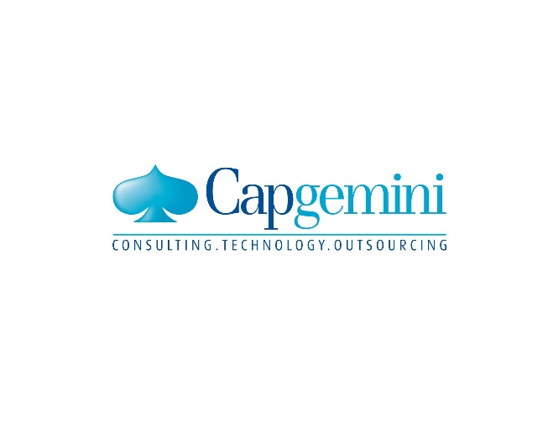

**DURATION: June 2015 – Feb 2019**

ROLES AND RESPONSILITIES:

* Business Analyst
* Salesforce Admin / Developer
* Software Engineer Trainee

**Personal Assets :**

* Ability to grasp new concepts and ideas, either technical or otherwise.
* Ability to work independently and as part of a team.
* Helping other teammates and colleagues in trouble shooting.
* Experience with Agile development practices.
* Taking initiatives for various learning sessions such as Knowledge Transfer Sessions and Certification training sessions to train colleagues and fresher’s.