Lakshmi Tulasi Batthineni 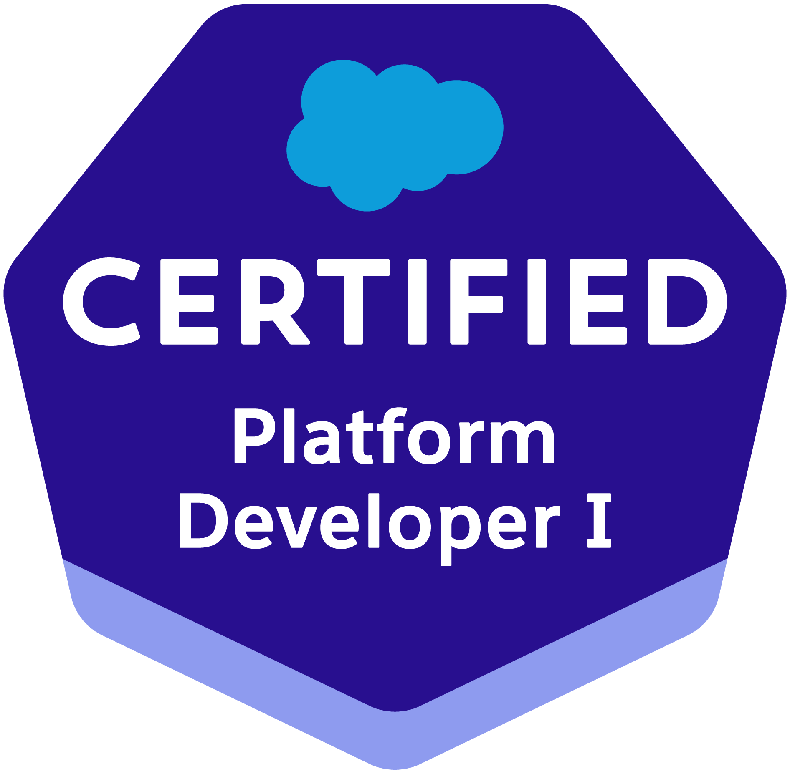 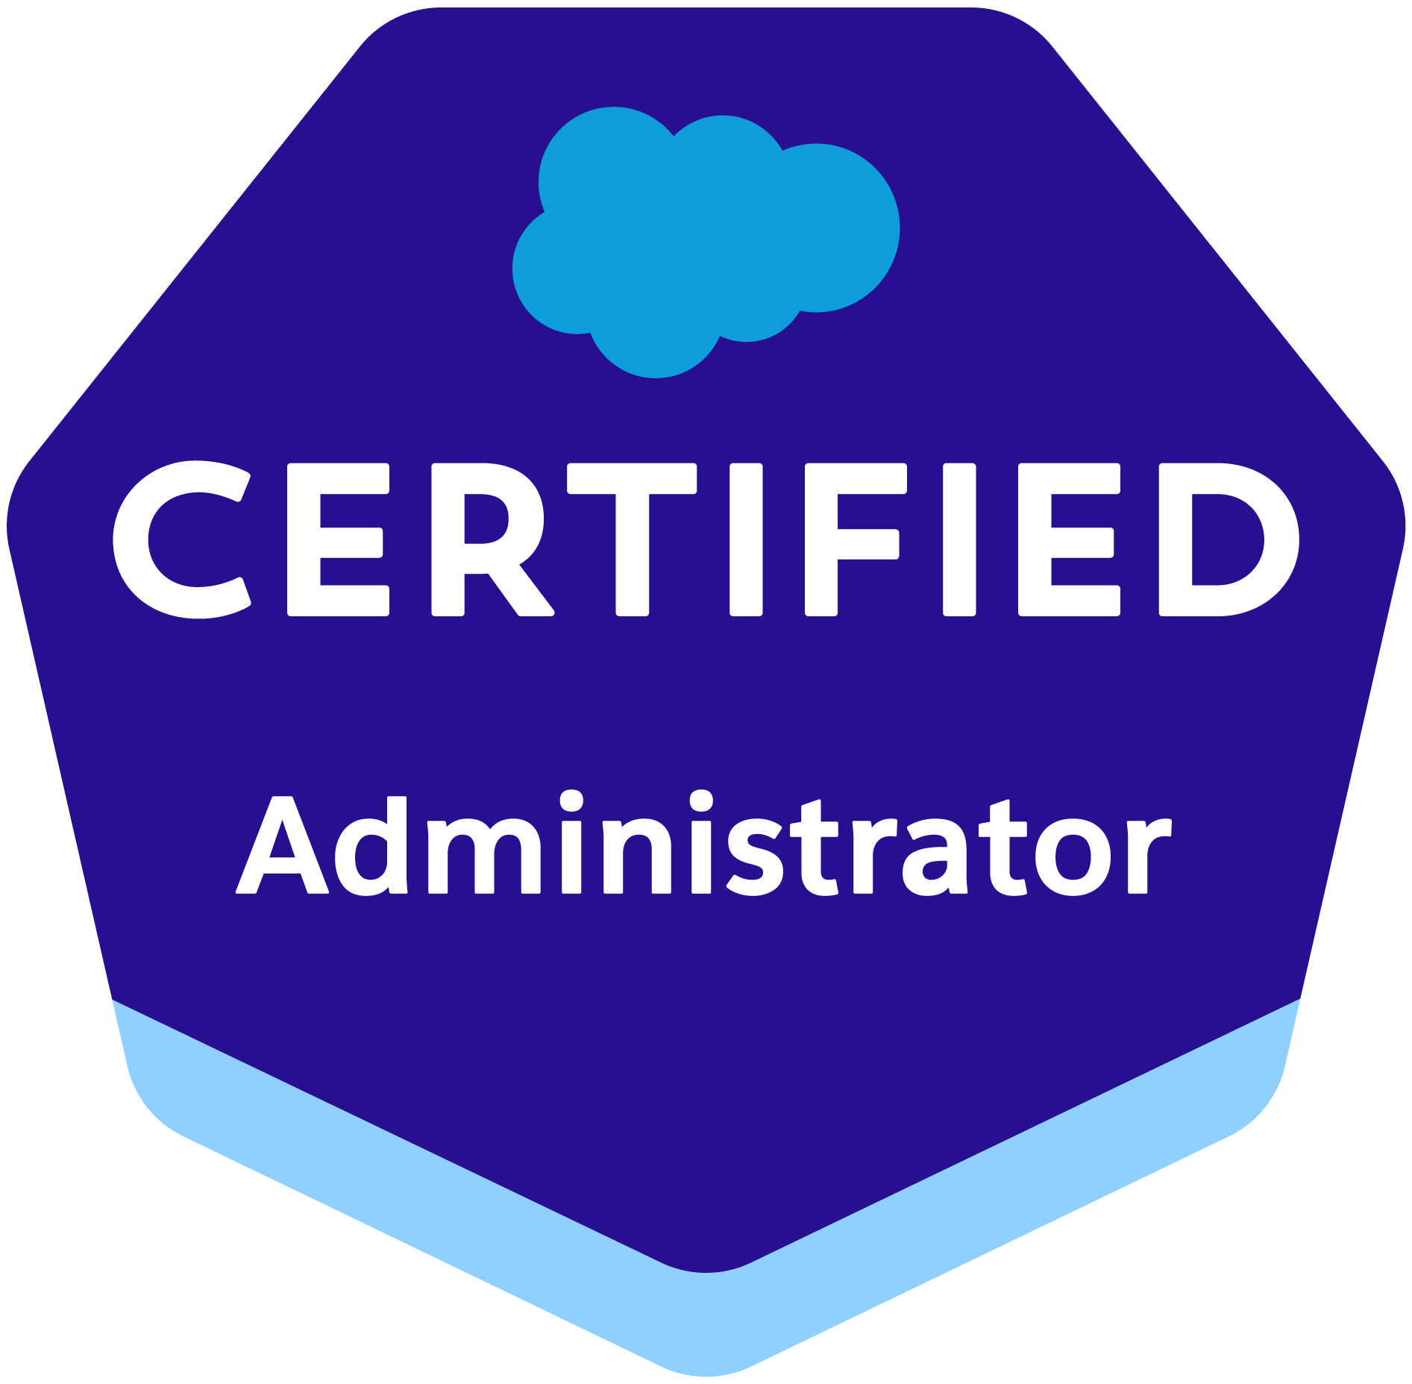
Phone: 949-299-8752 | Email: tulasib.usa@gmail.com https://www.linkedin.com/in/tulasi-batthineni

PROFESSIONAL SUMMARY
10+ years of total experience in information technology with 5 years as a Salesforce developer. My experience is focused mainly on custom development, maintaining the live production instance, UAT & Dev instances with frequent refreshes & migration activity such as code and data migrations. My primary focus is to provide business value in the solution and design strategically, based on priorities and quantifiable results. I am committed to collaborating and lead development teams with excellence, scalability, and reliability in mind, in practice, to provide the most business values with optimal recommended design.

- Implemented and delivered projects under an Agile development environment within large, medium & small teams.
- Strong experience in apex administration and development on the multitenant force.com platform with
specialization in lead to cash
- Experienced in working with various salesforce.com Standard Objects such as Accounts, Person Accounts, Contacts, Cases, Products, and Opportunities
- Experience in Sales Cloud, Service Cloud, Marketing Cloud, and exposure to Community Cloud
- Strong experience in developing efficient triggers, custom development, and integrating with external
applications using SOAP and REST APIs.
- Strong experience in developing custom components using Lightning Web Components & Aura
- Experience in developing efficient batch apex classes and scheduling to automate custom business needs
Efficiently.
- Extensive experience in designing, creating, and maintaining validation rules, workflow rules, approval processes, public groups, queues, and email templates.
- Enhanced UI of the current product to deliver user friendly, innovative and beautiful web that are branded for specific customer by leveraging the power capabilities of the velocity toolkit as well as the increasing palette of web development tool.
- Experience in designing, and developing efficient processes using process builders and flows.
- 1+ years of experience with Copado.
- Strong experience in multitenant force.com platform with specialization in deployments from sandbox to sandbox and sandbox to production environments
- Proven experience in code migrations using ANT, change sets, and workbench from sandbox to sandbox or production org.
- Hands-on experience working with sandbox, production, and pre-prod environments.
- Hands-on experience in maintaining different types of sandboxes such as Full copy, partial copy, developer pro, and developer sandboxes.
- Good knowledge of UI component of Vlocity.
- Implemented Continuous Improvement (CI) and Continuous Delivery (CD) for salesforce through Copado.
- Proven experience in regular sandbox refreshes by following org-specific pre/post-deployment steps manually and also by invoking refresh-specific apex class.
- Worked on custom objects, custom fields, formulae fields, Record Types, custom Tabs, Custom Reports, and Dashboards.
- Experienced in creating Platform events and platform event-triggered flows
- Experienced in integration of DocuSign with Salesforce.
- Excellent experience in maintaining data integrity during data migrations using tools such as data loader, import wizard, and workbench.
- Implemented Salesforce securities including user management, org access, profiles, permission sets, and data management (OWD & sharing settings).
- Experience in using apps from AppExchange, installing, managing, and evaluating the applications.
- Experience using developer console for SOQL queries, debug logs, test runs, code coverage, apex anonymous code runs, etc.
- Good knowledge of working models of GitLab & Jenkins for deployments
- Proficient in authoring Business Requirement Documents into System Requirement Specifications and identifying interface and business process specifications.
- Excellent communication skills with the ability to communicate with business users and the development team.
- Prepared technical design and deployment plan documentation.
- Self-starter with an urge to rapidly learn new technologies and relate to development goals.

Technical Skills:
Salesforce Technologies | Salesforce CRM, Sales Cloud, Service Cloud, Marketing Cloud, Lightning (Aura & LWC), Apex, Triggers, SFDX, ANT Migration, Workflow & Approvals, Case Management, Custom Objects, Reports & Dashboards, Flows, Process Builder, Salesforce Vlocity
Languages/Frameworks | Java-J2EE, Spring, Spring Boot, Microservices with Spring, Struts, SOAP, REST, PL/SQL, Apex, Ajax, JSF, and TestNG
Deployments CI/CD | Jenkins, Copado, Ant migration tool, changesets, metadata API, workbench, VS Code, SFDX
IDE Tools | Visual Studio Code (sfdx extension), Force.com IDE, Force.com API tools (Data Loader), Force.com Explorer, AppExchange, Soap UI, SVN, GitHub Enterprise, Bitbucket, Postman, JIRA, Source Tree, Eclipse and NetBeans, STS, CVS, ClearCase, Subversion
Web Services | SOAP, REST, WSDL, XML
Web Technologies | Salesforce Vlocity, HTML-5, CSS, JavaScript
Query Languages | SOQL, SQL
Project Acquired skills | Struts, JavaScript, Webservice (JAX-WS), JSF, Spring, Oracle, Ajax, HTML, JSF, Spring, Selenium Automation, Salesforce CRM
Web/Application servers | Apache Tomcat 7.0, WebSphere, JBoss
Automation Testing Tools | Selenium WebDriver

Certifications:
Salesforce Certified Administrator
Salesforce Certified Platform Developer I

Work Experience:
AT&T – Dallas, TX Jan 2022 - Present
Sr. Salesforce Developer/Administrator
Responsibilities:
- Developed and customized Lightning Components (Aura & LWC)
- Experienced in creating and troubleshooting Flows
- Worked on the conversion of existing process builder and workflow rules to flows
- Configured Service Cloud to handle Case management, Email-to-case routing, and sharing settings in a queue-based model.
- Involved in deployment of the code in the DEV Sandbox to the QA sandbox by using salesforce Copado.
- Designed a salesforce service cloud console to enhance productivity with a dashboard-like interface.
- Worked with various salesforce.com Standard Objects such as Accounts, Contacts, Cases, and Opportunities.
- Experience in integration of DocuSign with Salesforce, which has automated the manual work for ASMs
- Created Lightning Web Components (LWC) to send agreements and checklists to dealers using DocuSign from pipeline records, and load the data back into Salesforce
- Created flows to read the DocuSign envelope/recipient statuses and update the Salesforce pipeline records and send email notifications.
- Building Vlocity custom Templates
- Experienced in the development of Apex classes, Triggers, Test classes, and integration with external
applications using REST APIs
- Created new validation rules, list views, etc as part of the customization of the application
- Worked on data load of Individual Email Records for Marketing Cloud.
- Experience in release management tools like Copado
- Experience in Territory Management, Territory assignment rules, assignment of users to territories, and troubleshooting data discrepancies reported under territories
- Customized and validated changes to Effectiveness Evaluation forms
- Analyzed the existing profiles and permission sets to move access into profiles and reduce the dependency on permission sets
- Performed admin activities on a time-to-time basis to resolve daily production tickets
- Responsible for monitoring and scheduling jobs
- Responsible for manual and automated deployments from sandbox to sandbox and sandbox to the production environment.
- Responsible for sandbox maintenance such as refreshing the sandbox after major deployments and carrying out pre/post-deployment steps.
- Created and maintained different types of sandboxes such as developer, developer pro, and full copy sandboxes.
- Efficiently used force.com tools such as workbench for SOQL queries, extracting metadata, and custom/standard object definitions.
- Extensively used data migration tools such as Apex Data Loader with bulk API, Import wizard & Workbench for data migration purposes.
- Involved in maintenance of Jenkins jobs for deployments to different Salesforce sandboxes

Environment: Sales Cloud, Service Cloud, Marketing Cloud, Lightning Components, Apex, Triggers, VS Code, SFDX, SOQL, SOQL Queries, Process builder, Reports, Apex Data Loader, Copado, CSS, Custom Settings, Developer Console, Email Services, Github, HTML, JavaScript, Jenkins, JIRA, Postman, Velocity, Sublime Text3, Slack, Web services, Workbench, Workflow & Approvals

IBM May 2016 – Dec 2021
Salesforce Developer
Responsibilities:
- Worked on security model in implementing the roles and hierarchies across the org.
- Responsible for manual and automated deployments from sandbox to sandbox and sandbox to the production environment.
- Have been SME in handling deployments by setting up code versioning using GitHub and implementing deployments via metadata API and salesforce DX.
- Extensively used data migration tools such as Apex Data Loader with bulk API, Import wizard & Workbench for data migration purposes.
- Created and maintained different types of sandboxes such as developer, developer pro, and full copy sandboxes.
- Responsible for sandbox maintenance such as refreshing the sandbox after major deploys and carrying out pre/post deployment steps.
- Efficiently used force.com tools such as workbench for SOQL queries, extracting metadata, and custom/standard object definitions.
- Designing and developing Service cloud applications for advanced customer service in salesforce.
- Extensive experience in automating business processes using salesforce out-of-the-box functionalities such as process builder, flows, and workflow rules.
- Performed admin activities time to a time basis to resolve production daily tickets.
- Worked on User Security, Data Security, workflow rules, validation rules, Formula Fields, and various customization activities.
- Used Visualforce components in the custom Visualforce email templates for approval processes, to let users approve/reject the accounts and opportunities from email.
- Responsible for handling critical bugs in the UAT phase and plans in line for deploying the solution in a production environment.
- Created several approval processes for quoting approval flows.
- Used web to case for enabling the customer to create cases directly in our production environment.
- Experienced in creating and troubleshooting Flows
- Experienced in the development of Apex classes, Triggers, Test classes, and integration with external applications using SOAP and REST APIs
- Developed Apex Flows as a part of implementing a new security model for new business requirements.
- Responsible for maintenance of orgs codebase in SVN repository and keeping it up to date with development and production environments. Later moved to industry-standard GitHub.
- Part of the DevOps team to implement CI/CD pipeline in the salesforce environment using Jenkins, ANT & GitHub.
- Efficiently used eclipse IDE, developer console, and Mavens mate in a sublime text editor for development activities.
- Created Users, Roles, and Public Groups and implemented Role Hierarchies, Sharing Rules, and Record Level Permissions to manage sharing access among different users.
- Worked with various salesforce.com Standard Objects such as Accounts, Contacts, Cases, Products, Price Books, and Opportunities.
- Involved in project governance to effectively manage the process within the timelines set by the client.
- Worked on advanced approval rules to achieve approval customization via email and salesforce UI.
- Experienced in developing efficient apex classes to make callouts to different APIs within the governor limits
- Experienced in creating platform events and platform event-triggered flows
- Efficiently used force.com tools such as workbench for SOQL queries, extracting metadata, and custom/standard object definitions.
- Extensively used data migration tools such as Apex Data Loader with bulk API, Import wizard & Workbench for data migration purposes.

Environment: Apex, Lightning Components, Triggers, VS Code, SFDX, SOQL, SOQL Queries, Process builder, Reports, Apex Data Loader, CSS, Sales Cloud, Service Cloud, Custom Settings, Named Credentials, Developer Console, Bitbucket, HTML, JavaScript, JIRA, Postman, Workbench, Workflow

Tech Mahindra April 2011 – April 2016
Role: Senior Software Developer
Clients: General Electric

As a Java/J2EE developer worked on various technologies.

Responsibilities:
- As a developer, Analysis of the specifications provided by the clients involved in debugging the application logs and root-causing issues within the system and infrastructure.
- Developed application using Spring, Spring MVC, and spring boot frameworks.
- Consumed Enterprise Restful Web Services and used the Postman tool to test the service.
- Worked on writing JUnit test cases.
- Developed the DAO layer using hibernate for real-time performance and used the caching system for hibernating.
- Completed test cases using the JUnit and Mockito frameworks.
- Helped UI to integrate the java beans data using JSTL, Spring tags, JSP, JSON, and JSF Pages.
- Wrote SQL queries and Stored Procedures for interacting with the oracle SQL database.
- Experience maintaining CI environments with build automation tools like Jenkins, and Bamboo.
- Preparation of the Test Strategy and guiding the team.
- Involvement in the System Test Plan Preparation and Requirements Streamlining.
- Involvement in the Preparation of Test Procedures, Test Scenarios, Cases, and Test Data.
- Responsible for GUI and Functional Testing, using Black box Testing Techniques.
- Involvement in Test Execution, Results in Analyzing, and Defect Reporting.
- Involved in Automation Infrastructure Development using Selenium.
- Created Test cases Using Element locators and Selenium Web driver methods.
- Enhanced Test cases using Java programming features and TestNG Annotations.
- Conducting Data-driven testing, cross-browser testing, and parallel test execution.
- Enhancing the Test Scripts for Global Execution.
- Involvement in solving Environmental problems along with Technical Support People.
- Direct the offshore team for documentation of functional requirements for client submission and approvals.
- Preparation of technical design document and submission document for client approval. Implement client revisions and comments to the application design.
- Unit Testing, Integration Testing, and deployment.
- Responsible for working with new enhancements.
- Co-ordinate with onsite to get clarification on requirements implementation.
- Preparing design docs for new requirements.
- Development as per the requirements.
- Unit Testing, preparing the test cases and fixing defects
- Participated in reviews and client meetings.
- Developed reusable Business components, which abstract data and provide a common interface for business functionality.
- Worked on writing JUnit test cases.
- Collaborate with other application team members to resolve information technology issues. Provide Functional/application knowledge transfer to new business users.
- Maintained GIT branches during project development. Conduct merge and use Jenkins for building and deploying the application to the Tomcat server.
- Interactions with the Product Owner and Scrum Master for technical clarifications on user stories.
- Sprint planning estimations task allocation and monitoring of team members.
- Responsible for providing inputs on technical design developing proof of concepts and evaluating OOTB functionalities as well as demonstrating custom portlets capabilities.
- Extensively used Bootstrap CSS to customize components. Development on Velocity Templates.
- Used GIT for repository management and Jenkins for build management.

Environment: Java, Spring Core, Spring Web Flow, Spring DAO, Spring Boot, Mule, Angular JS, JavaScript, Mongo DB, CSS, HTML, JSP, jQuery, Maven, Selenium Web driver with TestNG framework.

