Pavan kumar 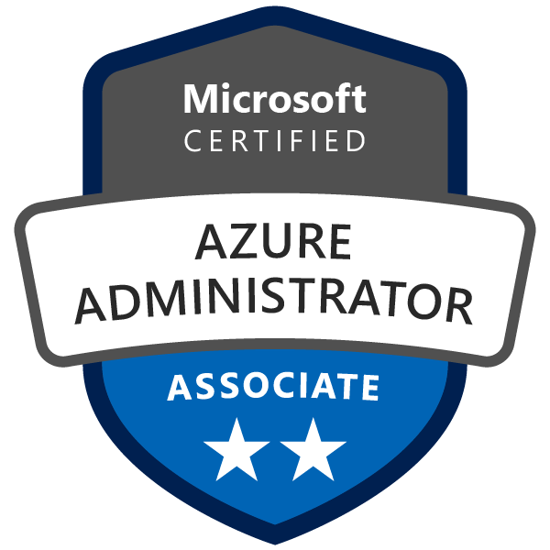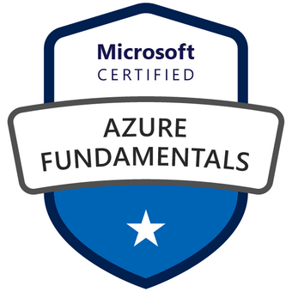
9133233921
pavankumarazure778@gmail.com

Summary

- Around 6+ years of experience in IT Industry and in that having around 3.8 years of experience in Configuring, Implementing, Deploying and Maintaining, provision the Infrastructure of Microsoft Azure services like IAAS, SAAS, PAAS
- Administration and managing on Windows 2003 and 2008 and 2012 servers.
- Hands on experience performing OS installation (Windows 2003 2008 & 2012 Servers)
- Installation and Configuration Windows 2003 and 2008r2 Active Directory.
- Good Knowledge in Azure cloud services, Azure storage, Azure active directory, Azure Service Bus.
- Created and managed Azure AD tenants and configured application with Azure AD. Integrated on-premises Windows AD with Azure AD Integrating on-premises identity with Azure AD
- Hands-on experience of creating point-to-point VPN and Site-to Site VPN
- Managing the new Microsoft Azure portal, creating the resource manager, and maintaining the infrastructure
- Having experience with ASR tool for the Hyper-V migration of on-premise servers in to Azure.
- Having good experience in Managing Azure services and subscriptions using Azure portals and managed Azure resources to Azure Resource Manager
- Experience in implementing and deploying workloads on Azure VM.
- Experience in implementing images and disks
- Good understanding of storage concepts. Experience in designing and implementing Azure Storage.
- Experience in creating and deploying virtual networks and virtual machines
- Experience in designing Azure Virtual Network, Implementing Point-to-Site VPN, V net-to-V net VPN, V net Peering and Network Security Groups (NSG)
- Good understanding of Azure Active Directory. Experience of integrating Azure AD with Windows based AD. Experience of integrating applications with Azure AD.
- Create Recovery Services like Backup Vault and Restoration of VM.
- Take Backup of VM, both Azure VM level backup and File & Folder level backup.
- Implementation and deployment of Traffic manager and Load balancer.
- Implementation of Auto scaling.
- Implementation and deployment of Availability set.
- Exposure in PowerShell scripting to automate many services management in azure.
- Self-motivated and industrious professional with good technical, communication, interpersonal and leadership skills with excellent analytical and problem-solving skills applied to simplify business processes
- Possess good organizational and interpersonal skills in a team-based environment.
- Excellent communication, interpersonal analytical, problem solving, oral, written skills.
- Experience in Assessment with MAP and Greenfield Migrations.
- Experience in export and import data to and from storage accounts across Azure subscriptions and within same subscription
- Experience in securing Azure Infrastructure by creating ACLs in old portal and NSG’s in new ARM portal
- Good understanding of Azure load balancer and experience in implementation
- Implemented OMS to monitor Azure Resources and configured Alerts for better SLA
- Implemented DSC configurations using Azure Automation.
- Experience on VSTS for Continuous Integration and Continuous Deployment

Related Technology Expertise

Azure Expertise : IaaS, PaaS, VM Migrations, Traffic Manager, Azure Cloud Services, SQL Azure, Active Directory, Express Route, Power Shell, Service bus, blob storages.
Application/Web Server : Tomcat 5.0/6.0, WebSphere 6.0.
Scripting Language : HTML, CSS and PowerShell, JSON
Database : SQL Server 2008/2014
Operating System : Windows98/NT/2000/2003/XP/Vista/Windows7, Windows Server 2012/2008, Windows Azure, Linux Visual Studio
Work Tracking : Visual Studio Online
Migration Tools : ASR, Cloud Amize, Cloud Endure, MAP.

Experience

Currently working as Cloud Engineer in Sonata Software
Project : PennyMac July 2017 - present
Role : Cloud/System Engineer
Roles and Responsibilities:
- Prepared capacity and architecture plan to create the Azure Cloud environment to host migrated IaaS VMs and PaaS role instances for refactored applications and databases.
- Created recommendations on duplicating a subset of on-premise machines to the Azure Infrastructure as a Service (IaaS) offering which will be used for disaster recovery. Analysis included the specifics to synchronize on premise data with SQL server and SharePoint instances hosted in VMs.
- Configuring the Load Balance Sets Azure Load Balancer, Internal Load Balancer and Traffic Manager and worked on Application Gateway.
- Worked on Power Shell scripts to automate the Azure cloud system creation including end-to-end infrastructure, VMs, storage, firewall rules.
- Creating Storage Pool and Stripping of Disk for Azure Virtual Machines. Backup, configure and Restore Azure VM using Azure backups.
- Provisioned Azure data lake store and azure data lake analytics, and leverage U-SQL to write federated queries across data stored in multiple azure services.
- Architecting the IAM scope for B2E and B2B identities using Azure AD, and Integrate Salesforce with Azure AD.
- Federating identities to access various SAS and on-premises applications with SSO.
- Co-ordinate with global identity and access management program involved in hybrid identity project.
- Design and plan auto provision of identities to various SAS applications through Azure AD.
- Enable MFA to the users across the applications.
- Worked on planning and deployment of Self-service password reset functionality of Azure AD which reduces IT helpdesk cost.
- Managed all the users and giving them the access to various SAS applications using various access policies.
- Worked on dynamic group membership rules (rules are based on attributes) to provide access to various applications.
- Troubleshooted the issues regarding to the access to the applications using the audit logs.

Project : Prism Nxt
Client : Microsoft
Role : Cloud Engineer
Roles and Responsibilities:
- Designed and configured Azure Virtual Networks (V Nets), subnets, Azure network settings, DHCP address blocks, DNS settings, security policies and routing.
- Configured Azure Traffic Manager to build routing for user traffic Infrastructure Migrations: Drive Operational efforts to migrate all legacy services to a fully virtualized Infrastructure.
- Designed Network Security Groups (NSGs) to control inbound and outbound access to network interfaces (NICs), VMs and subnets.
- Configuring and Controlling the Scale Up and Scale Out of the App Service Plans and Pricing tier (scale DTUs) while migrating the Databases and Applications from on-premises to Azure Cloud Platform.
- Created the VM Cluster and load balance for VMs using PowerShell in SQL & Windows Environment.
- Migrate Database Services from on-premises to Azure Cloud Environments using DMA and SSMS, updating the connection strings, collaborate with development and QA teams to maintain high-quality deployment.
- Worked on Azure AD connect to sync on-premises AD user data and groups to Azure AD and troubleshoot Azure services sync with on-premise AD and resync using the Azure tools.
- Integrating Azure Active Directory for user authentication/authorization and organization profiles.
- Designed and developed standalone data migration applications to retrieve and populate data from Azure Table / BLOB storage to on premise SQL Server instances.
- Utilized Agile Methodologies – Scrum meetings to manage full life-cycle development of the project.
- Configured VMs in Availability Sets using Azure Portal to provide resiliency for IaaS based solution and scale sets using Azure Resource Manager to manage network traffic.

Sify Technologies (Hyderabad) June 2015 to March 2017
Job Title: Windows Admin
Roles & Responsibilities:
- Administration of Server Assessments and Backup Monitoring
- Host and maintain server (i.e., IIS, business specific service, etc.)
- Patching/software upgrades
- Volume/partition space management
- Hardware migration
- Deploying Azure Virtual Networks and subnets
- Configure and manage Network Security Groups (NSG).
- Create and Manage Custom Roles using Role-Based Access Control (RBAC).
- Software licenses for all member server(s) added to their OU hierarchy
- Hardware maintenance for all non-Infrastructure-managed member servers
- Operating system maintenance for all non-Infrastructure-managed member servers
- Maintain level of member server system security by applying Service Packs and security patches
- Overflow team for peak periods / high volume of work
- Scheduled TNI audit and analysis
- Toolset deployment (After hours general work)
- Support for Internal IT environment
- Patching of entire infrastructure (Patching focus team) with test bed environment
- Consulting - server assessments / patching after hours
- Restore Tests
- Schedule Server Assessments and review of Event Log (for MS like CS)
- SCOM Admin reporting and analytics
- Builds Templates and service catalogs
- Automated Patching/deployment
- Provisioning (IaaS, BVD, Hosted Exchange)
- SCCM

Education
ACADEMIC PROFILE
Degree/Examination | Institute | Percentage
Bachelor of Technology, ECE | Itm groups, Jntu Kakinada (2012) | 70.11
Class XII | Sri chaitanya Junior College (2008) | 91.1%
Class X | Chaitanya Public School (2006) | 86.5%

