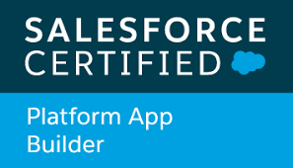 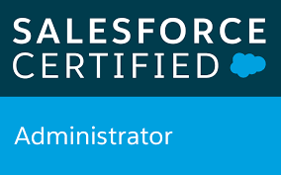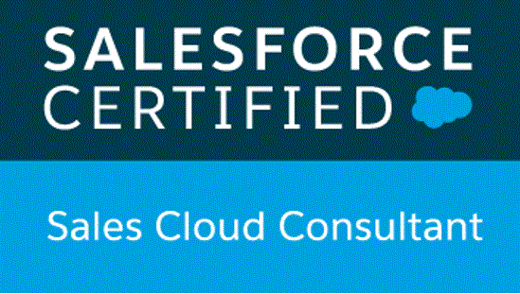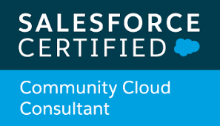

**Manjulata Yadav**

Manjulata has 10+ years of work experience in IT industry including 8 years in salesforce ecosystem. She has strength to deliver good performance in various areas. She has delivered 50+ projects successfully on various Salesforce products and services like Sales cloud, **Service cloud,** Community cloud, AppExchange, Third Party Integrations and eager to learn new things and enhance his knowledge and skills on cloud. Manjulata has salesforce application design/solution architecture and consulting experience.

Manjulata is presently working for US based clients as Salesforce Techno Functional Architect. She has good domain, consulting, functional and technical knowledge of Force.com, Salesforce, CRM, SDLC and BSS/OSS (operations support system and business support system) Implementation.

**Professional Summary**

* Working as a Project Manager and Technical Solution Architect.
* Experience with Salesforce Architecture, Design, and Project Leadership.
* Experience in developing the overall solution design and recommendations, conducting the design review meetings and lead the technical design and architecture and perform the gap analysis of requirements.
* Set up the technical standards and guidelines for the Project, and coach developers on reusability, best practices.
* Understanding business requirements and translating these into technical solutions based on the chosen platform.
* Designing and creating the underlying data structure and data flows to support the application build.
* Responsible for the detailed design of technical solutions, Proof-of-Concepts (POC), prototyping and documentation of technical design throughout the SDLC process.
* Experience in Administration, Configuration, Implementation and Support of Salesforce CRM and Salesforce applications.
* Implemented security and sharing rules at object, field, and record level for different users at different levels of organization. Also created various profiles and configured the permissions based on the organizational hierarchy.
* Created the Validation Rules, workflows for different business requirements.
* Triggers, Test Class Implementation.
* Designed various Webpages in VisualForce.
* Experience working with Data Loader, Import Wizard and salesforce.com Sandbox environments, CLI Process implementation Worked on the designing of custom objects, custom fields, role-based page layouts, custom Tabs, custom reports, report folders, report extractions to various formats, design of Visual Force Pages, Dashboards.
* Worked on SOAP, REST Integrations.
* Experience in Salesforce Lightning framework.
* Worked on implementation of Field Service Lightning.
* Having experience of working on Case Management, Live Agent, Lightning service console, Question to Case, Discussion to case, Knowledge articles etc. in Service Cloud
* Aware of Omni-channel Routing and Entitlements and Milestones in service cloud
* Worked on Lightning dialer for making calls and recording for review

**Devops experience:**

* Used Jenkins tool to automate the build process.
* Installing and configuring VSCode
* Setting up Github master and other branches.
* Built CI/CD pipeline on Jenkins and Bitbucket
* Automated the continuous integration and deployments using Jenkins.
* Played with AWS Lamda expression and integration of it with Salesforce
* Worked in GIT to manage source code.
* Taking the source code or change-set and compiling using Maven and package it in its distributable format, such as a WAR files.
* Setting up Gearset deployment tool for code comparison, deployment and automated test class run.
* Salesforce SFDX – creating scratch orgs, unlocked packages, converting to new folder structure
* SFDX Packaging

**Professional Certifications**

* Salesforce.com Certified Platform App Builder
* Salesforce.com Certified Administrator
* Salesforce.com Certified Sales Cloud Consultant
* Salesforce.com Certified Community Cloud Consultant

**Skill Set:**

* Management: Project Management, Estimation, Delivery, Client communication, Team coordination, Deliver on time.
* Functional: Solution Architect, Requirement Gathering, Requirement Analysis, Prepare Initial Solution Assessment, Prepare High-level Design documents, System Integration, Salesforce Certified Functional Consultant in Sales and Service.
* Technical: Salesforce Configuration and Customization including triggers and apex programming. Salesforce Certified Platform Developer I

**Key Accomplishments:**

* Architected and developed the community cloud implementations using SFDC Apex REST API and Apex SOAP API.
* Environments Utilized: **Service cloud,** Sales cloud, Salesforce.com Unlimited Edition, Apex Data Loader, SFDC Apex, Visual force, Advanced Query Tool, Force.com IDE Plug-in, Force.com Ant Tool, GitHub Client, Confluence, JIRA, Jenkins, BRUP Scanner, HTML5, JavaScript, CSS3, Apex Web Services, Apex REST API, Apex SOAP API, Apex Bulk API, Agile, Visio, Force.com Explorer, Salesforce Workbench, jQuery, AngularJS 1.6.1, Bootstrap 3.x, Agile, Scrum, Extreme Programming, Informatica, SoapUI, GearSet deployment tool, SF Dx, LWC, zapier integration tool, VS code tool
* Participated in Salesforce organized workshop of “Financial Cloud” which includes various sessions of Financial Accounts, Cases & Goals, Client & Household Profiles, Intelligent Referral Management, Relationship Builder & Map, Role based Banker Console, Analytics, and Communities. It also includes various financial cloud data models like Insurance, Mortgage. The hands ‐ on training included the practical workshop and an assignment on the financial cloud.

**Few Key Projects:**

* **MSU: One of the largest university of United State**
  + Sales Cloud
    - Lead to Applicant sales process
    - Email to lead and web to lead
  + Service Cloud
    - Case Management
    - Article and Knowledge Management
  + Community Cloud
    - Developed dynamic component so that by drag and drop new community for new college can be developed with minimal efforts
    - This was the key feature that university is able to onboard new program and colleges easily.
    - Dynamic Validation Rule
  + Pardot
    - Managing different Partdot account in single SF org for different colleges/programs
  + Payment Gateway
    - Multiple different Payment gateway integration
* **EPIC Games: One of the leading gaming company of United State**
  + Service Cloud
    - Case Management
    - Email to case
    - Web to case
    - Question and discussion to case
    - Article and knowledge management
  + Through this portal Gamers and Developers can easily raise their support cases and then from that queue available Agents pick up those cases and that is how users contact agents. Moreover, users can also refer the online articles for quicker resolutions.
  + Community Cloud
    - Managing multiple communities on one support platform.
    - Portal supports multilingual.
  + SSO
    - Single Sign on implemented to login gamers and developer from company website to their multiple enrolled community
* **Agile Urgent Care: Covid-19 Online Testing and Ecommerce Site**
  + Public and login based multiple different communities for Covid-19 testing and result sharing.
  + Ecommerce site for covid-19 testing kit with shipping and payment API integration
  + Health cloud system configuration and file based integration of HL7 files with Lab
* **Arizay: Appexchange Products**
  + Mass Email App development from scratch and publish on Salesforce AppExchange
  + Third party smart Bots and Salesforce Integration App
* **Amazone Alexa and Salesforce Integration**
  + Booking appointment and creating case in Salesforce using voice command via amazon Alexa device.

# Education Summary

Masters in Computer Application and Information Technology (M.Sc. ‐ IT) at Gujarat University, Ahmedabad, India.

**Personal Details**

|  |  |
| --- | --- |
| **Sex** | Female |
| **Nationality** | Indian |
| **Marital Status** | Married |