

🞂Abhinav Saral

Gurgaon (Haryana), INDIA

Phone: 7014188219

E-mail: [abnvsrl@gmail.com](mailto:abnvsrl@gmail.com)

**DOMAIN: REATIL DOMAIN ECOMMERCE, BANKING DOMAIN, MARKETING DOMAIN**

6+ years of experience building large, medium, Enterprise applications and Products leveraging Java EE technologies .Worked closely with customers while developing software Products.

Worked in Agile teams, and has expertise in design and development of JAVA, J2EE Enterprise Applications with Spring, Spring Boot, REST, Docker, and AWS.

Good understanding of Scrum and agile methodologies.

**Professional Exp.6years**

* **Organisation : INFOSYS, Bangalore **
* **Designation : Technology Analyst.**
* **Tenure : From Nov 2015 to till date.**
* **Organisation : Accentuer, Gurgaon **
* **Designation : Software Engineer.**
* **Tenure : From July 2014 to Oct. 2015date.**

**Agile process for product development:** user Stories, Epics, Product Owner, scrum master, Scrum Team, Story point, Velocity, sprint planning, daily standup, demo/sprint review, retrospective, Product Back lock, Sprint Back lock, Release Back lock, Shippable Product, Burn Up chart, Burn Down chart, Grooming.

**AMAZON CLOUD SERVICES:**

* AmazonFoundationService: AmazonEC2, Amazon VPC, AmazonS3, Amazon EBS.
* Security Identity, and Access Management –IAM
* Amazon Database: Amazon DynamoDB and Amazon RDS.
* Aws Elasticity and Management Tool: Auto scaling, Elastic load balancing, Amazon cloud watch and Trusted Advisor.

**Worked on Defect Fix & Release Process:**

* New defect is assigned to developer by the module lead and defect status is changed to *In Progress.*
* After the defect is fixed code is checked in by the developer. Comments with cause and resolution is added in defect.
* Developer also need to upload filled defect verification template in JIRA and ensure proper unit/regression testing is performed.
* Regression Impact, which is a mandatory field, updated in defect.
* Defect status is changed to *Fix/Review* and defect is assigned to module lead for review.
* Reviewer approves or rejects fixed defects with proper comments.
* If rejected, defect is assigned back to the developer to fox it.
* If approved, defect status is changed to *Retest.*

**Release process:**

* Check-ins are completed by developers after fixing defects
* Module Lead communicates for CI build and CI build is deployed
* Defect sanity of by developer/module lead on CI build.
* Defects are marked in retest and fix version is updated.
* Communication for Release Notes and BVT from module lead. Email includes Release No., Features
* Build is deployed on test server. Release Notes are prepared with all the details and BVT is done
* If BVT Fails start with 1st step
* If BVT Passes Release Notes validated by Module Lead.
* Tags are created and build released by Infra team.
* Build is released by Release Manager to testing team.

**Worked on build management, CI build preparation, environment setup:**

• Worked with Maven, Jenkins.

• CI setup in AMAP.

• Branch creation, tag creation.

• Building/deploying .war using CI.

• Prepared released notes.

• Setting up Tomcat, Jetty.

**Projects**

**Job Title 1   
Feb 2018 to till date.**

**Company Name; INFOSYS**

Project Name; DARE (deposit Application Repository)

Description: Deposit Application Repository) is internet banking application used by one of the us based bank that is Ally Financial Inc. (NYSE: ALLY) is a leading digital financial services company. DARE project handles backend of all the services provided in internet banking like fund transfer, online bill payments and get statements etc.

Technology:java8, Apache camel, open shift console, Docker, spring boot with microservices soap and rest, hibernate, Apache CXFEndpoint, Apache commons, Apache log4j, Oracle 11g.

Duties:

Requirement understanding from technical architect, product solution designing, Technology evaluation, module lead for financial institution, beneficiary, phone capability, response transfer and fund transfer, conducting code review, mentoring junior team members, also working as individual contributor.

**Jan 2017 to Jan 2018.**

**Company Name; INFOSYS**

**Project Name; Allied Irish Banks (AIB) Mortgage:**

**Description:** A mortgage is a loan; money that you borrow from a bank or other financial institution to finance the purchase of a home. Allied Irish Banks is an authorized agent and servicer of AIB Mortgage Bank in relation to origination and servicing of mortgage loans and mortgages. AIB Mortgage Bank is regulated by the Central Bank of Ireland.

**Technology:** Dispatcher servlet, controllers, Delegate, service, DAO DB2 IBM WebSphere application server.

**Duties**: Requirement understanding from technical architect, product solution designing, Technology evaluation, module lead for origination, Assessment, and Fulfillment, A/c Maintenance modules for design and coding and database of this module, conducting code review, mentoring junior team members, also working as individual contributor.

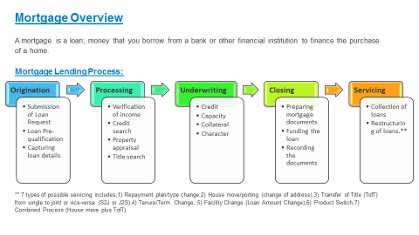

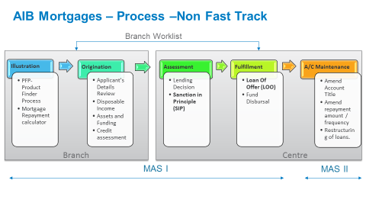

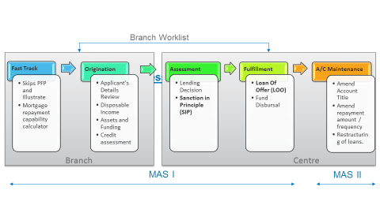

Nov 2015 to Jan 2017. Company Name; INFOSYS **Project Name; eFulfillment Management Portal for DHL**

**Description**: AP Portal is designed to provide a complete end to end fulfillment and shipping solution for small to medium merchants in Asia Pacific.

To achieve this, AP Portal need to link the four ecommerce segments, which are Sales Order Channels (e.g. Market Places, Web Stores etc.), Fulfillment Centers(Warehouses), Distribution Channels (e.g. Connect for Cross Border Shipment, Mirror for Domestic Shipment, Blue dart System for India specific Domestic Shipment) and Billing System (e.g. DHL SAP) into one single platform.

AP Portal’s targeted merchants can be categorized as follows: -

**1. eFulfillment Merchants** – Merchants who requires the ability to manage inventory, orders, and shipments via a single centralized portal, with end-to-end view on orders’ status tracking throughout the process lifecycle from order acquisition, orchestration, fulfilment down to Distribution.

**2. eFacilitation Merchants** – Merchants who, on top of the basic eFulfillment functionalities, requires services and consultations to integrate AP Portal with their existing business Platform for additional flexibility and feature such as invoice reconciliation, material Management etc.

**3. eShipping Merchants** – Merchants who requires only the order acquisition and distribution

Capability to ship their products to their customers. Majority of these merchants are the

Existing Asia Portal users.

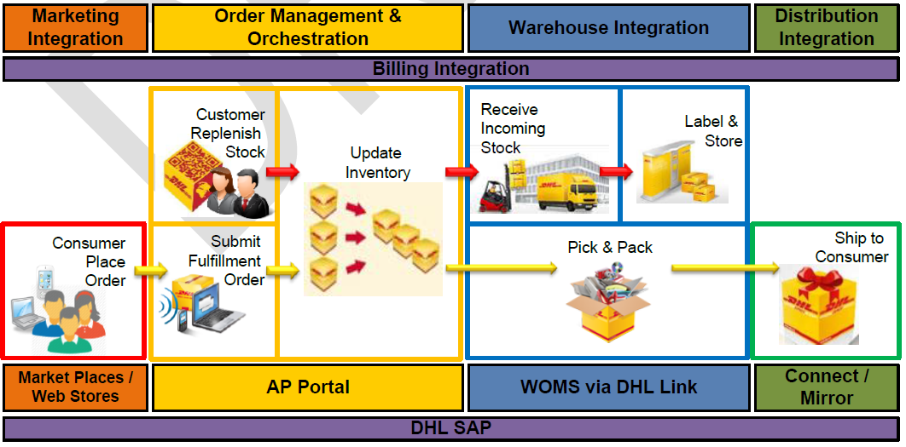

Technology; HIBERNATE 4.0.1, J2EE 6, JSON Messaging, Spring Framework 3.2.9, Spring Security 3.2.4, RESTFUL web service, JAVA (CORE, ADVANCE), JSF2.2.7, Prime face, and Maven 3.1., MYSQL version 5.6, Tomcat 8.0.9.

Duties.

* I Worked on Account management, Product management, and Inventory management, Order Management modules for design and coding and database of this module.

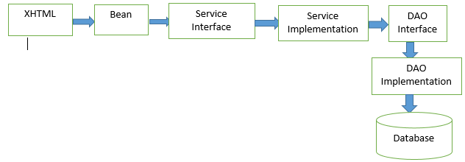

**Job Title 2**

**July 2014 to Nov 2015.**

**Company Name;** ACCENTURE

**Project Name; Accenture Marketing Analytics platform.**

**Description**: The Accenture Marketing Analytics Platform (AMAP) is a comprehensive marketing planning environment that enables timely assessment of marketing performance.

AMAP serves as the technology and analytics infrastructure to enable clients to increase marketing effectiveness on an on-going basis by incorporating the most recent market data.

**Technology**: HIBERNATE, SPRING MVC, JAVA (CORE, ADVANCE), EXTJS, DESIGN PATTERNS, Cometd, json, XML, MySQL server 2012, Tomcat 7.0.

**Duties**: Requirement understanding from technical architect, product solution designing, Technology evaluation, I Worked on Forget password service module for design and coding and database of this module. also working as individual contributor.

**Jan 2013 to June. 2014**

**Company Name; DATACUBE SOFTTECH PVT. Ltd.**  
Project Name; DATA CUBE RETAIL ERP

Description: Data Cube Retail ERP is accounting Software prepared for customize software for Accounting, Stock, Barcode, Billing, Vat.

Technology: JAVA (CORE), HIBERNATE FRAMEWORK, SWING/AWT. MYSQL

Duties**.**

* I Worked on Company, Administration module for design and coding and database of this module.

**Jan 2012 to July 2012**

**Company Name; ST. INFOSYS**  
Project Name; Custom Translator (ASCII TO EDI)

Description: Custom Translator is prepared for translation of flat file to EDI and vice versa. Custom Translator can handle multiple ST’s and Multiple GS.

Technology; JAVA (CORE), COLLECTION, INTERFACE, EXCEPTION, SWING/AWT MYSQL

Duties**:**

* There was some problem in this software like performance and not support multiple file formats. So, I worked to resolve these problems.
* Previously this software translates files in ASCII- EDI format only and if any file fail during translation than finding the error was complex because this software was created without UI, so I worked on creation of USER INTERFACE of this software

Education

Master’s in computer application 2008 to 2011  
University Name: Rajasthan Technical University, Rajasthan

* CompuCom Institute of Information Technology & Management, Jaipur
* 62.83%

Bachelor’s in computer application 2005 to 2008  
University Name: University Of Rajasthan, Rajasthan

* Tirupati College of Technical Education, Jaipur
* 61.11%

Technical Skills

* **Build management Tools**: MAVEN, JENKINS, JETTY, SVN,GIT,GIT bash, Confluence, JIRA
* **Core java:**

(Class, Object, Package, Interface, Inheritance, Exception Handling, Collection, Multithreading, Generics, Swing/Awt, String Handling).

Design pattern (singleton, command, broker, DTO, DAO, front controller, Template,

Factory pattern, Session façade)

Advance java: Apache camel, OpenShift cloud, Bitbucket, Docker, spring boot with microservices soap and rest, hibernate, Apache CXFEndpoint, Apache commons, Apache log4j, Oracle 11g.SDS

Hibernate framework, Spring MVC, Spring Boot, Webservices(REST,SOAP), Struts, Jdbc, Jsp, and Servlet.

* **Database:** MySQL, Oracle, MS Access.

Strength

* Adaptability and Quick Grasping Power
* Self-motivated and to motivate others.
* Diligent at work.
* Accept Challenges.

**Personal Information**

* Father’s Name **:** Mr. R.N Saral
* Date of Birth **:** 6/May/1990
* Gender **:** Male
* Languages **:** Hindi, English
* Permanent address **:** 119-A, Jawahar Colony, Jhalawar

Rajasthan, Pin – 326001

**Date** **:**  **Abhinav Saral.**