Harikritan Singh

INTERN

I got good programming skills in Core java with knowledge of Automation Tools and Selenium and Manual testing.I am also working on a few personal projects.

[harikritansingh920@gmail.com](mailto:harikritansingh920@gmail.com) 

8217242304 

Bangalore, India

# EDUCATION

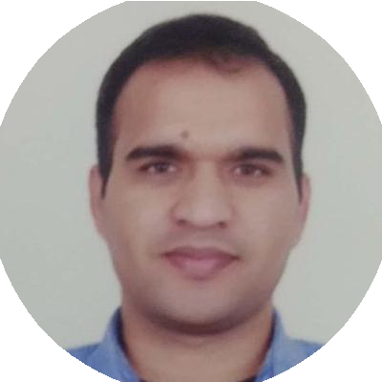

## Study Programme

### QSpiders Institute-Software Testing Training

*08/2017 - 02/2018*, *Bangalore, India Courses*

Object and String class

# SKILLS

core java

selenium

Automation tool

manual testing

SQL

Collections

HTML

CSS

**Manual Testing**-SDLC,

Functional Testing, Integration Testing,System Testing,Acceptance Testing, STCL,Defect Lyfe Cycle, Regression Testing.

**SQL**- DML, DDL,

TCL,JOIN, Functions.

**CSS**-Borders,Color, Selector,Background, CSS Text and Front

**Core java**-Oops Concept,

Object Class and Abstract, String Class, Collections,

**HTML**-

Tags,Forms,Attributes,

**Automation(Selenium)**- Locators,Xpath,Method of WebElement,List Box,Action, Frame,pop- Up

Interface and Abstraction

Exceptions

Constructor

# PERSONAL PROJECTS

Multtithreading

#### Detection and Analysis of Jellyﬁsh Attack in MANETs” (02/2017 - 05/2017)

we have implemented Jellyﬁsh delay variance attack on AODV and proposed a JFDV detection algorithm that analyzes packet delaying misbehavior of nodes and detect multiple JFDV attacker nodes. It reduces average end-to-end delay and increases throughput by re- routing data packets through alternate route consisting of non- malicious nodes.

#### GLSports Web Page Application (02/2021 - 05/2021)

I have created **web-page Application on GLSpports** by using

## Bachelor of Engineering

### Vijaya Vittala Institute of Technology

*08/2011 - 05/2017*, *Bangalore, india Courses*

Computer Science and

Engineering - 57%

## Class 12

### Bihar Board-R.L.S.Y. College West Champaran

*06/2008 - 04/2010*, *Patna, India*

*Courses*

**SCIENCE**-Physics, chemistry, Mathematics - 50%

**HTML and CSS .**And also i have created **REGISTRAION FORM** by using **HTML**

# CERTIFICATES

#### Internship-klupta Research labs Pvt. Ltd. (02/2017 - 05/2017)

*Project Name-"Detection and Analysis of Jelly ﬁsh Attack in MANETs"*

#### SOFTWARE TESTING (08/2017 - 03/2018)

*i have completed software testing course from* ***QSPIDER INSTITUTE*** *BANGALORE*

# LANGUAGES

English      Hindi     

# INTERESTS

Reading

Playing

cooking