**Name: Pavan Dudhwal** 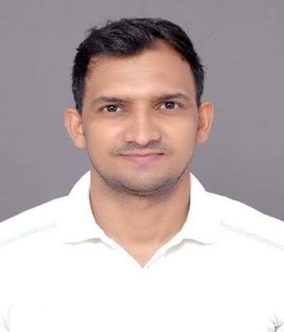

**Mail ID:** [**pavan.duggu@gmail.com**](mailto:pavan.duggu@gmail.com)

**Mob: +91 9014113360**

**Aspiration:**

To work, grow and excel with the Industry. I have a goal to be on top-level in the organization so that I can contribute in the growth of a company.

**Summary:**

* Having overall 5 years of total IT experience in PMO (Project Management Office)
* Coordinate project management activities such as tracking monthly/weekly reports and tracking pending invoices
* Responsible to coordinate and organize weekly meetings and prepare MIS report for the BU head with MoM action points.
* Tracking new or upgrade orders in the BU and following up till the invoices are raised for the payments
* Organize meetings for the BU head and manage the calendar timings.
* Coordinating with the different technology leads for SIPs and any other Adhoc requests
* Getting DSat tickets analysis done from different TLs and sharing it to feedback team
* Managed the KT sessions in the team from the client as well as reverse KT.
* Organizing daily/weekly meetings on regular and for other critical issues
* Tracking the revenue of the projects in the BU on weekly basis
* Other adhoc requirements for data sharing and analysis as per top management requirement
* Following up with PMs on the pending things of the BU projects
* Tightly follow up with PMs on HCR reports and get it closed on time every month.
* Responsible for Quality Check of the upgrade and existing POs in the BU projects.
* Tracking all the POs and make sure those are closed and invoices are raised

**Experience:**

* I am working with Cloud4c Services Pvt Ltd as Senior Executive- PMO from 25th Nov-19 till date.
* I have worked as SSE with Legato Health Technologies (payroll BCT) from 11th Feb 2019 to 19th July 2019
* Worked as Associate Consultant with Capgemini from 29th September 2014 to 29th September 2017.
* Worked as Technical support officer with Knoah Solutions Pvt ltd from Sep 2013 to May 2014.

**Project 1**: BIB- Bank in the Box

* Duration : 11 Months
* Industry : Banking domain
* Environment : PMO

**Project 2**: Anthem US

* Duration : 5 Months
* Industry : Health Care US
* Environment : Project coordinator

**Responsibilities:**

* Responsible for managing the KT of an application among the group of people
* Documenting and following up on important actions and decisions from meetings
* Responsible for project management like managing the team and the project requirements.
* Providing administrative support as needed
* Developing project strategies and determining project changes
* I was responsible for resource allocation in the project
* Monitor project progress and handle any issues that arise
* Making sure the meeting arrangements and booking the meeting rooms
* Make sure that client needs are met as projects evolve
* Sharing relevant documentation and reports with project teams

**Project 2:** Georgia Pacific (GP)

* Duration : 3 years
* Industry : Manufacturers of Tissue paper
* Environment : Project Coordinator / Project Management

**Responsibilities:**

* Responsible for project management like managing the team and the project requirements.
* I was involved in budget forecasting and setting up a new project team.
* Getting any approval from the concerned person in the team for all the time sheets.
* Monitor project progress and handle any issues that arise
* Coordinate project management activities, resources, equipment and information
* Developing project strategies and determining project changes
* Create and maintain comprehensive project documentation, plans and reports
* I was the point of contact for various working groups
* Responsible for Daily health checks of the systems and BO systems
* Performing basis activities such as system health checks across sap systems and R/3 administration, transport administration, performance tuning and workload analysis etc.
* TMS configuration and handling transport related problems, transport management.
* System monitoring (Checking for errors, warnings, etc) and troubleshooting.
* Responsible for daily health checks.

**Areas of interest:**

* PMO (Project Management Office) and Project coordination (Project Management)

**Education:**

* B-Tech in ECE stream from BVRIT, Narsapur in 2013 with 67%
* Intermediate from Narayana Jr.College, Secbad in 2009 with 87%
* SSC from Sri Vivekananda High School, Medchal in 2007 with 78.5%