Komali Guduru
komelig572@gmail.com | 360 926 1528
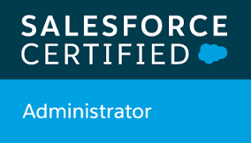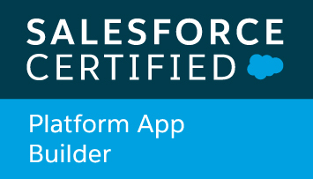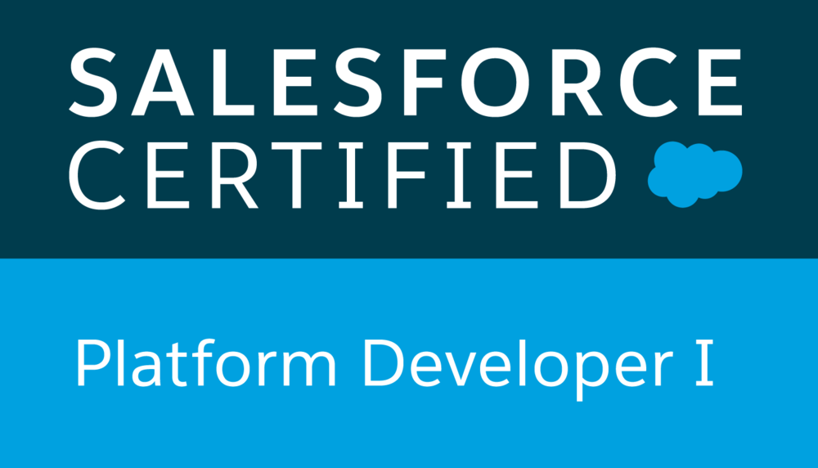
Introduction:
Over 6 years of IT experience as Salefoce platorm Administrator and Developer in application design, analysis, development, testing, documentation, implementation and execution of large & complex projects.

Professional Summary:
- Excellent understanding of Software Development Life Cycle (SDLC) including analysis, requirement gathering, architecture design, development, enhancements, testing, deployment and maintenance of enterprise applications
- Extensive experience in automating business processes using declarative features of Force.com
- Experienced in building Custom Applications that includes administration, configuration, implementation and support with Salesforce.com platform
- Experience in Force.com Customization, Security Access, Workflows, Approval process, Data Validation, Data Utilities, Analytics, Sales, Marketing, Customer Service and Support Administration
- Proficiency in SFDC Administrative tasks like creating Users, Profiles, Roles, Page Layouts, Record Types, Email Services, Reports, Dashboards, Tasks and Actions
- Experience working with various advanced fields like Picklists, Custom Formula Fields, Field Dependencies, Sharing Rules and Approval Processes for automated email alerts, field updates, and other workflow actions
- Experience in salesforce development using Apex classes, Apex Triggers and Visualforce pages, SOQL and SOSL
- Ability to meet deadlines and handle pressure in coordinating multiple tasks in a project environment
- Always eager to learn new technologies and implement them in challenging environments

Technical Skills:
- Force.com: Salesforce CRM, Apex Classes, Apex Triggers, Apex Web Services, SOQL, SOSL, Visualforce Pages, Workflows & Approvals, Reports, Dashboards, Analytic Snapshots, Custom Objects, Data Model
- Salesforce Tools: Force.com IDE, Apex Explorer, Data Loader
- Programming Languages: C, C++,C#, Java, Apex, Visualforce, Apex
- Database: DB2, VSAM, MySQL
- Web Technologies: HTML, CSS, JavaScript, XML
- Operating Systems: Windows 98/2000/XP/Vista/7/8/10, Unix, Linux, z/OS
- Other Tools: MS Office, Eclipse, HP Quality Center, HP Service Manager, ServiceNow, Endevor, File-Aid, Expeditor, Change man, MQ

Educational Qualifications:
- Master’s in Computer Applications (MCA) from SV University, India
- Bachelor’s in Mathematics from Nagarjuna University, India

Professional Experience:

Federal Aviation Administration (FAA) , Washington D.C Role: Salesforce Admin/ Developer
Project: CDMS Aug 2019 – Till Date

Roles & Responsibilities:
- Provided support to 300+ Salesforce users and acted as the primary point of contact for end-user support.
- Maintained and customized Salesforce.com scopes such as users, roles, profiles, groups, accounts, contacts, record types, sharing rules, custom objects, pick lists.
- Created Custom Objects and defined lookup and master-detail relationships on the objects. Also created junction objects to establish connectivity among objects.
- Created workflow rules and defined related tasks, time-triggered tasks, email alerts and field updates to implement business logic.
- Configured page layouts, search layouts to organize fields, custom links, related lists, and other components on a record detail and edit pages.
- Created document templates, record types,approval process & data fields.
- Developed reports, dashboards, and processes to continuously monitor data quality and integrity.
- Research, compare and enable 3rd party offerings using the AppExchange.
- Deployed workflows and email Templates using change sets.
- Managed multiple sandbox environments.
- Managed ongoing support request and administrative needs of users.
- Implementation of multiple uses of Apex, SOQL queries and SOSL.
- Customized several Validation Rules, tasks,Triggers, Apex classes to achieve the complex business functionality.
- Designed, developed and deployed Apex Classes, Controller Classes, Extensions and Apex Triggers for various functional needs in the application using the Eclipse IDE.
- Used SOQL & SOSL with consideration to Governor Limits for data manipulation needs of the application using platform database objects.
- Load/Manage the data using Apex Data Loader.
- Implemented Docusign App Exchange Application.
- Used Force.com IDE Plug-in for Development and deployment changes/application on production.
- Performed Unit Testing, for the customizations and developments done during the project and also was involved in the Integration Testing.
- Worked closely with the legal team in implementing an end to end solution.
- Completed work in timely manner.

Virginia Retirement System, Richmond, VA Role: Salesforce Admin/ Developer
Project: Wealth Management System July 2017 – April 2019

Roles & Responsibilities:
- Customized Accounts, Contacts, Leads, Campaigns and Cases.
- Customized several Validation Rules, tasks, Workflow rules, Triggers, Apex classes to achieve the complex business functionality.
- Implemented Configuration, Customization and Development with Salesforce.com on Service Cloud and Sales Cloud.
- Created page layouts, search layouts to organize fields, custom links, related lists, and other components on a record detail and edit pages.
- Designed, developed and deployed Apex Classes, Controller Classes, Extensions and Apex Triggers for various functional needs in the application using the Eclipse IDE.
- Developed Visual Force Pages, Visual Force Custom Controllers Components, Advanced Search Functionality, Custom Objects, Analytic Snapshots, Tabs, Tags and Components.
- Used SOQL & SOSL with consideration to Governor Limits for data manipulation needs of the application using platform database objects.
- Used Force.com web service API for implementing WSDL in the application for access to data from external systems and web sites.
- Integrated the SOAP and Rest based Web Services for extracting the data from external systems to display in the pages of salesforce.com.
- Load/Manage the data using Apex Data Loader.
- Developed and configured various Reports for different user profiles based on the need in the organization.
- Implemented Docusign App Exchange Application.
- Created Custom Objects and defined lookup and master-detail relationships on the objects. Also created junction objects to establish connectivity among objects.
- Created workflow rules and defined related tasks, time-triggered tasks, email alerts and field updates to implement business logic.
- Used Force.com IDE Plug-in for Development and deployment changes/application on production.
- Performed Unit Testing, for the customizations and developments done during the project and also was involved in the Integration Testing
- Maintained data cleanliness and accuracy by adding custom validation rules, custom formulas, reports and dashboards.

TCS, Bloomfield, CT Oct 2012 to May 2016
Role: Salesforce Administrator
Project 1 #: MedTracker Sept 2014 – May 2016
Role: Salesforce Administrator

Roles & Responsibilities:
- Interacted with the various business groups for requirement gathering throughout the planning and implementation
- Worked with various salesforce.com objects like Accounts, contacts, Solutions and Custom Objects
- Developed various Custom Tabs, Tags and Components
- Developed Apex Classes, Controller Classes and Apex Triggers for various functional needs in the application
- Developed and deployed workflows and approval processes for opportunities and products/ assets management
- Implemented the requirements on Salesforce.com platform and Force.com IDE Plug-in using Eclipse
- Successfully established a new lead follow-up procedure which shortened the response time to qualified leads and generated more meetings for the account executives
- Created and used Email templates in HTML and Visualforce
- Integrated the web services by generating the necessary stubs from the WSDL files
- Created dashboard and reports for the business users
- Performed the roles of Salesforce.com Developer and Administrator in the organization
- Used the sandbox for testing and migrated the code to the deployment instance after testing
- Responsible for all the activities related to configuring Data Loader, uploading data in CSV files into salesforce.com, checking for the correctness of the data

# 3) Client: Cigna, Bloomfield, CT
Project 2#: Dentacom Oct 2012 – Aug 2014
Role: Salesforce Adminstrator

Roles & Responsibilities:
- Gathered requirements and developing client-specific solutions by understanding customers and business and technical environment.
- Prepared the Design document and training manual for the entire application.
- Created the Technical Design document to record the detail process.
- Designed, and developed the Custom objects, Formula fields, validation rules, Page layouts, components, Visual Force Pages to suit the needs of the application.
- Created Custom Profiles, Public Groups and Roles to distribute user rights and functionality.
- Created and implemented object level, field level and record level security.
- Involved in Testing new enhancements and functions to ensure quality.
- Perform day to day admin tasks and provide User training about the new enhanced feature.
- Migrated data from MS Excel / CSV files to SFDC using Data Loader.
- Provided support ongoing salesforce.com maintenance and administration services including periodic data cleansing, custom objects, workflow and triggers.
- Prepared documentation regarding existing integration of salesforce with other systems in the company.

