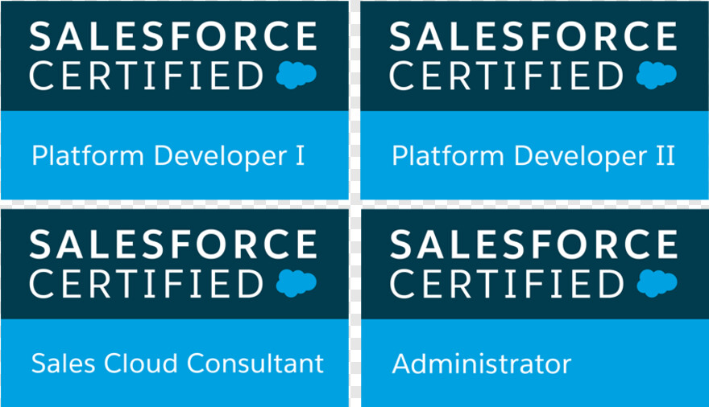
Harish Gogineni
Salesforce Developer
937-336-7694
goginenihari123@gmail.com

PROFESSIONAL SUMMARY:
- Seven Plus years of IT experience with Analysis, Design, Development, Coding, Testing, Deployment and Support of Enterprise CRM/Web applications in various domains like Financial and Banking.
- Seven Years of Development, Configuration, Administration with Sales force CRM implementations using Sales Cloud, Service Cloud, Communities and Lightning.
- Strong customization experience using Apex Classes, Controllers, Triggers, Web Services, Aura Framework, Schedule, Batch classes, Visual force Pages, JavaScript, CSS.
- Experience in developing custom solutions on Force.com platform using Sites and Communities by building rich Visual force pages with custom look and feel.
- Proficient with Apex Query Language (SOQL, SOSL), working with large data volumes and tuning queries to void hitting Governor limits
- Good UI development using Aura Framework, JavaScript, CSS.
- Strong sales force integration experience by providing Enterprise WSDL to external consumers and developing customized integrations by writing Apex SOAP, REST web services classes.
- Strong Salesforce1 Lightning experience with Lightning App builder, Lightning Components, Server/Client controllers and Lightning Design System styles.
- Experience in rollout of Sales force classic apps into Salesforce1 Lightning experience by developing custom components and converting existing Visual force pages to working Salesforce1 & Lightning.
- Strong experience in writing Unit test classes to meet 75% of code coverage, developing test factory classes to create test data, to handle Deployments (continuous integration).
- Sets, Groups, Queues, Single Sign-On, Sharing rules, Certificates and Key management.
- Good experience in configuring Service Cloud, Service Console, Entitlements, Email-to-Case, Auto response, Escalation rules in Service cloud.
- Expertise in performing data cleansing, deducing and migration using Data Loader, Informatics and Demand tools, preparing Data dictionary for data integration.
- Proficient in deploying Salesforce applications across various sandbox and production instances using Force.com and Migration tool, Change Sets, Workbench and Eclipse.
- Good experience with Agile methodology and RTC, Agile Accelerator tools to track user stories and provide status updates to the team and Scrum Master.
- Good experience in developing web pages using HTML, CSS, Bootstrap, JavaScript, Sales Cloud, creating Dashboards and Reports.
- Expertise in performing data cleansing, deducing and migration using Data Loader, Informatics and Demand tools, preparing Data dictionary for data integration.

Technical Skills
Salesforce Technologies | Apex, Triggers, Scheduler, Batch Apex, Apex Class & Apex Web Service, Visualforce, Salesforce Lightning, CPQ, Sales Cloud, Service Cloud, Custom Controllers, Extensions, Record Types, Chatter, SOQL, OWD (Organization Wide Default), Apex Data Loader, SOSL, Workflow, Outbound Messages, Approvals, Field updates, Reports, Custom Objects, Custom settings, Custom labels and Tabs, Email Services, Role Hierarchy, Lightning, Salesforce Communities, Dashboards, Security Controls, AppExchange, Sandbox, Salesforce 1.
Salesforce API’s | BULK API, REST API, Metadata API, SOAP API
ETL Tools / Integration / Data Migration Tools: | Apex Data Loader, Force.com Migration Tool.
MS Office / Other Tools | Microsoft Project, MS Visio / MS Word, Excel, Power Point, Outlook.
Force.com Tools | Workbench, CTI toolkit, Excel Connector, Force.com Eclipse IDE
Programming Languages: | JAVA, Dot Net platform, C#, C, C++, VB, APEX and UML.
Web Technologies | JavaScript, CSS, HTML.
CPQ | Product Rules, Price Rules, Discount Schedules, Pricing methods
Service Cloud: | Live Agent, CTI, Knowledge, Web to case, Email to case, Escalation Rules.
Databases: | Oracle 9i/10g/11i, DB2, MS-Access, Microsoft SQL Server 2008/05/2000, and MySQL.
Version Control / CI | GIT, GitHub.

Education & Certifications:

- Bachelor of Technology in Computer Science from JNTU, INDIA.
- Master’s in computer science from University of Cumberland’s.
- Certified Salesforce Platform Developer 1.
- Certified Salesforce Administrator.
- Certified Salesforce Platform App Builder.
- Certified Salesforce Sales Cloud.
- Certified Salesforce Platform Developer 2.

PROFESSIONAL EXPERIENCE:

Client- Centrify Sep 2019 – Current
Location : Santa Clara, CA
Role: Salesforce Developer

- In-depth knowledge in Product setup, Product Options, Product configuration & rules, Pricing, Discounting and Quote templates in Steel brick CPQ.
- Experience leading user requirement sessions focused on CPQ processes and experience documenting detailed requirements, business processes and solution design.
- Worked on implementing the lightning components using with Aura.
- Worked on Lightning interfaces and components, Implemented Client-side controllers, and server-side controllers.
- Worked with SOQL and SOSL queries for retrieving data from Force.com platform and optimized SOQL while querying against large data sets.
- Implemented salesforce best practices in Triggers, Controllers, and written utility classes for recurring logic.
- Created Report Types and built Reports and Dashboards using standard/custom report types on various objects for business users.
- Created Case Escalation rules, Assignment rules and Auto case generation using Email-to-case.
- Created Workflow Rules, Page Layouts, Approval Process, Tasks, Email Alerts, Field Updates and Outbound Messages to manage the Workflow & Approvals.
- Supported the project end to end implementation.
- Upgraded the CPQ Package to Latest version in both Sandbox and Prod.
- Worked on Optimizing the Workflows and Process Builders.
- Worked on Product rules and Pricing rules on CPQ.
- Migrated data from legacy systems to Salesforce system.
- Created Reports and Dashboards as per the customer requirements.
- Worked on Record Types, Validation Rules, Triggers and Page Layouts.
- Involved in end-to-end QA and UAT testing.
- Developed Visual force pages, components for Account, Opportunity, Campaign and custom objects customizations and written apex Controllers.
- Implemented salesforce best practices in Triggers, Controllers, and written utility classes for recurring logic.
- Worked on critical production issues raised by business users directly and migrated to production based on issue.
- Involved with Salesforce.com Premier Support and handled the support cases with the help of Sales force support.
- Created Report Types and built Reports and Dashboards using standard/custom report types on various objects for business users.

Client- Infoblox Jan 2018 – Aug 2019
Location : Santa Clara, CA
Role : Salesforce Developer

- Worked with SOQL and SOSL queries for retrieving data from Force.com platform and optimized SOQL while querying against large data sets.
- Implemented salesforce best practices in Triggers, Controllers, and written utility classes for recurring logic.
- Created Report Types and built Reports and Dashboards using standard/custom report types on various objects for business users.
- Created Case Escalation rules, Assignment rules and Auto case generation using Email-to-case.
- Created Workflow Rules, Page Layouts, Approval Process, Tasks, Email Alerts, Field Updates and Outbound Messages to manage the Workflow & Approvals.
- Supported the project end to end implementation.
- Upgraded the CPQ Package to Latest version in both Sandbox and Prod.
- Worked on Optimizing the Workflows and Process Builders.
- Worked on Product rules and Pricing rules on CPQ.
- Worked on implementing the lightning components using with Aura.
- Worked on Lightning interfaces and components, Implemented Client-side controllers and server-side controllers.
- In-depth knowledge in Product setup, Product Options, Product configuration & rules, Pricing, Discounting and Quote templates in Steel brick CPQ.
- Experience leading user requirement sessions focused on CPQ processes and experience documenting detailed requirements, business processes and solution design.
- Migrated data from legacy systems to Salesforce system.
- Created Reports and Dashboards as per the customer requirements.
- Worked on Record Types, Validation Rules, Triggers and Page Layouts.
- Involved in end-to-end QA and UAT testing.
- Developed Visual force pages, components for Account, Opportunity, Campaign and custom objects customizations and written apex Controllers.
- Implemented salesforce best practices in Triggers, Controllers, and written utility classes for recurring logic.

Conduent- Pennington, NJ Oct-2016 to Nov-2017 Salesforce Developer
Roles & Responsibilities:
- Written SOQL, SOSL queries for the application in Apex Classes, Controllers & Triggers, and optimized queries to handle bulk data.
- Written Apex Classes, Custom Controllers, Extension Controllers and Apex Triggers in the application for various functional requirements, Sales Cloud, creating Dashboards and Reports
- Developed application using Apex Controllers (Standard, Custom and Extension Controllers) to handle user actions performed in the Visual force pages.
- Written Apex Test Classes for unit testing to ensure at least 75% of code coverage in order to move code to production, to handle Deployments (continuous integration).
- Used Force.com as an IDE for development for Visual force Pages, Apex classes, Triggers and creating Objects.
- Involved in customization of salesforce application setup activities like managing users, role hierarchy, profiles, permission set, network settings and validation rules.
- Customized Standard objects Lead, Account, Contact, Opportunity, Campaign, Cases & created new Custom Objects.
- Created and customized Page layouts, complex Formula fields, Validation rules, Triggers and Custom tabs.
- Implemented Cases, Service Console for the support/call center business users.
- Developed/implemented business workflows using Workflow rules and Approval process and performed Actions like Field Update, Email update for Standard and Custom Objects as per the business needs.
- Implemented Web-to-Lead and converted Lead to Account.
- Implemented security for the applications using Profiles, Roles, Permission Sets and Sharing rules for the organization.
- Written call scripts in visual flows to generate quotes by the call center team to the customers based on the information provided by the users, experience in a fast-paced, services environment.
- Used Data Loader to bulk data import/exporting to Salesforce.com from external sources.
- Created and customized salesforce.com Reports and Dashboards required for various business groups.
- Deployed application from Sandbox to different other Sandbox as well as into Production environments using Change sets.

Bank of America -Newark, DE Feb-2015 to Aug-2016
Salesforce Developer

Roles &Responsibilities:
- Interacted with various business team members to gather the requirements and documented the requirements.
- Developed various Apex classes, Controller classes and Apex Triggers for various functional needs in the application.
- Designed and developed Visual force pages based on the business requirements.
- Worked on Web services and XML Parsing and mapping the XML string into the object entities.
- Integrated the Rest Web Services API for extracting the data from external systems to display in the pages of salesforce, Sales Cloud, creating Dashboards and Reports.
- Worked on different portals like Self Service Portal, Partner Portal and Customer Portal.
- Used Eclipse as an IDE for development of Apex classes, Visual force pages and meta-data changes.
- Worked on Salesforce application setup activities and performed configuration of Users, Roles, Profiles, IP filtering and Outlook connector, to handle Deployments (continuous integration).
- Defined Lookup and master-detail relationships on the objects and created junction objects to establish connectivity among objects.
- Created Custom Objects and fields for transactional and contractual information.
- Worked on Validation Rules, Workflows and Approval Processes, Page Layouts, sharing rules, Profiles, Creating Roles.
- Developed and configured various Reports and Report Folders for different user profiles based on the need in the organization.
- Load/Manage the data using Apex Data Loader and Excel Connector.
- Using Apex Data Loader and Import Wizard for migrating records to sources and loaded data into Call Center application and for cleaning of data.

HSBC Insurance-India Feb 2014 – Dec 2015 Java Developer

- Involved in the database design and analysis of the business requirements. Coding in MVC-Struts design pattern with best java patterns for action classes, form beans, data access and business object classes.
- Developed the application-level flow by using Java Servlets, JSP, JavaScript, EJB.
- Developed stateless session beans for business logic implementations.
- Involved in design modeling in rational rose by using the various java Patterns like DAO, Service locator and Value List handler.
- Updated the information into the database with all the options and provided an option to write the information as an XML file that can be stored on the file system.
- Utilized various stored procedures, views, functions and triggers to develop the business modules based on the required functionality.
- Design, Develop and implement customer requirements using J2EE, Java, Java Server Pages (JSP), JavaBeans and XML.
- Involved in coding of Administration module for configuring Auditors.
- Wrote various Queries to augment the application logic.
- Mailing system using Java Mail API to notify the staff when a customer submitted a policy.

