Ankit kumar   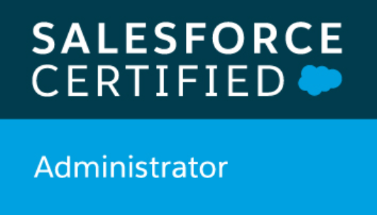

Phone : +91-8130581175
Email Id:ankit.kumar833@gmail.com

PROFILE SUMMARY
- 7.5+ years of IT experience with ample exposure to Salesforce.
- Good experience in developing and implementing Salesforce LWC and Aura framework.
- Good experience in working with Sales Cloud, Service cloud and Community Cloud.

Extensive experience in handling Flows, Apex triggers and Batch.

Good experience in making Configuration Changes.

Proficient in Customization, Documentation and Development on Salesforce.com and Force.com Platform.

WORK EXPERIENCE
Working as Associate Salesforce Associate Technical Lead in LTIMindtree. | Dec 2020 – Present
Worked as Salesforce Technical Consultant in Wipro Limited. | July 2018 – Dec 2020
Worked as Software Developer in Zynom Technologies Private Limited. | Aug 2015 - June 2018

ACADEMIC QUALIFICATIONS

Bachelor of Engineering (E&C) in 2013 from PIET, RTM Nagpur University.

TECHNICAL EXPERTISE

- Expert in Apex Triggers, Apex Class, Aura Framework & Visualforce, Workflows, Process Builder and other configuration modules.
- Designed and Implemented Lightning Web Components for various business requirement.
- Experience in designing optimum solutions, mapping requirements technically to Salesforce product, understanding new features of salesforce and suggesting it to customer as applicable.
- Proactive in implementing of value added modules & tools in various projects to enhance end-user productivity.

PROJECT DETAILS

Jan 2020 to present
Kohler Power Dealer
Description:

Client- Kohler

Description:
- Kohler uses this Salesforce to assign their product like Generator and engines and keep a track of their business branches and Customer. Kohler is using various integrated system through which Salesforce receive various leads in the form of accounts and Contact. Designing and Implementing Lightning Web Components for various business requirement.

Roles
- Responsible for various software development activities including requirement analysis, design, development and defect fixing.
- Involve in implementing their new community.

Jan 2019 to Dec 2020
Care Partner Connect Portal
Client-Philips

Description:
Philips uses this Portal to assign assets to the Patients i.e Personal account in Salesforce. In asset there are emergency buttons which triggers message to Hospital i.e Business account in Salesforce and Contacts. Here contacts refers to Responders from Hospitals who reaches out to the Patients in case of emergency.

Roles
- Responsible for various software development activities including requirement analysis, design, development and defect fixing.
- Involve in implementing and migration from Salesforce Classic to Lightning.

Aug 2018 to Dec 2018
RFPP- (Retail Frontline Performance Platform)
Client-Shell

Description:
RFPP is the app which enables users of downstream retail business to record all the data related to their site related activities and assessments. Salesforce table which is being used to store all the users of the RFPP app and all the records of Shell Sites and Partners.

Roles:
- Responsible for various software development activities including requirement analysis, design, development and defect fixing.
- Providing support to the client side which include feature demonstration to the onsite team and client.
- Working on the Cases, Analytics Studio, Salesforce Chatter, Dashboard and reports.

Aug-2017 to June-2018
Inside Sales Application
Client: Mobiloitte

Description:
The Purpose of this Project is to automate the Manual Case Creation Process using Customize Email to Case feature of Salesforce and Created the new Application inside App for the group of users.
Roles
- Created the Application “Inside Sales Application” for the set of users which have several customize features as per the functional requirement.
- Created Sharing rules, Permission Set, Case Assignment Rules, Email Templates, AutoResponse rules, Workflow rules, Process Builder, Custom links, Queues, Public Groups, Validation rules, Record Types, Page Layout, Custom Object Creation etc.

PERSONAL DETAILS

- Date of Birth : 14.11.1990
- Gender : Male
- Languages Known : Hindi, English
- Address : 809, 2nd Cross, C-Block, AECS Layout, Bangalore -560037

DECLARATION

I hereby state that the information provided above by me is correct to the best of my knowledge.

Place: Bangalore Ankit kumar

