**teamware Solution 6 Months**

**Flexi-One Solution 6 Months**

**iGATE Global Solution**

**5 + Years**

**Capgemini**

**10+ years Running**

**Khitish Chandra Behera**

Agile Digital Project Manager | Scrum Master

(+91) 9380733722| [khitys@hotmail.com](mailto:khitys@hotmail.com)

**Career Timeline -**

**Career Summary –**

As an agile practitioner I have close to **15 + years** of experience in software industry with core focus in Agile Coaching (Changing Mindset, Challenging status Quo, Agile transformation), Product & project Management**.** I have expertise in setting up the agile environment by providing coaching and trainings to software development teams in lean agile software principles, facilitating all Scrum ceremonies and mentoring product owners, scrum masters, individuals, and teams. His blended engagements include serving as Agile Coach, Scrum Master, Product Owner. I have experienced on web and mobile application (native and hybrid) development. Currently working with **Capgemini Technology services**.

**Highlights –**

* Last Six years working as Digital Agile Project Manager | Release Manager | Scrum master
* 8+ years of Scrum experience along with distributed agile and handled projects with Microsoft technologies, Hybris, hybrid, and native mobile app, Stibo master data management, Remedy, Java.
* 12+ year of technical experience in Microsoft Technologies (C#, ASP.net, MVC 6, SQL, Sybase, SharePoint)
* 4+ years worked at a customer-facing role in Japan and Norway.
* 4+ years worked with Japanese customer and 9 years with European
* Service support and operation, Service Transition, Service Operation, Continual Service Improvement; Client and vendor coordination
* At a peak Handled 40+ team, multiple projects (application development and maintenance projects)
* Good hands on experience in progress analysis - team (burn down chart), analyzing group Agility, conducting Agile audits & self-assessment drives
* Have worked as facilitator for Agile ceremonies, estimations, hackathons, war-room sessions
* Expertise techniques in discovery sessions, release planning, guiding on epics, user-stories formations, backlog grooming, sprint planning, definitions-of-done, poker card estimations - story points & hourly, daily scrums with in-house & multi-location teams, sprint. demos, retrospective meetings, velocity chart, sprint burn down chart, release burn down.
* Streamlining org level processes
* Defining agile roles as per org structure
* Partner with the Product Owners, Product Strategy group, other Scrum Masters, and engineering teams to achieve the highest level of customer satisfaction.
* Developed and delivered team and organization training materials and workshops, building knowledge and skills to facilitate the Agile transformation.

|  |  |
| --- | --- |
|  |  |

**About Me –**

A resolute & committed IT professional offering chronicled success of 15 + years of IT industry with E-Commerce, Telecom, Oil and natural gas, Banking and Finance domain, having good exposure on delivery, Project Management, SDLC, Agile methodologies.

**Key Competencies**

* SCRUM Coaching
* Agile transformation
* Agile in Distributed teams
* Organisational initiative

**Achievements**

* Present project growth: started in April 2017 with 2 developers which reached to 45
* As Release Manager delivered a 3 parallel releases 6 teams (60+ team members) spread over 6 geographies.
* Converted a project from orange to green

**Domain**

* E-Commerce - 7 years
* Telecom – 4 years
* Oil and natural gas – 3 years
* BFSI – 2 years

**Certifications**

* SAFe Agilist 5.0
* CSM
* AZ 900
* MCP

**Education**

* MCA- Berhampur University

**Personal Info –**

* DoB – 1st June
* Status – Married
* Passport – N2913700

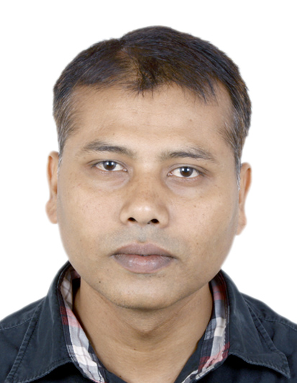

**Major Assignments:**

**15+Yr Running**

|  |  |
| --- | --- |
| **Assignment 1:** | Jun 2020 to till date |
| **Customer** | Celcom, Malaysia. |
| **Industry** | Telecom |
| **Project Type** | DevOps |
| **Environment** | IBM MobileFirst Platform – Angular, Cordova ionic, MySQL, GCP |
| **Role** | Digital Project manager/Agile coach |
| **Responsibility** |  |
|  | * Handling3 scrum distributed agile team of 30+ FT, 4 different vendors across India and Malaysia to help business for smooth delivery, growth on sales, cost reduction and customer satisfaction * Helping team to follow scrum practice, educate BAs on story readiness and grooming, helping POs on defining the business value and release planning. * Guiding other scrum masters and implementing scrum throughout origination |
| **Assignment 2:** | Aug 2016 to Dec 2020 |
| **Customer** | Siemens, Switzerland |
| **Industry** | Manufacturing |
| **Project Type** | DevOps |
| **Environment** | STIBO (Master Data Management), Java, FileNet, Maximo, Cognos, Azure cloud |
| **Role** | Release Manager/Scrum Master |
| **Responsibility** |  |
|  | * 60+ team members of 6 different teams across the world, 3 phases of parallel development. * Expertise in top-down and agile methodology in development projects * Client and vendor coordination to resolve conflict * Planning and executing agile transformation for multiple projects * Service support and operation, [Service Transition](https://wiki.en.it-processmaps.com/index.php/ITIL_Service_Transition), [Service Operation](https://wiki.en.it-processmaps.com/index.php/ITIL_Service_Operation), Continual Service Improvement * Planning and executing CI/CD in DevOps * Customer satisfaction – Build and maintain client relationship |
| **Assignment 3:** | Jan 2014 to June 2016 |
| **Customer** | Statoil, Norway |
| **Industry** | Oil & Natural Gas |
| **Project Type** | Development, migration, enhancement, support, and maintenance |
| **Environment** | SharePoint 2013, C#, SQL, EF, AngularJS, jQuery, SQL |
| **Role** | Technical Manager/technical lead – Application development |
| **Responsibility** |  |
|  | * Managed 25+ members of the application development team. * Solution provider, client interaction and requirement gathering * Coding, code reviewing, deployment, performance improvement * Risk, change request and managing Service support * KT, Swift Sustain, KAP, Transition |