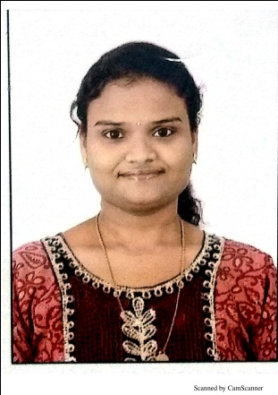 |  | SWAPNA SREE 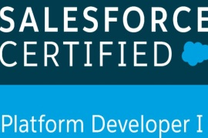  Senior Process Executive  Salesforce Certifications and Trailhead Badges  Salesforce Certified Platform Developer 1  Trailhead Badges: 129  Trailblazer ID : https://trailblazer.me/id/smant
Contact  PHONE:  9052367829  EMAIL:  swapnasreemantha4@gmail.com  LinkedIn:  https://www.linkedin.com/in/ swapna-sree-mantha-b8b19628/  Trailhead Profile:  https://trailblazer.me/id/smant |  | Work Experience  Infosys BPM Senior Process Executive  Nov 13 2013–Dec 15 2020.  Project Details: LTO is a Light touch Specific Handing of T4 Listings. This Process handing different works flows like (Lto Review, Lto Flex, Lto Revisits, Lto Creates...etc.).  Roles & Responsibilities:  - Hands on experience in operations for Global Clients Australia, US, India, Japan and China  - Categorization and authentication of Business Listing for all Global Clients  - Ability to write business letters and reports  - Excellent prioritizing, planning and organizing skills  - Prepare and send internal team productivity and quality reports  - Contributed improvement ideas on Daily Downtime Report which was approved and used across team.  - Prepared documentation(SOP) on exception handling for Authentication of business listings  - Worked in ETO (Express Touch Operations) Quality Team.  - Provided various performance trackers through spreadsheets which helped the team to analyze and improvise its performance.  - Analyzing the quality of the data on Google Maps with all the available resources i.e. web search and street view.  - Providing inputs and testing new upgrade version tools and providing reviews.  - Diagnosed and addressed operational data requests with interacting and communicating with respective clients.  - Worked in LDO project, which uses Pinwheel & Pushpin tool for functioning, reviewing, verifying information and issues in Google Maps.  - Proud to be part of the pilot batch of a prestigious project like Alchemy which helped the organization to analyze the potential and quality of the data.

EDUCATION
B.Tech from Avanthi’s Sri Gnaneswari Research & Technological Academy For Women Engineering College (JNTUK) during 2009-2013 and secured 78.03%.
Received excellence award merit certificate in B Tech at Graduation Day of Avanthi Group Of Colleges Function.

Technical Skills.
- Knowledge on Customization, Configuration, Implementation and Support of Salesforce CRM and applications.
- Knowledge on creating various Profiles,Roles,Users and configured the permissions based on the organizational hierarchy.
- Created Approval Process, workflows .Relationships.
- Designed various Webpages in Visual Force for functional needs within Salesforce.
- Designed and developed Apex Triggers for various functional needs in the application.
- Knowledge on Data Loader, Import Wizard and salesforce.com Sandbox environments.
- Worked on the designing of custom objects, custom fields, role based page layouts, custom Tabs, custom reports, report folders, report types design of Visual Force Pages, Dashboards and various other components as per the requirements.
- Excellent team player, self-motivated, quick learner with good communication skills
- Knowledge on SOQL, Web Services (RESTAPI).
- Knowledge on Lightning, Aura.
- Knowledge on how to work with LWC.
- I have learned and updated my skillset through Trailhead Badges &Journey2Salesforce Program.

Achievements
- Successfully reached target till date with expected level of accuracy.
- Awarded for best performer in Dec 2013 for top in productivity.
- Consistently achieving highest ratings in the team from the inception of the process.
- Received SPOT Award for the Best Performance.
- Received the Client Appreciation Award (I STAR) for successfully reaching the targets.
- Performed the mentor role for the new bees that joined in the team.

