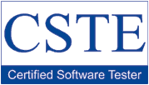
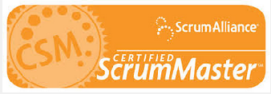

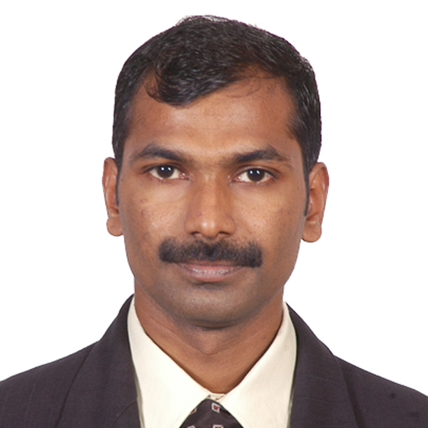

Jinumon K.M.
LinkedIn: http://linkedin.com/in/jkunnumpurath
Mob: +919645075906
Email: jinumon3@gmail.com

CAREER OBJECTIVE:

A challenging role as a Scrum Master, where I can utilize my skillset and knowledge I gained from my decade of experience in Software Industry in align with company’s goal and objective and add value to the organization.

PROFESSIONAL EXPERIANCE:

- A certified Scrum Master with 14 years of experience in IT Industry.

- Acted as Scrum Master for Product teams with a focus on guiding the teams towards improving the way they work.
- Facilitated agile-scrum adoption for the organization with the leadership and guided teams with outcome resulting in enhanced performance.
- Coached/Mentored a cross functional team of 8 resources to deliver quality products.
- Met regularly with Business and internal stakeholders to understand the company's plans for the products.
- Facilitated Release Planning, Sprint Planning, Backlog Grooming, and Retrospective meetings
- Developed best practices and procedures to be used by the entire team which spanned various internal projects.
- Gathered user business requirements by meeting business users and generated business models and use cases.
- Enforced Kanban principles as a scrum master that resulted in reduction of Cycle time and increasing team's throughput.

- Enabled improvement in team delivery commitments and capacity planning for sprints by identifying & tracking hidden tasks that increased customer satisfaction.

- Removed obstacle for the team by escalating an issue to leadership resulting in early delivery of customer issue solution.

- Facilitated Release Planning, Sprint Planning, Backlog Grooming, and Retrospective meetings.
- Removed team impediments on a daily basis to allow the team to deliver the sprint goals and deliverables.

- Facilitated Scrum of Scrum for offshore Scrum teams in US and India.

- Worked with customers and product manager to prioritize and validate requirements.
- Collaborated with members of the Product, Business and Engineering Teams to develop and maintain Product Backlogs

ACHIEVEMENTS /CERTIFICATIONS:

- Certified Scrum Master.
- Sig Sigma certified Professional.
- CSTE Certification.
- EAGLE AWARD (Achievement Award).
- Eagle Squad Award (Best Team award).

WORK EXPERIENCE:

Company | Duration
Xerox Business Services India Pvt Ltd. | July 2010 – Till Date
Stabilix Solutions Pvt Ltd. | June 2009 – June 2010
Cordiant technologies Pvt Ltd. | Dec 2006 – June 2009

EDUCATION:

A Mechanical Engineering Graduate with first class honors from Kannur University, batch 1999-2003.

TECHNICAL SKILLS

- Testing Tools : Visual Studio, Team Foundation Server.
- Defect Tracking Tool : Microsoft Test Manager.
- Operating Systems : Windows flavors.
- Database : MS SQL

PROJECTS DONE

The following gives a brief summary of few core projects I have worked on.

1. XEROX SERVICES PORTAL, FLEET MANAGEMENT PORTAL and Xerox Services Integrations: Xerox Services Manager (XSM) is the core application of entire MPS (Managed Print Services) suite of Xerox Corporation. It acts as the service end point, which handles all the data MPS platform deals with. XSM has its own management UI for different modules like incident, asset, supplies etc. and has a customer facing module (CFP) though which users can interact with XSM.
Role/Responsibilities: Functioned as Scrum Master and QA Lead for a team comprising 9 members. Facilitating release planning, sprint planning, daily scrum and retrospective meetings. Unblocking the team whenever needed. Leading and coordinating team activities. Ensure Team is on Track with the Sprint. Served as Feature SM for a feature that span different application and multiple teams. Served as domain experts for the core modules.

Application Environment : ASP.NET.
Database : MS SQL Server.

2. FELIX INFRASTRUCTURE: Felix is a software development and integration platform based on open system computing standards. FELIX provides the tools to rapidly integrate sophisticated process management into business operations and applications. It models, extends, configures, and automates business processes. The software platform is a portfolio of integrated yet highly modular solutions for service automation, analytics and enterprise information integration. Whatever user need, whether it is incremental automation, major overhaul, or enterprise-wide integration, FELIX can help the user by making it easy to connect people, information and applications in just the right combination.

Role/Responsibilities: Test development and managing test execution. Leading a team of 5 members. Coordinated test various application teams and product support team for issue resolution and support.

Application Environment : JAVA.
Database : ORACLE 10.

3. RUBIKON: Rubikon is a universal banking system with a broad spectrum of banking services which include current, savings, loans, mortgages, treasury, trade finance, clearing, budgeting, document management, portfolio management, multiple service channels, customer relationship management and electronic banking. Rubikon truly models the bank’s preferred business processes.

Role/Responsibilities: Generation of Test cases for manual testing. Performing Functionality testing. Tracking the issues using ‘Jira’ and retesting the defects. Generated the detailed reports of the Bugs and Pass-Fail report. Applied software testing principles and concepts

Application Environment : JAVA.
Database : ORACLE 10.

PERSONAL PROFILE:

- Father’s name : Mohanan K.M
- Date of birth : 29-05-1982.
- Nationality : Indian.
- Passport Number : F8408897
- Visa : US B1 Visa valid till 2020.
- Marital status : Married.
- Languages known : English, Hindi and Malayalam.
- Permanent Address : Pilachikara PO, Parappa, Kasaragode – 671533.

:

