**Kalahasthi Vasu** 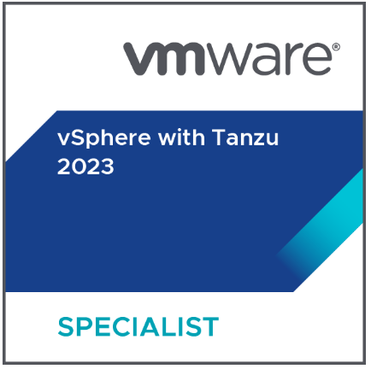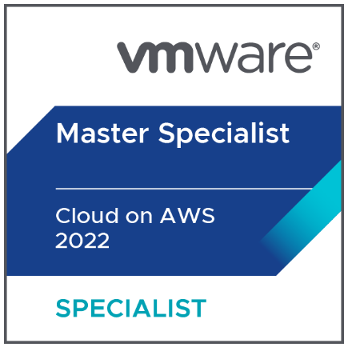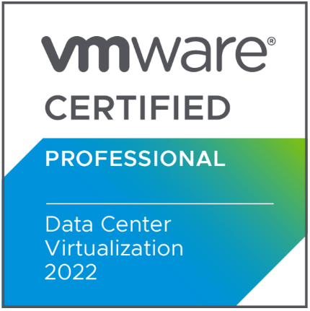

**E-Mail :** [**kalahasthi.vasu1989@gmail.com**](mailto:kalahasthi.vasu1989@gmail.com) **Mobile** : +91- 8123453245/9704579143



To pursue a professionally satisfying growth and challenging career, seeking a quality environment where my knowledge can be shared and enriched for the growth of the organization and self.



**TECHNICAL PROFICIENCY**



* **Current Employer:** Deloitte Consulting India Private Limited.
* **Period:** March 2022 to till date.

**Nature of Job:** VMware Engineer Technical Lead

Part of 7 Members team involved in complete VMWare activates, vSAN, network activities and Hardware. Building, Managing and Maintaining 7K+ servers, 670+ ESXI.

* **Current Employer:** Tata Consultancy Services
* **Client:** Socitie Generale (Banking)
* **Period:** Sep 2017 to March 2022.

**Nature of Job:** Special Sys Engineer (VMware Engineer, UNIX Administrator)

Part of 30 Members team involved in complete VMWare activates, Hardware x86 , UNIX activities, Building, Managing and Maintaining 30K+ servers, 2500 ESXI.

* **Previous Employer:** Advaiatam Tech Solutions Pvt Limited (Telecom)
* **Period:** Nov-2014 to August-2017.
* **Nature of Job:** Product support Engineer – Linux & Windows

Part of 9 Members team involved in Complete Linux & Windows activities, Managing and Maintaining servers

**SUMMARY**

* Having 8+ years of overall experience in core VMware Engineering, Linux.
* Analyze and troubleshoot ESXi production related issues
* Trained in VMware vSphere: Install, Configure, Manage [V6.7] [v7.0], VMC on AWS, vSphere with Tanzu Kubernetes
* Experience in migration and upgrade activities which includes ESXi and vCenter upgrades
* Experience in global DR activities using SRM
* Strong work experience in ESXi patching, upgrades and vCenter upgrades
* Experience in configuring and managing VMWare vSAN Infra end to end
* Configuration knowledge and troubleshooting skills in NFS and vSAN Storages
* VMware Horizon-VDI management
* Worked in hardware troubleshooting which includes Blade/Rack Servers from CISCO, DELL, HP, CIARA hardware.
* Experience in managing physical server profiles and configuration.
* Experience in creating and managing hardware RAID and disk management
* Worked on multiple hardware issues and upgrade activities including firmware in Cisco-UCS, HP ILO, DELL iDRAC and CIARA management console.
* Worked on Nutanix cloud environment ESXi support (monitoring health in prism, host upgrade, maintenance activities)
* Strong Experience in Level2 support Incident and Change management.
* Having knowledge in VRops as monitoring the infra issues in the vCenter
* Having basic knowledge in the NSX-T and VCF environment
* Use to work on service now ticketing tool on daily based on ITIL management process (Incident, Change, Request, Task)
* We do maintain the certificate management in the vCenter, Certificate Renew and management.
* Created documentation on knowledge articles and troubleshooting documents
* Created some VMwareCLI scripts for day-to-day activities
* Good Knowledge in Unix flavors – Red hat Linux, CentOS

**Achievements:**

## Appreciation from client and senior management for the extra efforts put in the work and for the technical expertise.

## Implemented VMware vSAN environment from scratch successfully

## Received 1 Spot and 1 Applause awards for the best technical exposure and received 15k rewards.

## Achieved 3 VMWare Certification in within 6 months

## Fixed multiple vulnerabilities and Authentication issues.

**ROLES AND RESPONSIBILITIES**

**In VMware:**

* Managing more than 670+ ESXI hosts and more than 7000+ virtual machines in environment.
* Managing SRM protection groups and recovery plans configuration.
* Planning and implementing disaster recovery exercise and test manually and by using SRM.
* Handling host down incidents with complete hardware issues resolution
* Configuring ESXi hosts within the cluster using HA and DRS.
* Developed and implemented VMware vCenter upgrades from version 6.7 to 7.0.
* Applied patches using VMware vCenter Update Manager/Life Cycle manager and EsxCLI commands for the ESXi’ s
* Patch and upgrade activities on vSAN deployed clusters.
* Configured VMware HA, VMware DRS in acquiring higher efficiency for VMware Infrastructure.
* .
* Configured VMware vDS and Standard Switch, port groups.
* Creation Virtual Machines, cloning virtual machines, Snapshots management.
* Performed P2V and V2V migrations using VMWare standard converter
* Creating monthly and weekly reports regarding storage, memory, CPU usage and summary of the VM’s.
* Network Configuration on ESXi servers which include NIC Teaming.
* Performed VMWare tools and VM hardware version upgradation on various servers
* Fixed multiple migration issues- vMotion
* vDisks conversion and management
* Datastores management -VMFS5/6 , NFS
* Managing Content Libraries and templates
* Cross vCenter migrations
* vCenter’s Linked mode configuration
* VM’s restore activities from Avamar backups
* VMware Horizon 8.x
  + Deploying new pools
  + Updating golden Images
  + Fixing certificate issues
  + Connection servers and UAG’s management
  + Performance tuning for the VDI’s
  + FSLOGIX profile management
  + DEM Profile management
  + MFA issues and fixes
* Outages and incident management
* BCP power maintenance activities

**X86 Platform:**

* Server racking’s/Decommission on Datacenter’s
  + Cisco -UCS blades /Rack servers
  + HP Blades/Rackservers
  + DELL Rack and DELL VRTX blade servers
  + CIARA Rack Servers
* Blade server profile creation – Cisco UCS, HP blades
* Working with Vendor for all type of H/W failure cases
* Firmware upgrades on Cisco, DELL, HP and CIARA servers
* Validating and monitoring physical server’s health with logs
* Decision making to arrange vendor to replace faulty spares
* Remote support for faulty spare identification and replacement.
* Change management, Normal, Significant, Minor and Emergency changes.
* On-Call support on weekends
* Meeting client's SLA and make sure that SLA is not violated
* Attending CAB meetings and getting approval for the changes and implanting the changes on scheduled timings.
* Worked with 24x7 Production Support environment.

**In Linux:**

* Build/ Remastering of OS for standard requirements
* Managing server decoms
* Users and groups management
* ACL’s, Special permissions, SUDO.
* SSH (encryption techniques), SSH key based authentication.
* Package management using yum and rpm.
* Performance issues like CPU high utilization, swap issues, memory issues
* Perform day-to-day systems administration tasks, user management, file system maintenance, backup/recovery, and monitoring.
* Troubleshooting and monitoring performance related issues.
* Performed regular job scheduled using crontab.
* Starting and stopping services as per client request.
* Performing UNIX servers reboot and monitoring it on scheduled changes.
* Managing Disk File Systems usage.
* DNS and its functionality
* LVM file system management
* San storage –disk scanning’s, allocation storage to servers.
* NFS
* Linux Security- Hardening.
* Creating Links soft/Hard
* Taking care of server down/restart related to capacity upgrades RAM/CPU or downgrades.
* Bash SHELL scripting for day-to-day tasks.
* Ansible Ad-Hoc command line scripting
* Managing files
* Cloud knowledge on AWS, Azure.
* Remote support on all types of H/W issues for DELL IDRACK & HP Rack/Blade servers

**CORE-COMPETENCIES**



* Adaptability
* Incident Management
* Analytical and Problem-solving skills
* Ability to work under pressure
* Quick Learning Capabilities
* Good at Teamwork and active interaction with team

**EDUCATIONAL QUALIFICATION**



* M.C.A from S.V. University.
* B.SC. from S.V. University.
* Intermediate from Board of Intermediate Education.
* SSC from Secondary School Education.

**PERSONAL DOSSIER**



|  |  |  |
| --- | --- | --- |
| Date of Birth | : | 15-08-1989 |
| Marital Status | : | Married |
| Passport Available | : | Yes |
| Languages known | : | English, Telugu, Tamil |
|  |  |  |

**Declaration:**

I do hereby declare that the above declarations given by me are true to the best of my knowledge and concern.

**Place: Chennai (Kalahasthi vasu)**

**Date: SIGNATURE**