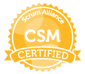
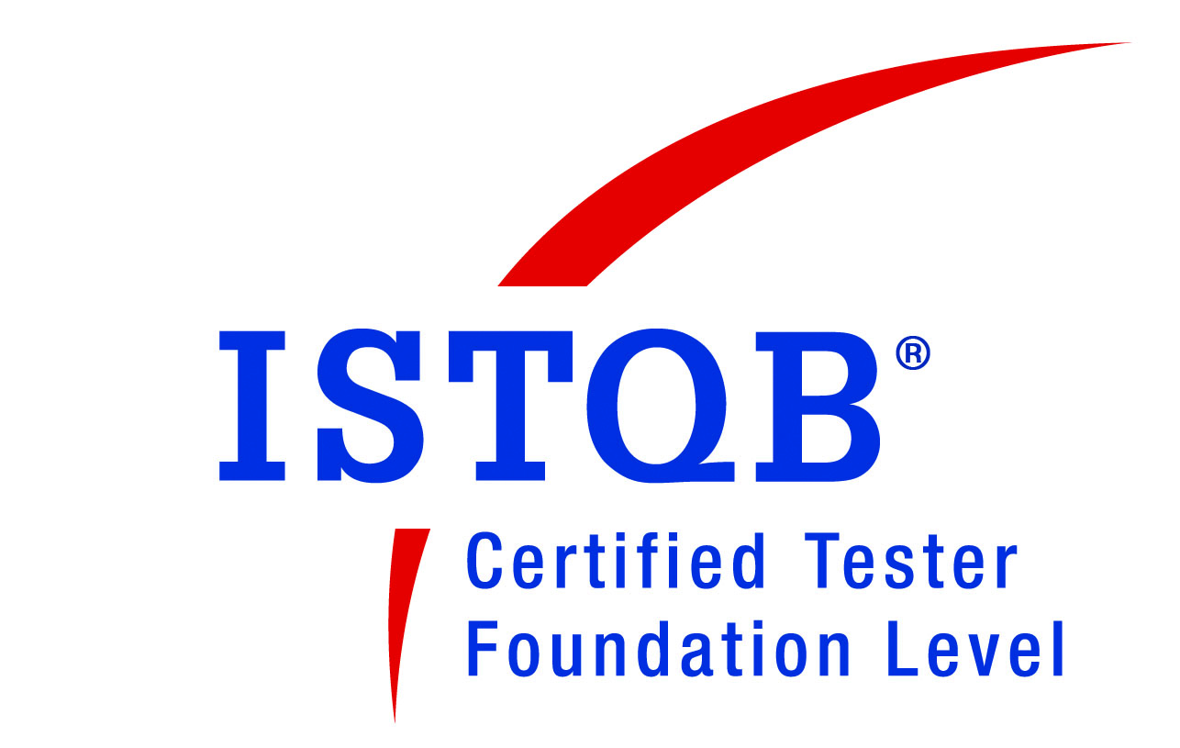

Swapnil Gazbare
Email id: swapnil.gazbare@gmail.com
Mobile no.: 9923697079
_________________________________________________________________
Synopsis: My Objective is to work in a challenging and creative environment and effectively contribute towards the goals of the Organization.

EXPERIENCE SUMMARY
- Over all 13.11 years of experience in IT.
- 6 years of experience as scrum master, CSM Certified.
- Facilitate all scrum ceremonies (backlog refinement, sprint planning, reviews, retrospectives, daily stand-ups)
- Work closely with project owner in backlog management and continuous delivery of features.
- Facilitated agile adoption for the organization with the leadership and guided teams with outcome resulting in enhanced performance.
- Worked from Onshore with Product Owner during foundation sprint for T-shirt sizing, story mapping, prioritizing backlog, story pointing of upcoming 6 sprints.
- Working with scrum team to resolve impediments and improve velocity to get a better prediction of the number of sprints that will be required to complete the feature/epic
- Engaging external teams at the right time to get over dependencies or business specific mandates (NFR)
- Enact change and continuous improvement increasing the productivity of Scrum teams and the quality of deliverables.
- Empowered teams to self-organize and grow cross-functionality.
- Protect team from over-commitment, manage backlog and prioritize resolution of defects/bugs.
- Experience in Pairing of team members to work on task to get the result faster.
- Web applications and Mobile application testing on both IOS and ANDR platform.
- Track and communicate team velocity and sprint/release progress.
- Publicizing the team's progress and successes to make sure they are highly visible to product owner/stakeholders.
- Knowledge on agile methodologies like Scrum, Kanban.
- Experience in testing on web/mobile based (RWD), including 1+ year onsite (Finland) as test lead / scrum master also with strong experience in handling Onsite and Offshore testing teams.
- Good hands on API Testing using POSTMAN and Selenium Web driver & Grid
- Good Knowledge of creating Visual Studio Web Test and Load Test for Performance Testing
- Having valuable Onsite experience [Finland, Helsinki] for UAT.
- Good hands on of building and reviewing Test plans, Test scenarios, Test cases, Test procedures, Test reports and documenting manual tests and also have exposure to Agile process and methodologies.
- Knowledge of Synetracker, HP Quality Centre 10.0, Jira, TFS (VSTS) / Azure devops.
- Ability to handle multiple tasks in changing deadlines, work effectively with peers, in-group and independently.
- Handled project single handed from test plan to test report creation.
- Worked extensively on various domains like Banking, Insurance and Education.

QUALIFICATION
Degree | Institute | Year
Bachelor of Engineering[EXTC] | Pune University | 2005

PROFESSIONAL SUMMARY
Duration | Organization | Designation
June 2019 – Till Date | Deutsche Telekom | Scrum Master
Sept 2014 – June 2019 | Capita India Pvt. Ltd | QA lead
Aug 2009 – Sept 2014 | Tieto software Technologies PVT Ltd Pune. | Sr. Test Engineer
March 2007- Aug 2009 | Synechron Technologies PVT Ltd Pune. | Associate -Quality

TECHNICAL SKILLS

O. S. | Windows XP/ME, Windows 7
Languages | SQL
Tools | Winrunner,QTP,TestDirector
RDBMS | MS SQL Server 2008
Industries | Insurance,E-commerce,Banking , Transportation
Defect Tracking tools | Synetracker, ALM, Jira,TFS.

CERTIFICATION

Certification | Institute | Year
Certified SCRUM master | Scrum Alliance | 2016
ITILv3 Foundation Exam | Tieto software PUNE. | 2012
ISTQB Certified Tester  (Foundation Level) | Certification Guru ,Pimpri-Pune -18 | 2011
Brain bench certification in Software Quality Assurance | Online  (Having Transcript ID number 6835375) | 2007
Software testing | SEED InfoTech Pvt. Ltd. Pune | 2005
Hardware & Networking | Government polytechnic Pune | 2004

PROJECTS

Deutsche Telekom Clinical Solutions India Private Limited June2019-Till Date Trial Connect
Project : Trial Complete.
Designation : Project Manager/Scrum master
Platform : Angular, ASP DOT NET, SQL Server 2012

Description: The Trial Complete clinical data management system (CDMS) collects and organizes data from pharmaceutical, biomedical, and clinical studies. Security is guaranteed through the use of ISO/IEC 27001-certified data centers operated by Deutsche Telekom, which of course satisfy the requirements of the General Data Protection Regulation (GDPR).

Responsibilities:

- Working as a scrum master
- Facilitate all scrum ceremonies (backlog refinement, sprint planning, reviews, retrospectives, daily stand-ups)
- Leading 3 teams having total 15 members. Mentoring them for various testing and agile ceremonies.

Capita India Pvt. Ltd. Sept 2014-June2019
SIMS

Project : SIMS (School Information Management System)
Designation : Scrum master
Platform : C# DOT NET, SQL Server 2012

Description: SIMS is a web-based, centrally hosted School Management Information System, which enables school leaders, teachers and administrators to perform their designated tasks.

Responsibilities:
- Working as a scrum master
- Facilitate all scrum ceremonies (backlog refinement, sprint planning, reviews, retrospectives, daily stand-ups)
- Supporting and educating the Product Owner, especially on grooming and maintaining the product backlog.
- Remove impediments to faster team productivity, to ensure scrum practices are followed.
- Facilitate cross functional team, encourage them to pick their own work, encourage process improvements.
- Providing all support to the team using a servant leadership style whenever possible and leading by example.
- Assisting in various reports preparation for management.
- Keep track of the new requirements / change in requirements of the Project.
- Setting up process useful for achieving sprint goals.
- Assisting with internal and external communication, improving transparency, and radiating information.
- Leading a team of 9 members. Mentoring them for various testing and agile ceremonies.

TIETO Software Technologies Pvt. ltd. June2012-Sept2014 Enter Cards (Banking)

Customers : Enter-Cards, Nordic countries
Environment : Java, SQL2012
Designation : QA ENGG
Platform : MS Windows XP/2000, IE 6, Google chrome.

Responsibilities:
- Working as a scrum master and QA
- Facilitate all scrum ceremonies (backlog refinement, sprint planning, reviews, retrospectives, daily stand-ups)
- Working with scrum team to resolve impediments and improve velocity
- Working with Product owner on Artifacts such as Product Backlog, Sprint Backlog, Sprint and Release Burn down.
- Also Playing a role of a Test Engineer for this Project and is responsible for:
- Writing Test plan test cases, reviewing test cases, preparation of test data, test cases execution
- Defect reporting and management using Mercury Quality Center, jira.
- Co-coordinating with offshore team members to resolve issues and facilitate delivery.
- Co-coordination with Client on different Application Functionalities.

TIETO Software Technologies pvt ltd. Aug2009-June2012 LIS(Life Insurance Solutions)

Customers : LIS, Finland
Designation : QA ENGG
Environment : Java, DB2
Testing Tools : Manual Testing
Role : Test Engg.
Platform : MS Windows XP/2000, IE 6

Responsibilities:

- Playing a role of Sr.Test Engineer for this Project and is responsible for:
- Writing test cases, reviewing test cases, preparation of test data, test cases execution
- Defect reporting and management using Mercury Quality Center
- Co-coordination with Client on different Application Functionalities.

Synechron Technologies pvt ltd. March2007 –Aug2009 CS STARS, USA

Customers : CS STARS, USA
Environment : ASP.Net 1.1, SQL 2005
Testing Tools : Manual Testing
Role : Software tester.
Platform : SQL Analyzer, MS Windows XP/2000, MAC

Responsibilities:
- Developed Test Strategy documentation (Test objective) for various CR’s
- Used SQA Analyzer and Oracle Toad tool in validating data from various tables in databases
- Coordinated with development team and business team in verifying issues and defects
- Organized test data and created test data profiles for test execution.
- Prepared test completion report.
- Tracked defect using Jira and creation of Test Summary Report and Defect Verification Report.

Synechron Technologies pvt ltd. Johnson tiles

Customers : Agency dot com, London.
Environment : ASP.Net 1.1, SQL 2005
Testing Tools : Manual Testing
Role : software tester
Platform : Windows XP/98, 2000, IE6, IE7, FIREFOX, SAFARI

Responsibilities:
- Involved as a Test Engineer for the JHONSON TILE application.
- Application testing using different browsers like IE6,IE7, MOZILLA2.1, SAFARI 3.1
- Involved in the Test cases Preparation phase
- Execution of the Test Cases.
- Reporting Defect. Verify and closing of Defects.

Personal Details

Name as in Passport : Swapnil k. Gazbare
Permanent address : Sunflower-B Building, Flat no.19, Sukhwani campus,
Vallbhnagar, pimpri, Pune-18.
Passport No : G3210521
Nationality : Indian
Languages Known : English, Hindi and Marathi
DOB : 15TH JAN 1982
PAN : ALWPG6073E

